Fay’s Chemistry Notes

Year 10

Chapter 1: Changes of State

Properties

There are 3 main states of matter[1]: solid, liquid, and gas. There are a multitude of properties that are used to scientifically describe these states.

Physical properties include:

* Shape
* Volume
* Compressibility
* Density
* Flow/diffusibility

Particle properties include:

* Forces of attraction
* Movement
* Arrangement
* Distance between particles

Solids

Physically, solids have a fixed shape and volume, and are not compressible. They cannot be compressed due to how packed their particles are, and so are also very dense. They cannot diffuse[2] because their particles are not free to move.

On a particle level, solids have the strongest forces of attraction, and so, particle movement is extremely limited, vibrating in place.

The particles of a solid have a regular and tightly packed arrangement, so distance between particles is minimal.

Liquids

Physically, a liquid’s shape is dictated by its container, though volume is constant and can barely be compressed as the distance between particles remains close and the same. The density of a liquid is high, not far from a solid.

Liquids are fluid and can easily diffuse due to the weaker particle forces of attraction.

On a particle level, liquids have weaker forces of attraction than solids and can slide around each other with a loose arrangement. The distance between particles is small, following its density.

Gas

Physically, a gas has no fixed shape or volume and can easily be compressed. It has a low density and can diffuse in all directions.

On a particle level, it has no forces of attraction between particles and has no set arrangement. The particles can move freely in all directions and have a far distance between each other.

If you’re lazy and want a bullet list

Physical

Solids:

* Fixed shape
* Incompressible
* High density
* Fixed volume
* Cannot diffuse

Liquids:

* Variable shape
* Basically incompressible
* Fairly high density
* Fixed volume
* Can diffuse

Gas:

* A shapeshifting master
* Very compressible
* Low density
* Volume? do I know her
* Very diffusible
* Only rival is plasma

Particle Level

Solids:

* Very strong forces of attraction
* Vibrates in place
* Tightly packed and arranged as a regular lattice structure
* Very little space between particles

Liquids:

* Weaker forces of attraction
* Can slide around each other
* Loose arrangement
* Small distance between particles

Gas:

* No forces of attraction
* Moves freely
* Random arrangement
* Big distance between particles

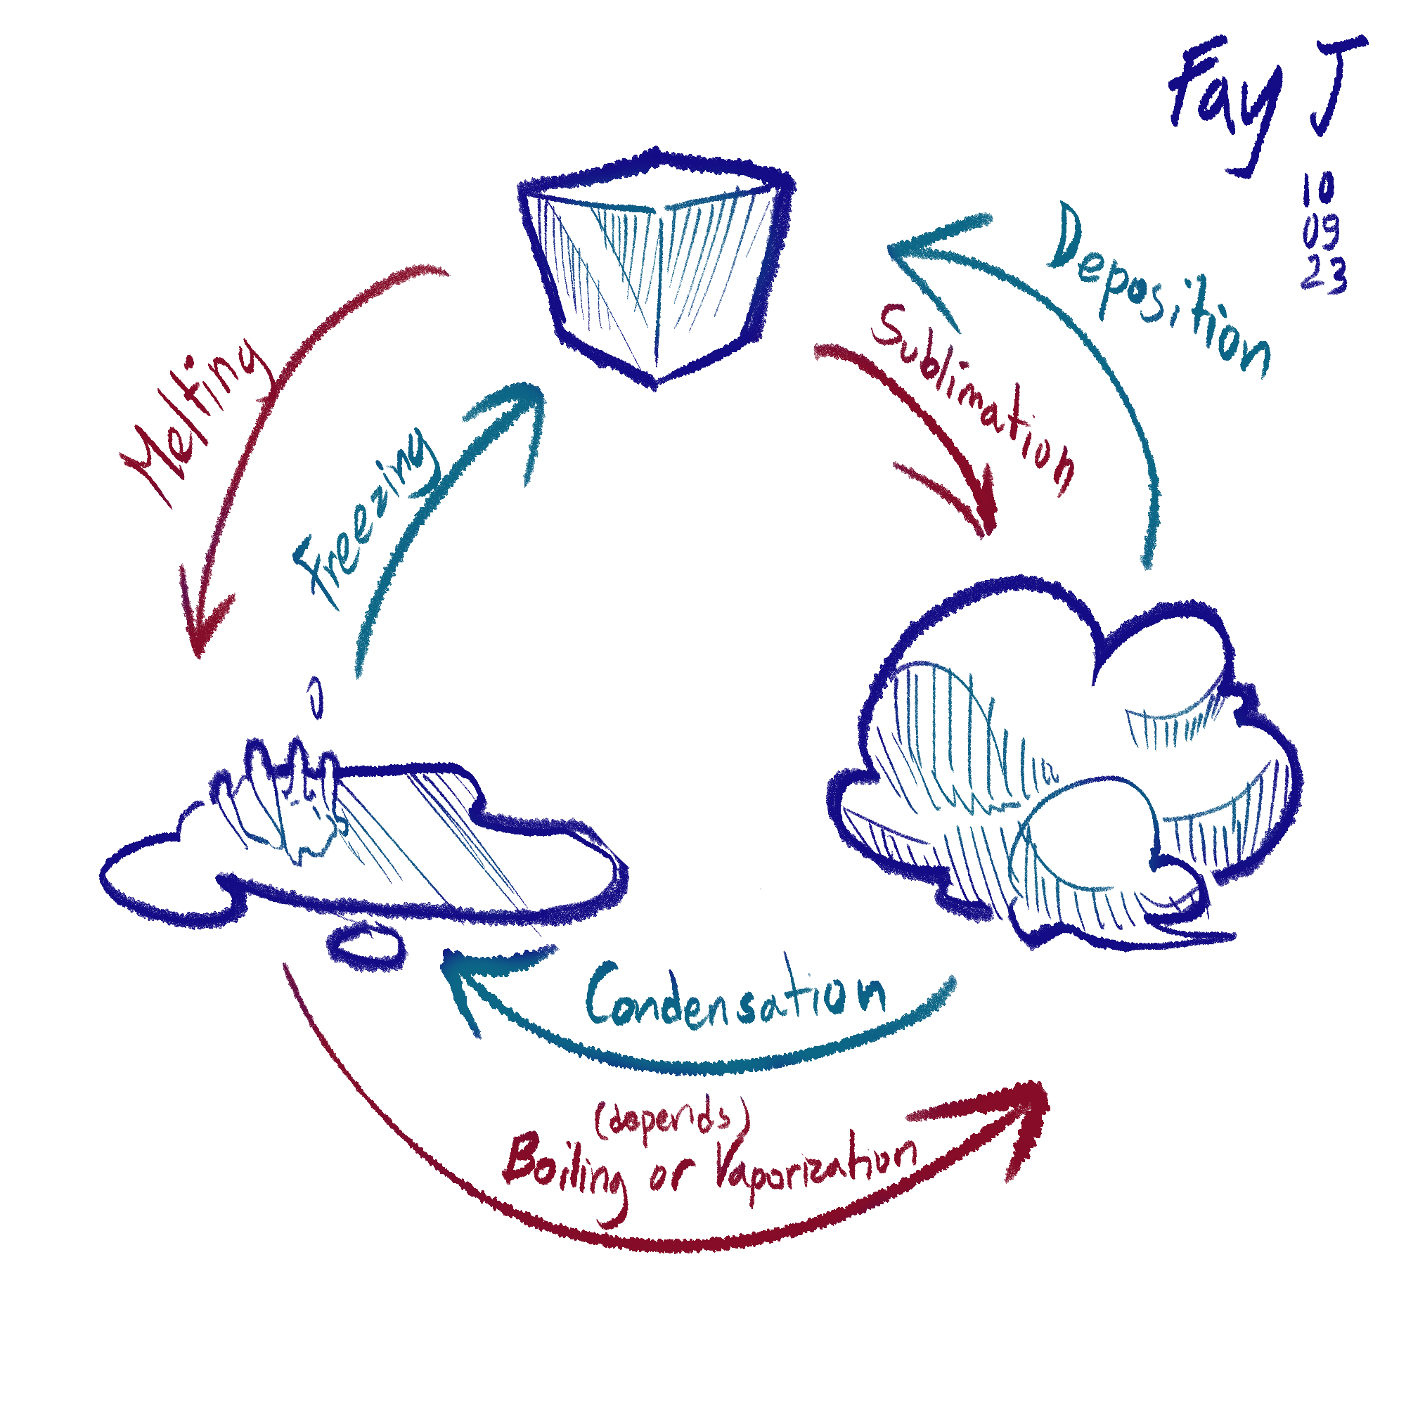

Changing state

Boiling only happens when the substance reaches its boiling point, while evaporation can happen without it reaching the boiling point.

Evaporation happens mainly on the surface of the liquid and uses energy (usually heat) from its surroundings to build up kinetic energy[3] to break its particle forces of attraction and have its particles escape the liquid.

Boiling happens less gradually than vaporization and happens throughout the entire substance, using its own heat energy[4] to break particle forces of attraction and turn into gas.

There are 4 main steps to explaining any change of state:

1. Energy decrease or increase; heated or cooled
2. Movement of particles as a result
3. Forces between particles are described
4. Final outcome; particles’ current state

Here is an example of this structure being used[5]:

*In water’s change of state from solid to liquid, heat is added so the ice reaches its melting point. The particles of the solid start moving faster and weaken the forces of attraction between them, letting the particles move more freely and slide around, which is the state of liquid.*

Graphing temperature changes in tandem with state changes

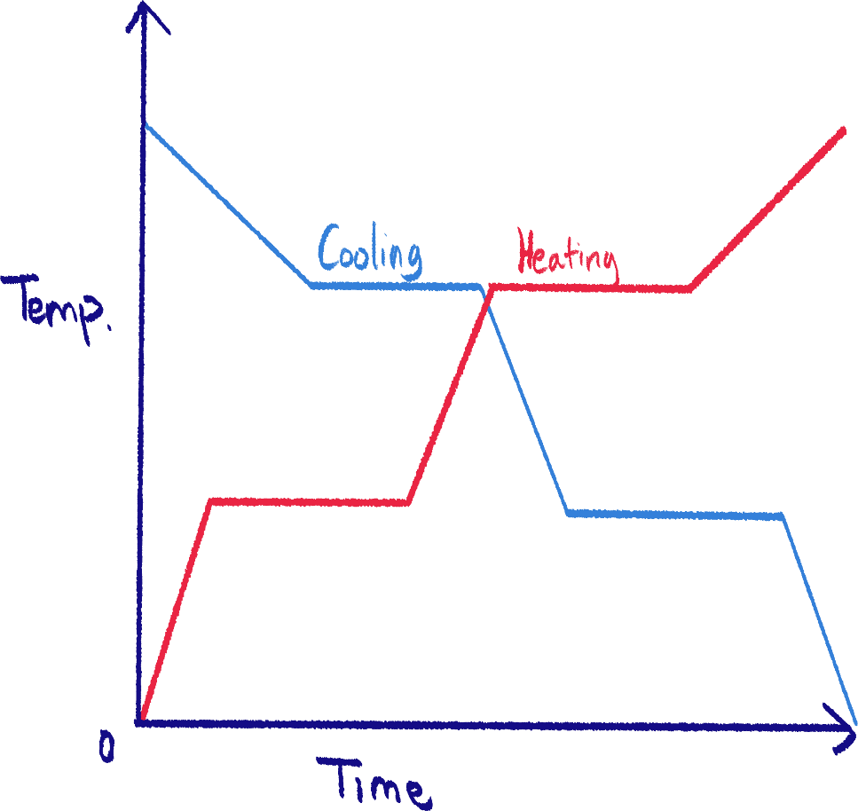 There are two ways to draw a temperature-to-time graph; as a cooling or heating curve. It depends on the kind of change of state being presented.

There are some parts of the graph where the line plateaus, or when the temperature does not change for some time. This is where the substance is transitioning from one state to another.

In heating, the temperature does not change in this part because the heat energy is being used/absorbed to weaken the particle forces of attraction.

In cooling, the temperature does not change in this part because heat energy is being released to reform particle forces of attraction and change state.

Impurities[6]

Impurities are an important factor as they can lower the melting point and increase the boiling point of a substance. (You can skip italics)

*Impurities disrupt the intermolecular forces and lattice structure between solid particles, so it melts at a lower temperature. This is called a melting point depression.*

*But they also increase the boiling point, called a boiling point elevation, because the impurity takes up space in the liquid and reduces the surface particles of the pure substance. Boiling only happens when there are enough vapor particles above the liquid to counter atmospheric pressure, so because there are fewer surface particles vaporizing, more energy is needed to reach the right amount of vapor particles to boil*.

For example, mineral drinking water will not have the same boiling point as distilled water. Water with salt added to it will have a higher boiling point than 100˚C[7].

When salt is added to ice, it will have a lower melting point, which means it will melt easier.

Diffusion

The definition of diffusion is the process in which particles spread out from an area of high concentration to a low concentration as they move around randomly.

Factors of diffusion:

1. State

I already told you. Solids barely diffuse, liquids can, and gases are the best at it.

Why? Because liquids are free to move, but are still slower at diffusing than gases because there are still some weak forces of attraction between particles.

1. Temperature

The higher the temperature, the more kinetic energy particles have, the faster they’ll move, the faster they’ll collide and bounce away from each other, and the faster they’ll diffuse.

1. Mass

Particles are often not little spheres like how we draw in the particle model. Instead, they may be molecules or ionic compounds.

Thus, they will have different masses, and the less mass they have, the faster they will diffuse, and vice versa[8].

The reaction between ammonia and hydrochloric acid

I think IGCSE Chemistry really loves this experiment.

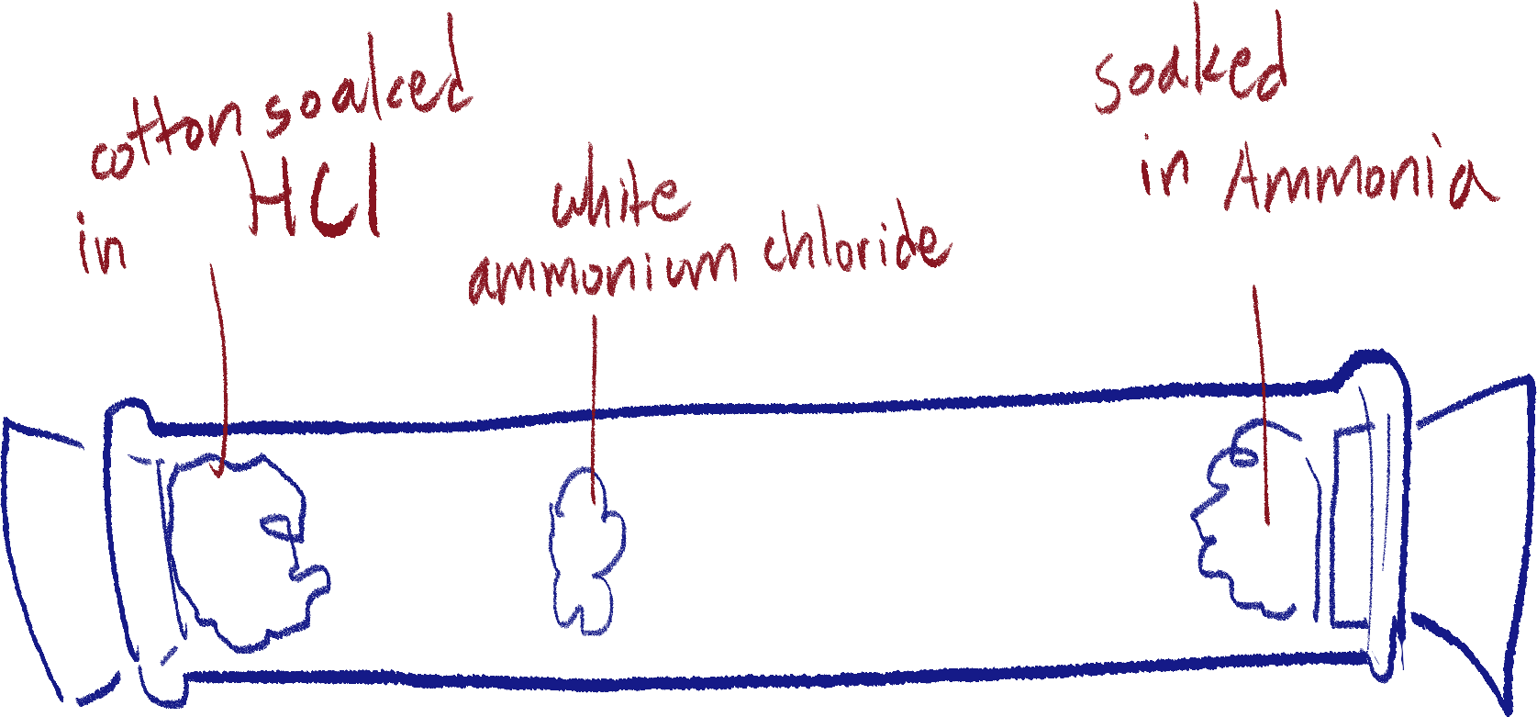

All you need to know is that ammonia has a lower mass than hydrochloric acid, so it diffuses further through the tube than hydrochloric acid, and so it reacts closer to the acid’s starting position.

Gas pressure and the factors that affect it

Gas pressure is caused by gas particles moving randomly, hitting the walls of the container it’s in. The more often they hit and the harder they hit, the higher the gas pressure is.

They respond to pressure like this because their particles have no forces of attraction between them. Liquids and solids do not have this property.

There are three factors which affect gas pressure:

1. Temperature

If the gas has a higher temperature, it means its particles have more kinetic energy, which also means they are moving faster. This results in the particles hitting the container walls more frequently, as well as hitting it harder.

1. Volume

Increasing the volume of the container means that there will be more distance between particles, which results in them colliding and bouncing off each other less.

Thus, they will hit the container walls less often and the gas pressure will be lower.

1. Amount

The more gas particles there are, the more crowded it will be, and so, the particles will bounce off each other and hit the container walls more, increasing the gas pressure.

All of these factors also apply vice versa. (i.e., less volume > higher pressure)

With these factors, gas pressure can be calculated with this formula (disclaimer, you probably don’t need this for a test):

P = nRT ÷ V

(Pressure = amount (in moles) * gas constant[9] * temperature (in Kelvin))

Chapter 2: Experimental Design and Separation Methods

Different types of substances

No, not going into atomic theory right now, but we’re only going over the classifications of substances according to their composition.

Matter is anything with mass, and takes up volume. Anything made up of atoms or ions is matter.

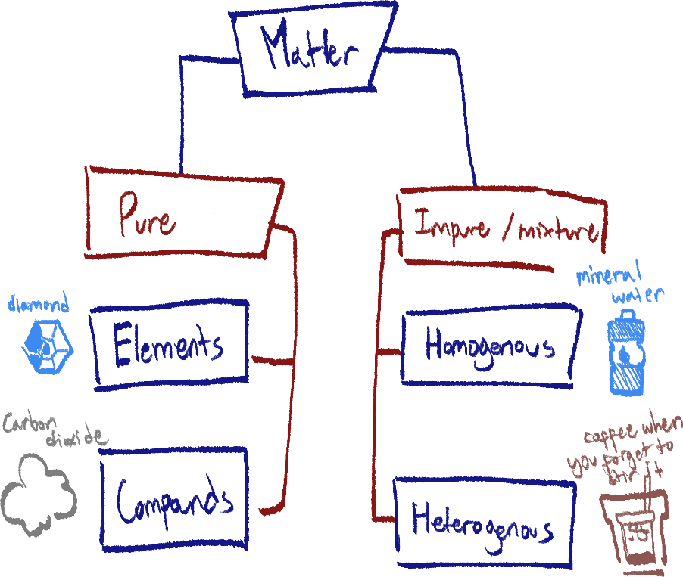There are two types of any substance: those that are pure and those that are not:

Pure substances are made up of only one element or compound, and thus cannot be separated by physical means.

An element is made up of one type of atom, but a compound is made out of multiple different elements chemically bonded.[10]

An impure substance, or mixture, is made up of two or more elements and/or compounds physically kept together. Mineral water is pure water with many different minerals dissolved in it.

A mixture can be homogenous or heterogenous. Homogenous mixtures have their components uniformly distributed throughout the substance, while heterogenous mixtures have their components divided, which one can usually see with the naked eye.

All of the lab equipment

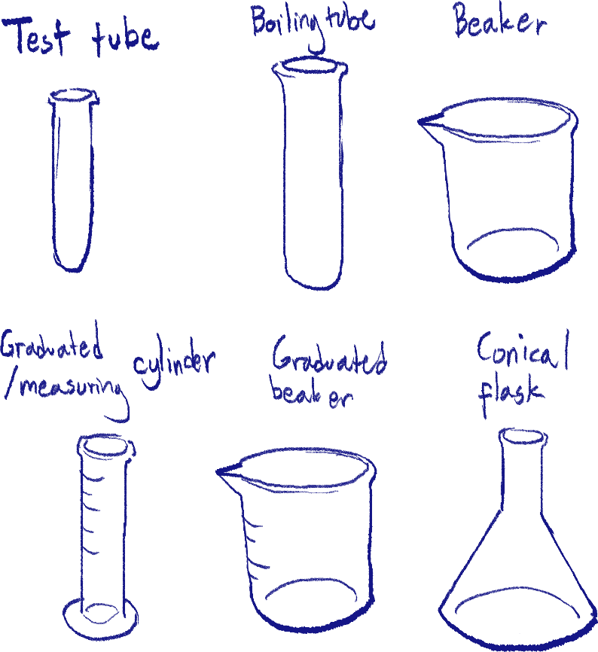Additional notes:

Boiling tube is thicker in diameter as well as glass thickness.

Beakers are usually for mixing, heating, or transporting substances rather than measuring their volume, a measuring cylinder is more fit for that.

A conical flask can be used for heating, holding, mixing, and chemical reactions. Plus, they can be corked, and used in closed methods like simple distillation.

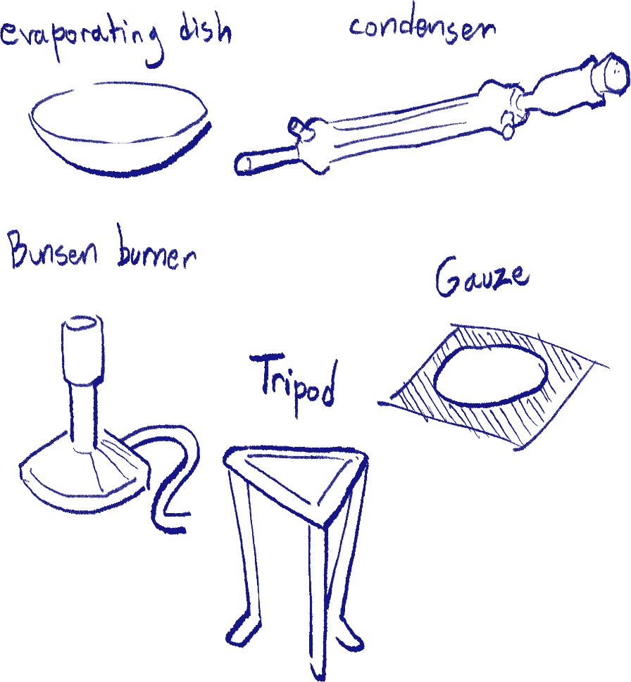

A gauze as lab equipment is a metal mesh (often with a ceramic plate as well) used to support an evaporating dish, beaker, or flask over a tripod and Bunsen burner while heating. This is because glass cannot be held directly over an open flame.

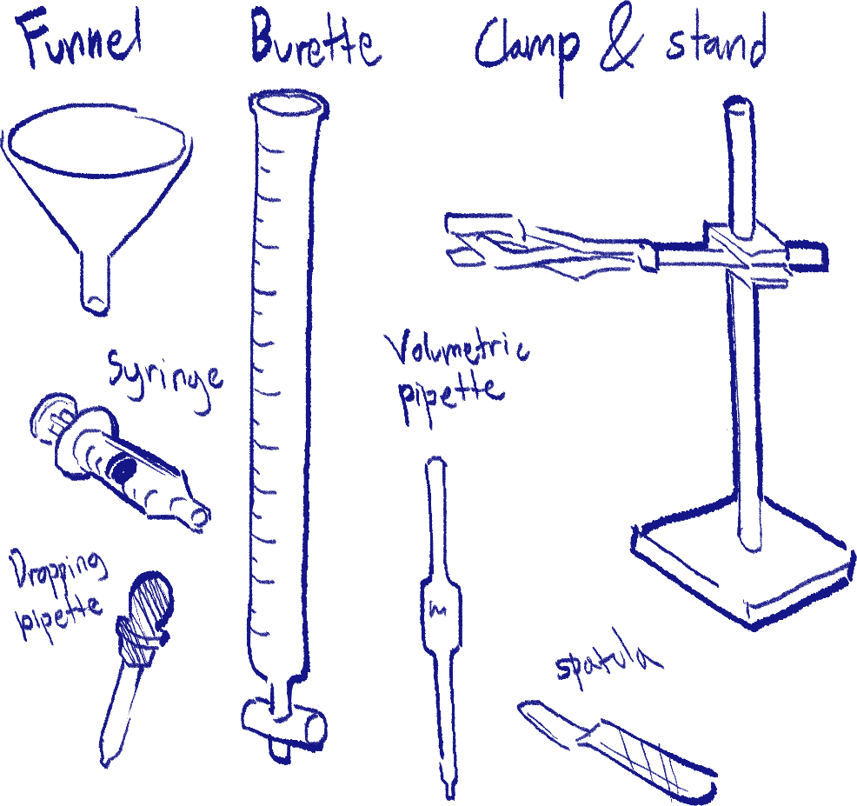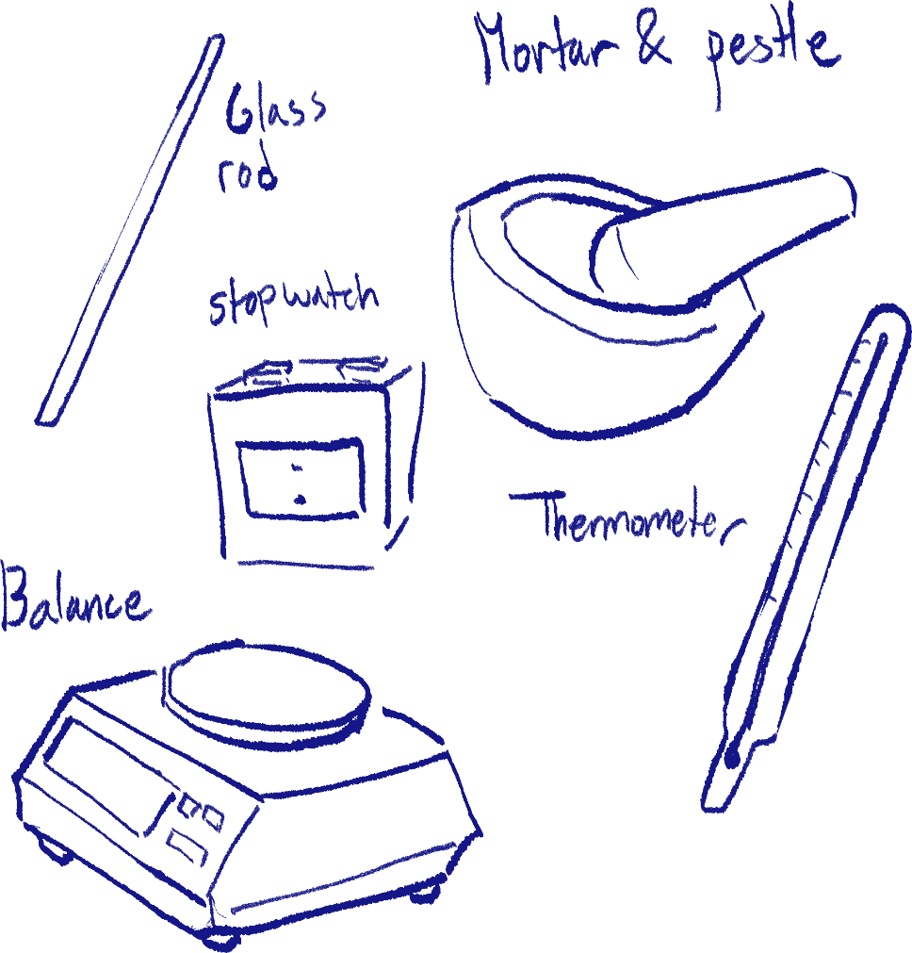The burette, unlike most measurement tools, measures the amount of liquid that has exited it, not the amount that is currently in it.

Clamp and stand are used in experiments such as the *ammonia + hydrochloric acid observation*.

A dropping pipette is typically used for instances where accurate amounts are not required, as acquiring a specific volume of liquid is very susceptible to human error using it.

A volumetric pipette, on the other hand, will carry a fixed amount of liquid, which is good when accuracy is important.

A balance’s resolution is how small of a change in mass the balance can detect. For example, a high-resolution balance can detect up to 0.001 grams.

Many measurement tools such as the balance or digital thermometers need to be calibrated for accuracy.

Filtration

Filtration is only used for heterogenous liquid-solid mixtures A.K.A. liquids with insoluble solids in them, an example being sand and water.

There are two ways to go through, but they follow the same core; liquid passes filter paper, while the solid is collected on the paper.

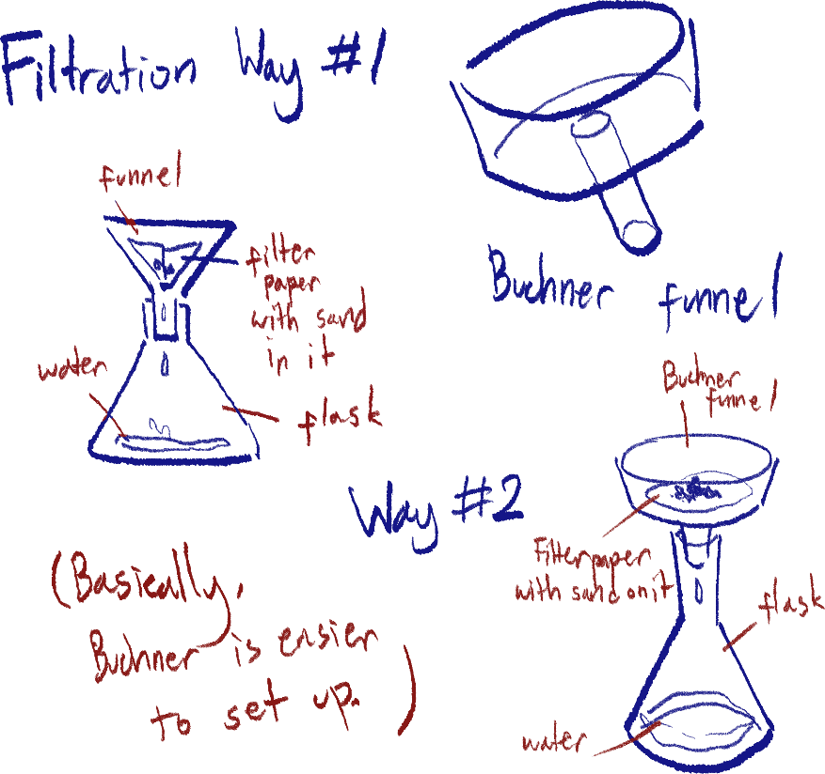

Sometimes, a vacuum pump is connected to the flask to speed up the process.

Remember, the solid collected by the filter paper is called the residue, and the liquid is called the filtrate.

Evaporation

Evaporation should be used when instructed to obtain a solid from a solid-liquid solution, but not if crystals are specified, as evaporation will result in the solid collected in powder form.

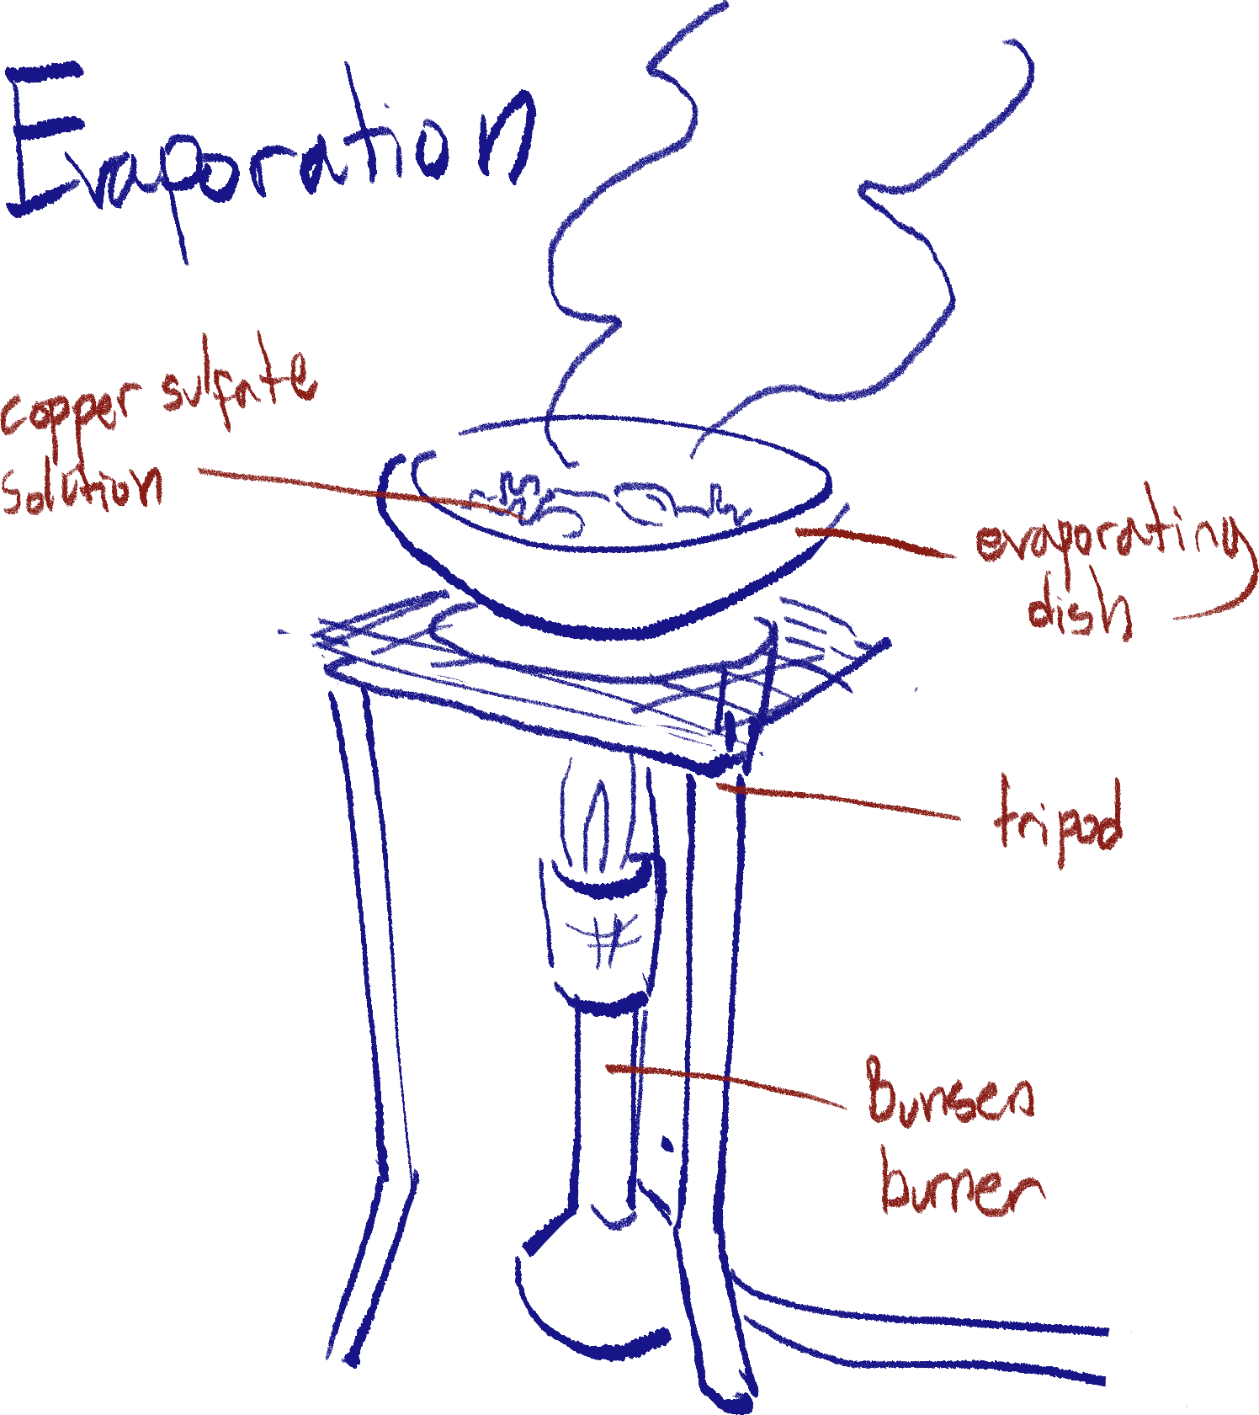 The solution is simply heated over a Bunsen burner until all of the solvent has evaporated, leaving the solid in powder form.

The powder should be left to dry for best collection results.

This method relies on the differences in boiling points inherent in the two substances’ states at room temperature.

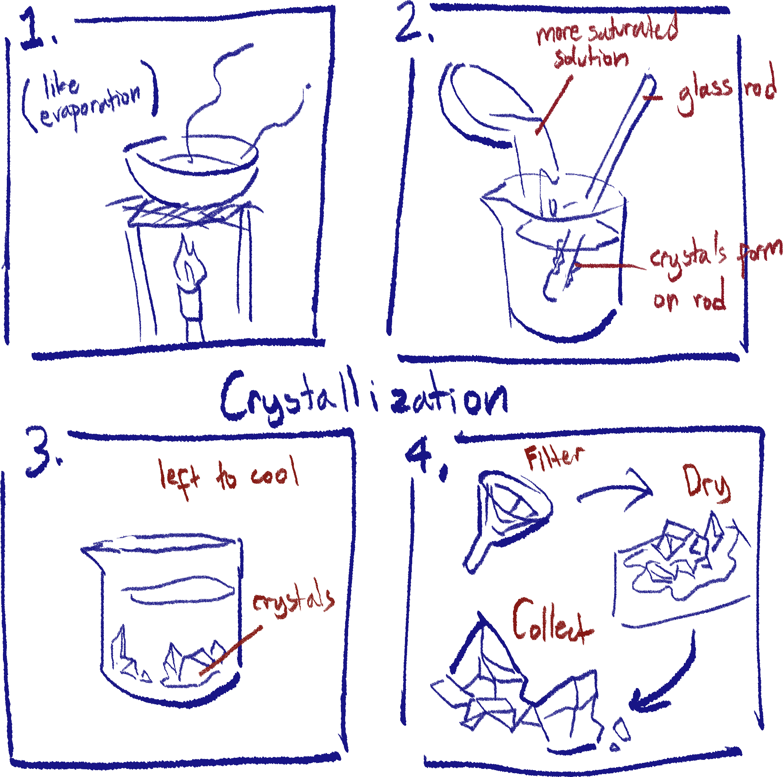Crystallization

Crystallization is a similar concept to evaporation, and is used for the same type of solutions. The difference is that the solid’s form will be in crystals.

(Diagram is just an example so you could also just go through the whole thing with a beaker, dish or beaker doesn’t matter much)

1. The solution is heated to evaporate the solvent off until appropriately saturated (the next section will touch upon this).
2. The saturation can be checked before cooling by using a glass rod to see whether crystals form on it or not.
3. The now saturated solution is left to cool and form crystals. A cold water bath can help speed this up.
4. The crystals are filtered out of the remaining liquid and left to dry. They can then be collected.

It should be noted that it is difficult to collect the entirety of the solute in this method, and that both *evaporation* and *crystallization* will not collect the solvent, only the solid solute.

Simple distillation

Simple distillation is used to separate a solid-liquid solution, whilst obtaining both components of the mixture.

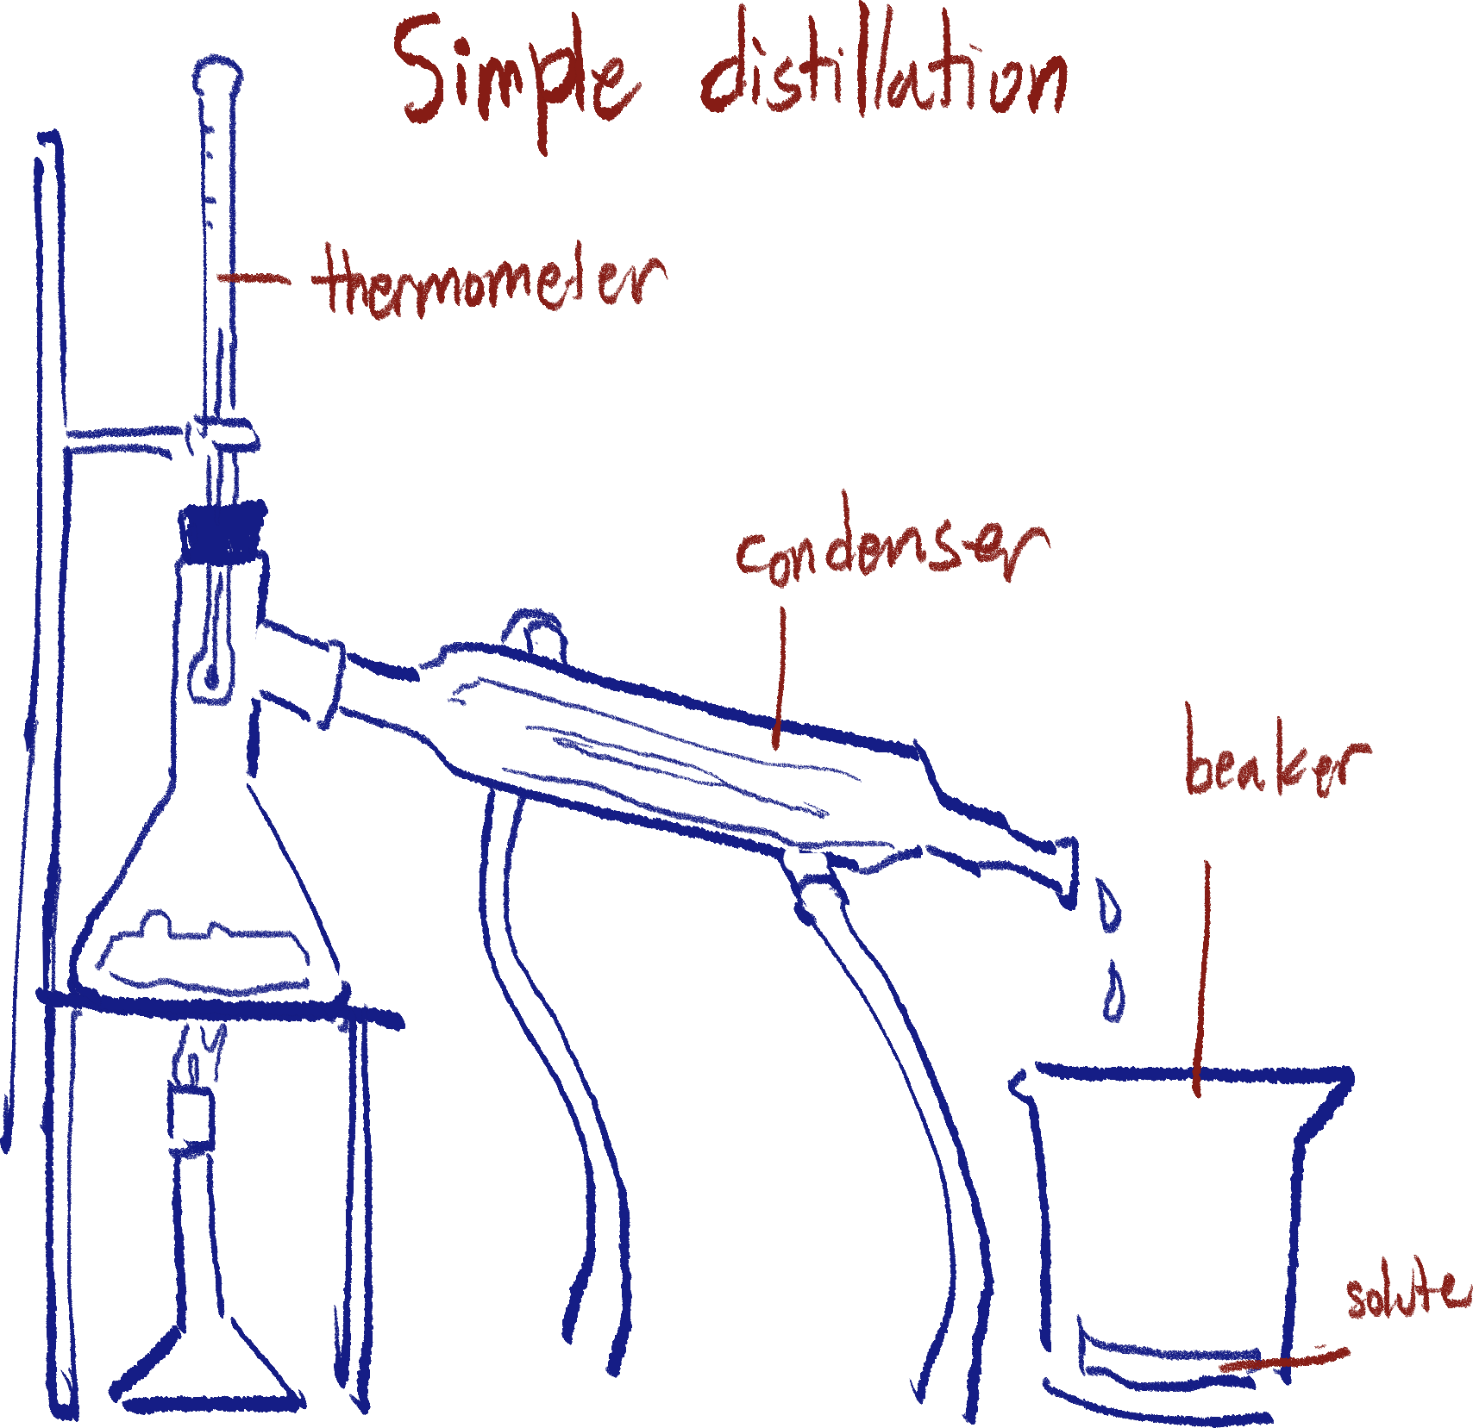

The solution is heated over a Bunsen burner, and only the solvent will boil and turn into a gas.

The gas solvent will move into the condenser, which has a constant stream of cold water cooling the gas, where it will condense back into a liquid, and flow into the beaker to be collected.

The liquid solvent will be in the beaker and the solid solute in the flask.

Fractional distillation

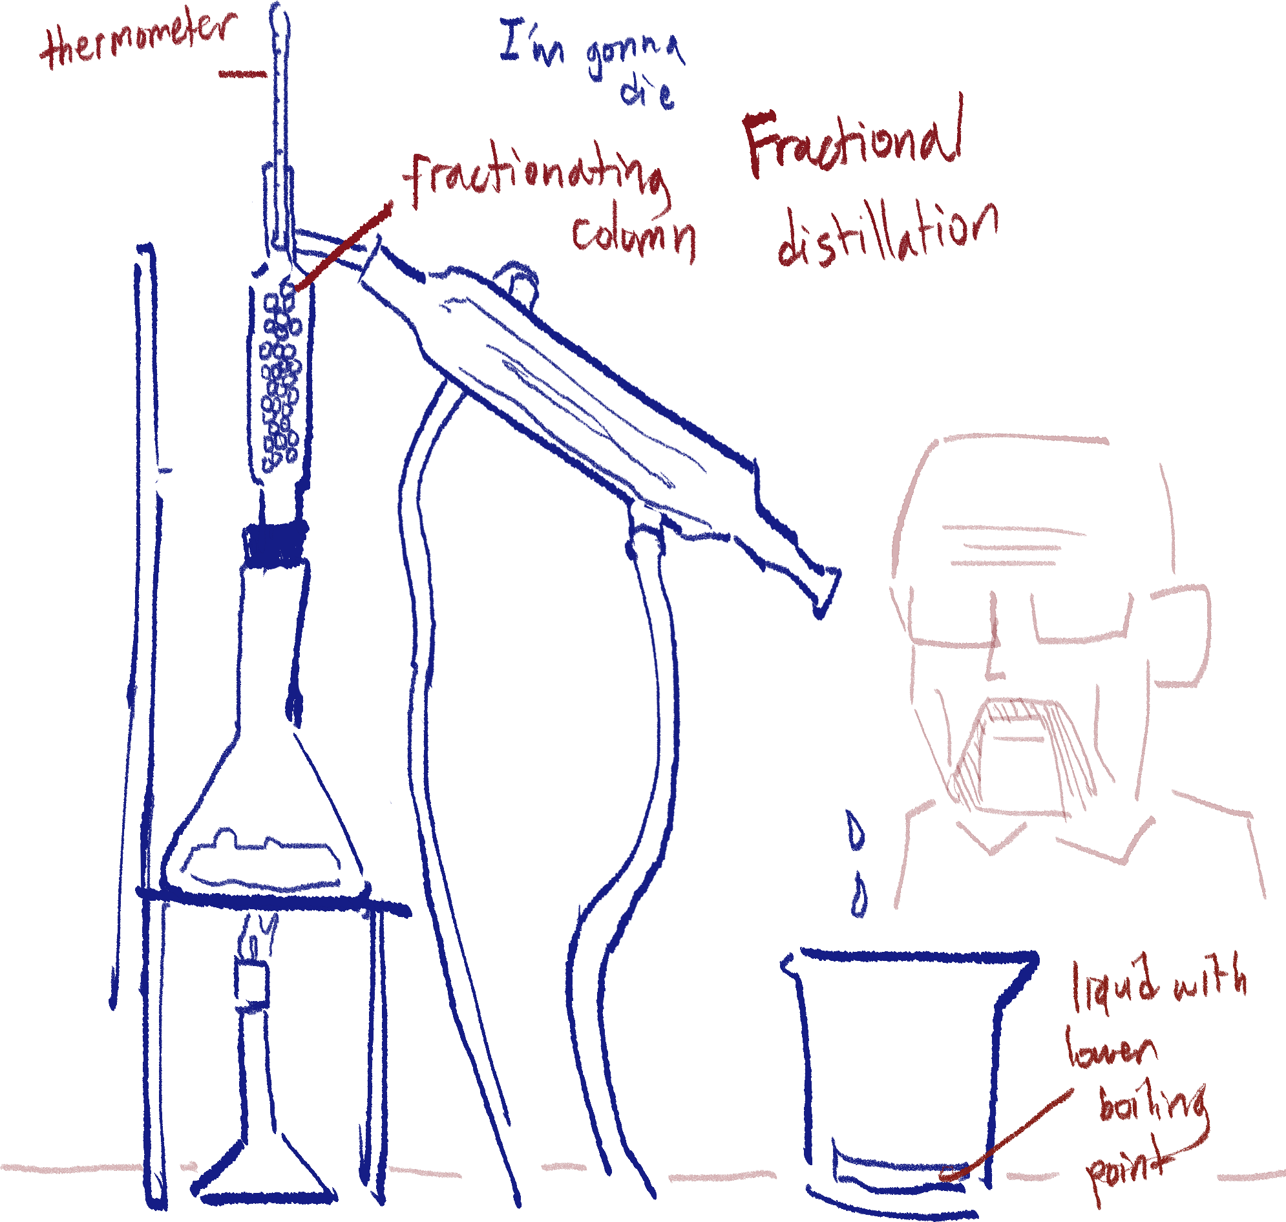Fractional distillation is essentially *simple distillation* except it is for separating a liquid-liquid solution. They are two different substances in a mixture so they will have different boiling points, but as they’re liquids, both will evaporate at once.

In this method, the liquid with the lower boiling point is moved out of the first flask, leaving the second liquid in the first.

To achieve this, a fractionating column is connected between the flask and condenser. It is filled with glass balls, so only the gas particles with enough energy – the fully boiled ones – will be able to pass, as otherwise they would lose their energy from the glass’ cooling and turn back into liquid.

Besides that, the process is the same as *simple distillation*.

Saturation of solutions

There are three levels of saturation that are important to understand for working with any kind of solution; unsaturated, saturated, and super-saturated.

Every substance has a solubility; the maximum concentration of itself possible when dissolved. Insoluble objects are considered to have a solubility of 0. Salt, for example, has a high solubility, and a high amount of salt can be dissolved in one cup of water.

1. Unsaturated

Amount of solute in solution < max. capacity at any given temperature

1. Saturated

Amount of solute in solution = max. capacity at any given temperature

1. Super-saturated

Amount of solute in solution > max. capacity at any given temperature

A super-saturated solution can only be produced by heating the solution while adding more solute, as higher temperatures increase solubility.

When a super-saturated solution cools, crystals of the solute will start forming.

Chromatography

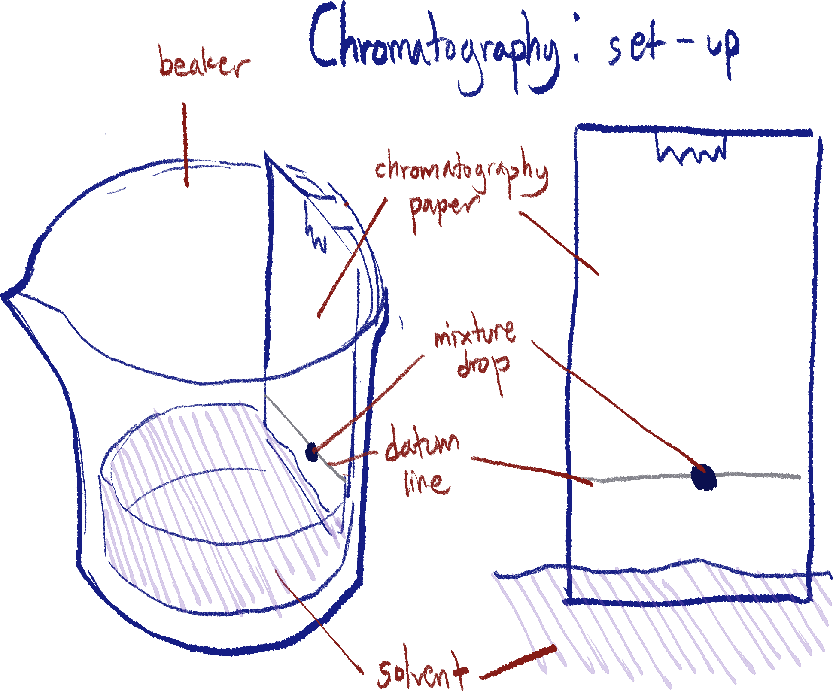Chromatography is a mixture separation technique, but it cannot be used to collect any of the components. Rather, it is used to identify components of a mixture according to their solubility[11]. A common mixture to test in chromatography is ink or dye – when tested, one will be able to see the different colored inks that make up the original color.

Pay attention to the diagram.

When setting up the experiment, a datum line is drawn on the paper, and the tested mixture will be dropped directly on said line.

The paper in this case is called the stationary phase, and the solvent is the mobile phase[12].

The datum line is drawn in pencil so it will not dissolve, as the line is a reference point of where the mixture started.

The solvent will be absorbed up the chromatography paper, carrying soluble components of the mixture with it. This is due to capillary action. The more soluble components will be further up the paper, while the less soluble ones will not have moved as far. [13]

Once the solvent front (the solvent’s furthest point) is near the top of the paper[14], it can be taken out to be analyzed. The pattern as a result is called a chromatogram.

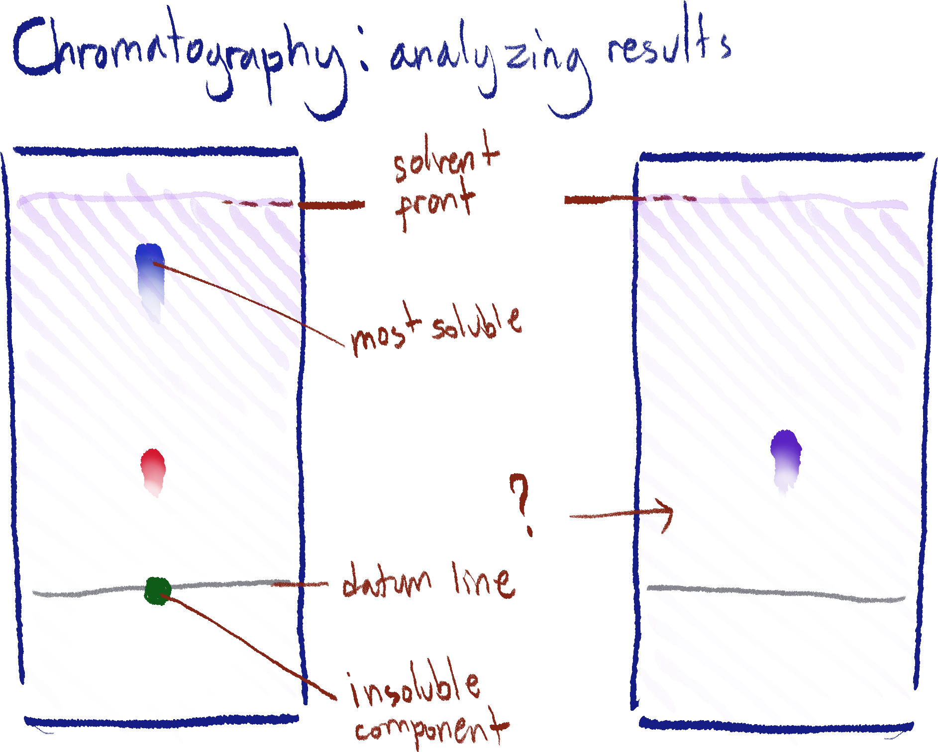

The first diagram example here shows that there are 3 visible components of the mixture.

The most soluble is the blue substance, because it is furthest up the paper. The green substance is insoluble, because it has not moved from the datum line.

The second example only has one visible component. This means that either it is a pure substance, or that there are other components that are colorless.[15] In the case there are colorless components, a locating agent[16] can be used to mark the components.

The Rf value of a component is important to identify what kind of substance it is, as the value depends on the solubility of the substance, no matter what mixture it is in, it will always have the same Rf value.

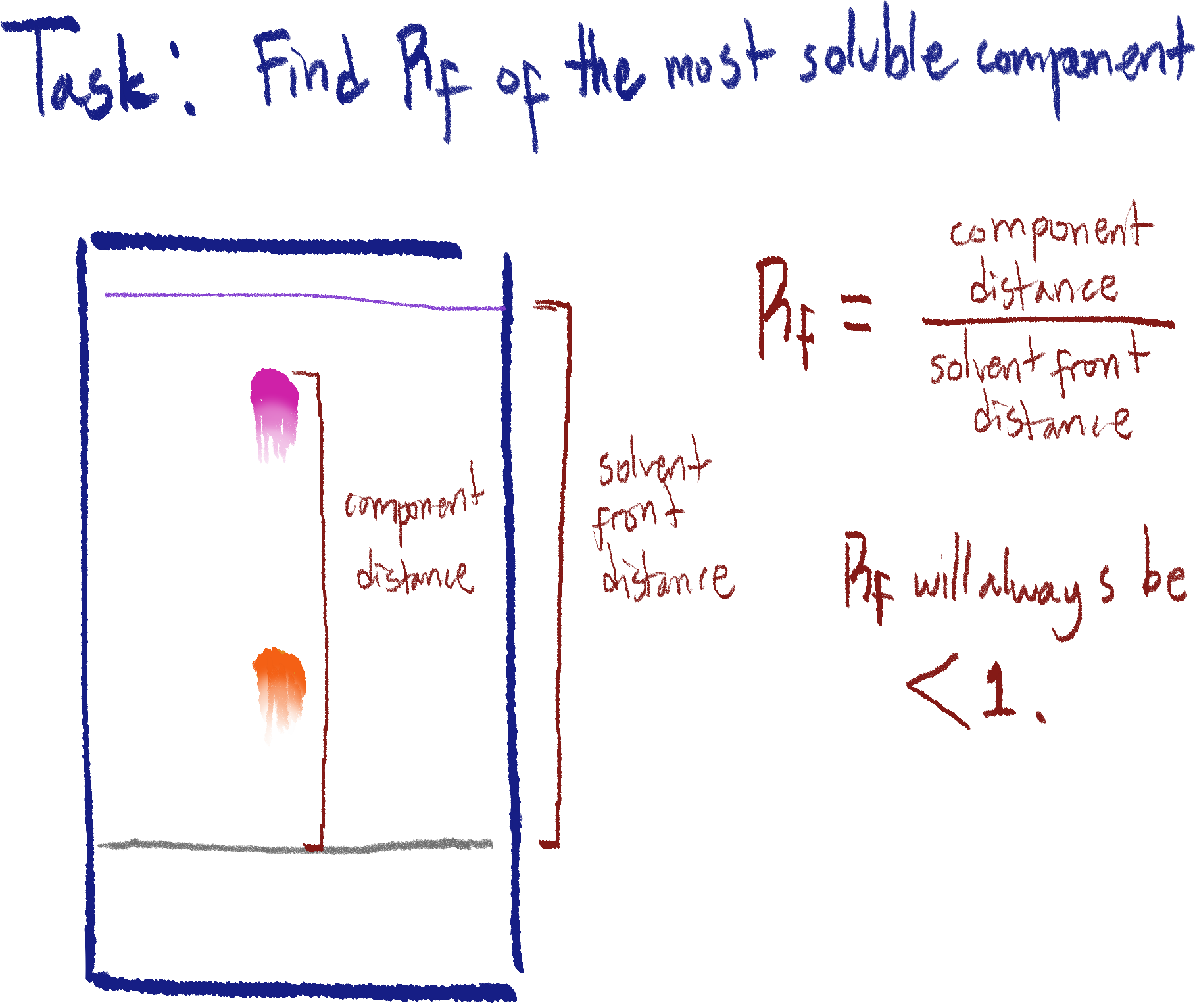

It is calculated by measuring both the component’s[17] and the solvent front’s distance from the datum line and dividing the component’s distance by the solvent front’s.[18]

Final keywords for chromatography

* Chromatography paper
* Solvent
* Mobile phase
* Stationary phase
* Rf value
* Component
* Datum line
* Solvent & solvent front
* Locating agent
* Chromatogram

I’m not reformatting to add this note to the beginning (you can also skip this)

Sedimentation and decantation are other methods besides *filtration* to separate heterogeneous solid-liquid mixtures. Essentially, *sedimentation* is a technique where one keeps the mixture still until the mixture settles itself in clean layers, and *decantation* is where one pours out the liquid carefully to keep the solid (precipitate) in the container.

But filtration is more efficient so just answer with that.

Precision and accuracy

Look at my physics notes for a longer explanation, but as an example, an accurate measurement is a mass measurement using a well-calibrated balance.

An example of a precise measurement is after a multitude of attempts, the measurement of a mass is relatively similar.

Chapter 3: Atomic Structure

The structure of an atom

An atom is known as the smallest unit of matter that can be gained through chemical means. It is also the smallest unit of matter that can retain its characteristics.

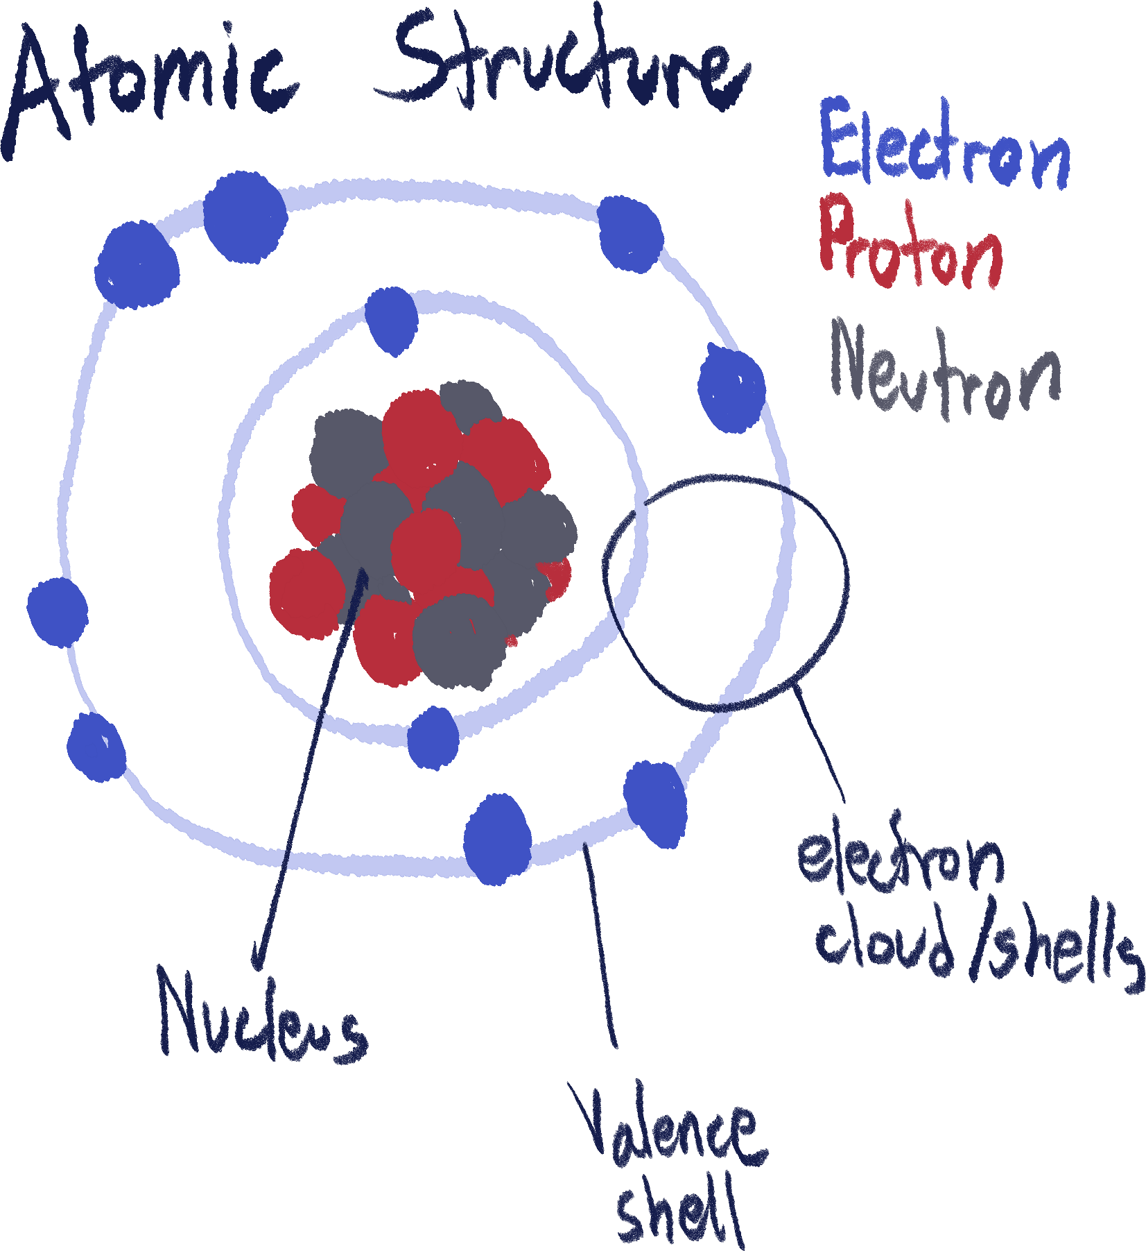Despite that, it is still made up of subatomic particles – neutrons, protons, and electrons.

Electrons are found in the electron cloud and exist at certain energy levels. Protons and neutrons exist in the nucleus, which is why they are categorized as nucleons.

The number of electrons and protons defines the atom's characteristics, which is what makes atoms of different elements unique from one another.

Atoms are very, very minuscule, so their mass is too small to measure in regular units such as grams or kilograms. When discussing mass on a subatomic level, we use AMU (atomic mass unit).

Keep in mind each subatomic particle’s mass and charge. There is always an equal amount of protons to electrons in an atom, so an *atom* will always have a neutral charge in the end, because the charges of the electrons and protons balance out.

This isn’t the case for ions, which will be discussed further later.

|  |  |  |
| --- | --- | --- |
| Subatomic Particle | Charge | Atomic mass |
| Neutron | None | 1 |
| Proton | 1+ | 1 |
| Electron | 1- | ≈0 |

Electron configuration

Electrons exist in electron shells according to their energy, which is why shells are also called energy levels. The further away an electron is from the nucleus, the higher its energy level.

However, electrons can only go to the next further shell once the prerequisite shell before it has been completely filled.

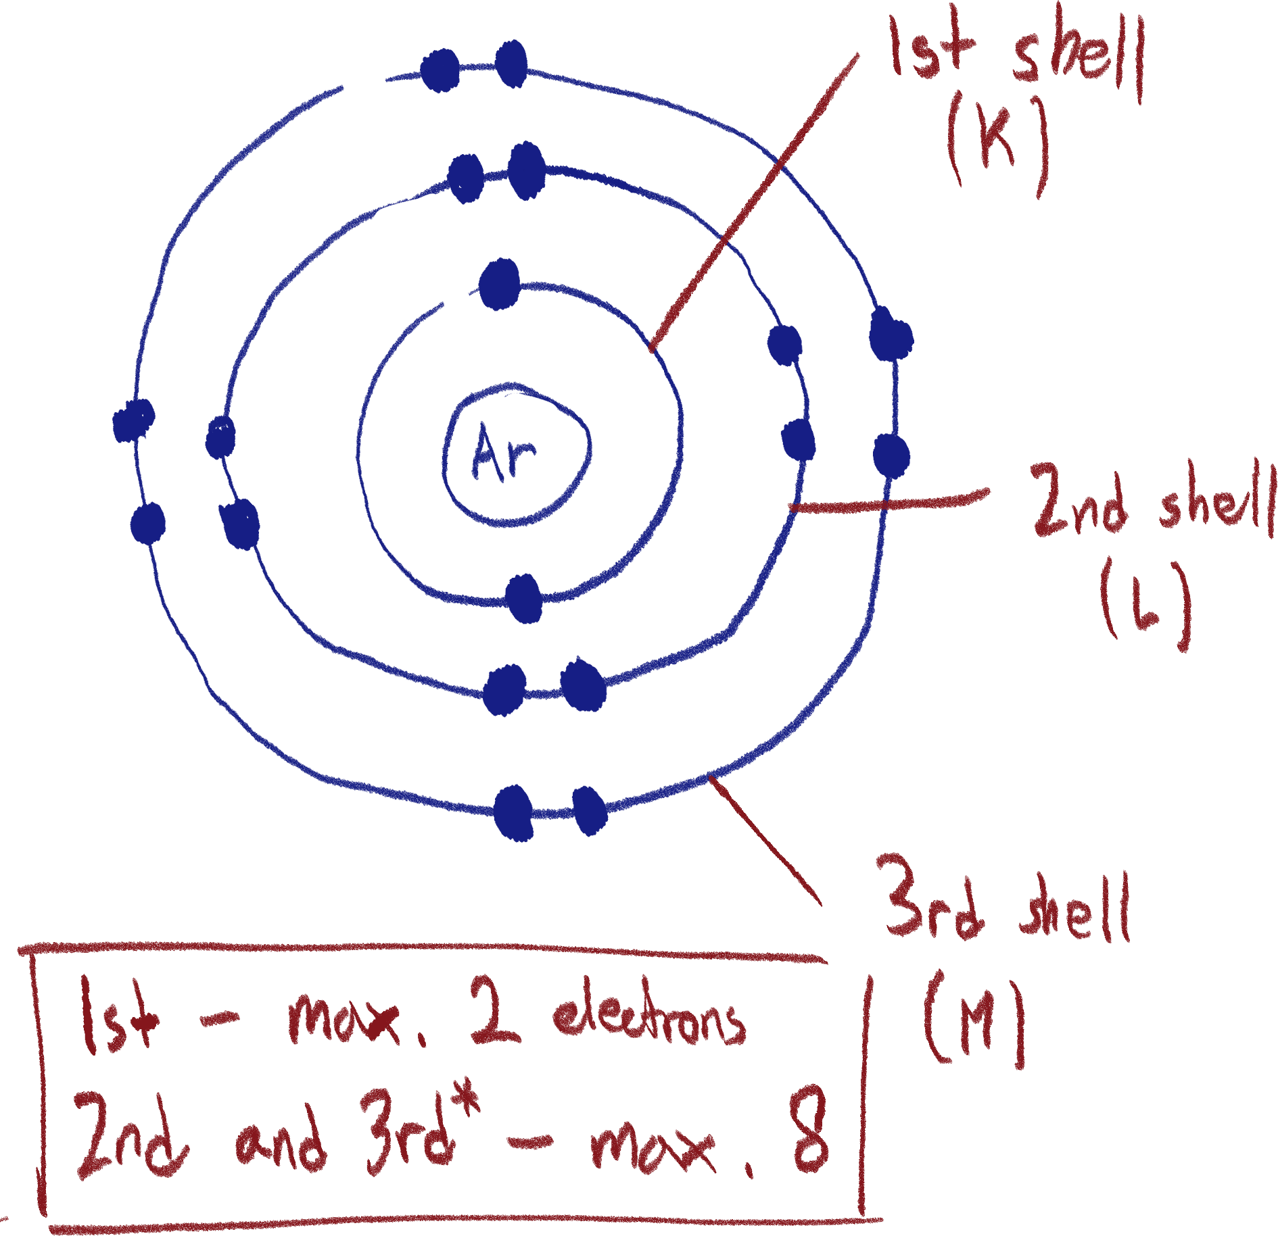

There are more, but we’ll be focusing on the first 3 shells. They are named alphabetically starting with K, but you can refer to them by number as well. The first shell can hold a maximum of 2 electrons, so any more electrons will be brought over to the second shell, where 8 is the maximum.

For now, every shell from 2 onwards’ maximum electron amount is 8, but this is only for the sake of convenience and is not accurate.

The outermost shell of an atom is called its valence shell. The electrons in the valence shell are called valence electrons.

Keep in mind that if an atom loses a shell (effectively becoming ions), the current outermost shell is *not* the valence shell, and can only be called its outermost shell. Thus, an atom’s valence shell is fixed.

Reading an element in the periodic table

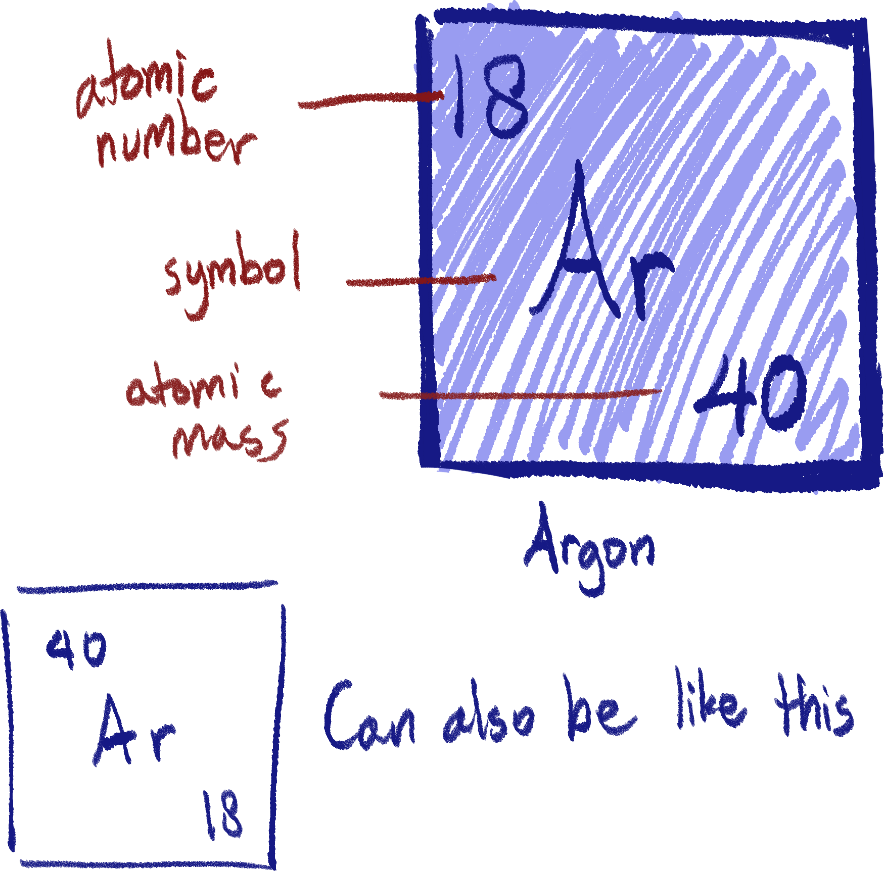

Usually, an element will be shown on the periodic table like this. The element’s symbol just represents the element’s name, in this case, argon.

The atomic number of an element represents how many protons it has, which also means that the atomic number shows how many electrons the element has. Every element will have a unique atomic number, as the number of protons and electrons defines their characteristics.

Atomic mass is the total mass of an atom of the element. Because only protons and neutrons have 1 AMU each, atomic mass can be deduced as the sum of protons and neutrons in an atom. With this, the number of neutrons can be found by subtracting the atomic number from the atomic mass.

The larger number out of the two shown is thus always the atomic mass (excluding hydrogen which doesn’t have any neutrons)

The periodic table

There are multiple ways the periodic table sorts elements at once:

1. Elements are placed in order of atomic number, in ascending order.
2. The column of an element shows how many electrons there are in its valence shell. Elements in the same column/which have the same valency are said to be in the same group. Sodium, in the 1st column, has 1 valence electron.

There are 8 groups (excluding transition metals). For example, column 1 contains elements of group 1, also known as alkali metals. Group 7 contains the halogens and group 8 contains the noble gases.

Elements in the same group tend to have similar characteristics. Noble gases are all unreactive gases, while alkali metals are all very reactive metals.

1. The row that an element is in shows how many electron shells it has. For example, sodium is in the 3rd row and has 3 electron shells.
2. There are 3 main types of elements; metals, metalloids, and non-metals. Metals take up the left side of the table, while non-metals take up the right side. Metalloids exist on the border between the other two.

Isotopes

On most periodic tables, the atomic mass of an element is often not a whole number, and has decimals. Logically, an atom cannot have an atomic mass with decimals as all nucleons have an atomic mass of 1.

The reason for this is because of the existence of isotopes. Isotopes are atoms from a specific element but can vary in neutrons. An element is defined by its atomic number, so if the number of neutrons it has changes, it is still the same element.

Carbon-12, carbon-13, and carbon-14 are all isotopes of carbon. The number mentioned besides the name is the isotope’s atomic mass.

Isotopes generally have the same *chemical* properties though, because they have the same number of electrons and thus the same number of valence electrons, which are the electrons that engage in chemical reactions.

However, *physical* properties between isotopes can vary, because the atomic mass does affect things like the boiling and melting point.

Average atomic mass

Continuing to answer the first statement of the last section on isotopes, what we see on the periodic table is the average atomic mass of the element, which is its average mass accounting all its isotopes.

However, you cannot simply add the masses of the isotopes and divide by number, because some isotopes are found more often than others. Carbon-12 is much more common than carbon-13.

So, we also use the percentage abundance of each isotope, which is how many of the isotope one would find in 100 samples of the element.

If you had 100 samples of carbon, around 99 of them would be carbon-12, and 1 would be carbon-13. So, we can say carbon-12 and carbon-13 respectively have a percentage abundance of 99% and 1%.

Next, we find the mean average of the element’s atomic mass while using the abundance.

The formula is:

$$\frac{(i1 * a1) + (i2 * a2)}{100}$$

i1 = mass of 1st isotope

a1 = abundance of 1st isotope

i2 and a2 being the same for the 2nd isotope.

More isotopes can be added the same way.

We divide by 100 because the abundance is a percentage number.

We will use this with carbon’s isotopes; carbon-12 and carbon-13.

$$\frac{(12 * 99) + (13 * 1)}{100}$$

= 12.01 AMU

Carbon-12

Just a brief note: the atomic mass of all elements in the periodic table is relative to that of carbon 12.

Nucleon number vs atomic mass

Nucleon number is *not* the same as atomic mass. Atomic mass is what’s shown on the periodic table, and is the calculated average relative mass of all isotopes of an element. This is why you will see periodic tables with decimals in their masses, even though the relative mass of a neutron and a proton is 1 AMU. Nucleon number, on the other hand, refers to the number of protons + neutrons in the nucleus of an atom. However, we still use atomic mass in our calculations of finding the number of neutrons and such because it is still close enough and is found on the periodic table.

Uses of isotopes

Scary sounding, but useful.

1. Radiotracing, where radioactive isotopes are used to track and find cracks or damage in pipes for troubleshooting.
2. Biological tracers, which can flow through a person’s body and be tracked for any abnormal behavior in the body’s processes.
3. Used in smoke detectors as certain radioactive isotopes emit alpha particles which the smoke can absorb, so the device can detect it.
4. Used to sterilize medical equipment through gamma sterilization from radioactive isotopes to kill microorganisms.
5. Used to treat cancer in radiotherapy.
6. Used to generate electricity/energy as heat can be generated from the radioactive decay of isotopes.
7. Carbon dating; carbon-12 and carbon-14 is found naturally in every living organism everywhere. When an organism dies, it stops taking in carbon from the atmosphere. Carbon-14 decays over time, so the amount of carbon-14 in a dead organism can be used to determine its time of death.

Chemical bonding

All elements are inclined to have a full outer shell of electrons, which is usually 8 electrons on the outer shell[19], to reach stability. In order to have a full shell, atoms may need to have more electrons or lose some electrons, depending on the element.

An example of this is the alkali metal sodium, group 1 of the periodic table. It is too difficult to gain 7 more electrons to fill its current valence shell, so it will lose 1 electron, removing its valence shell and leaving its second electron level as its full outer shell.

When this happens, the overall charge of the atom is now positive, because there are more protons than electrons. So, it is now considered an ion.

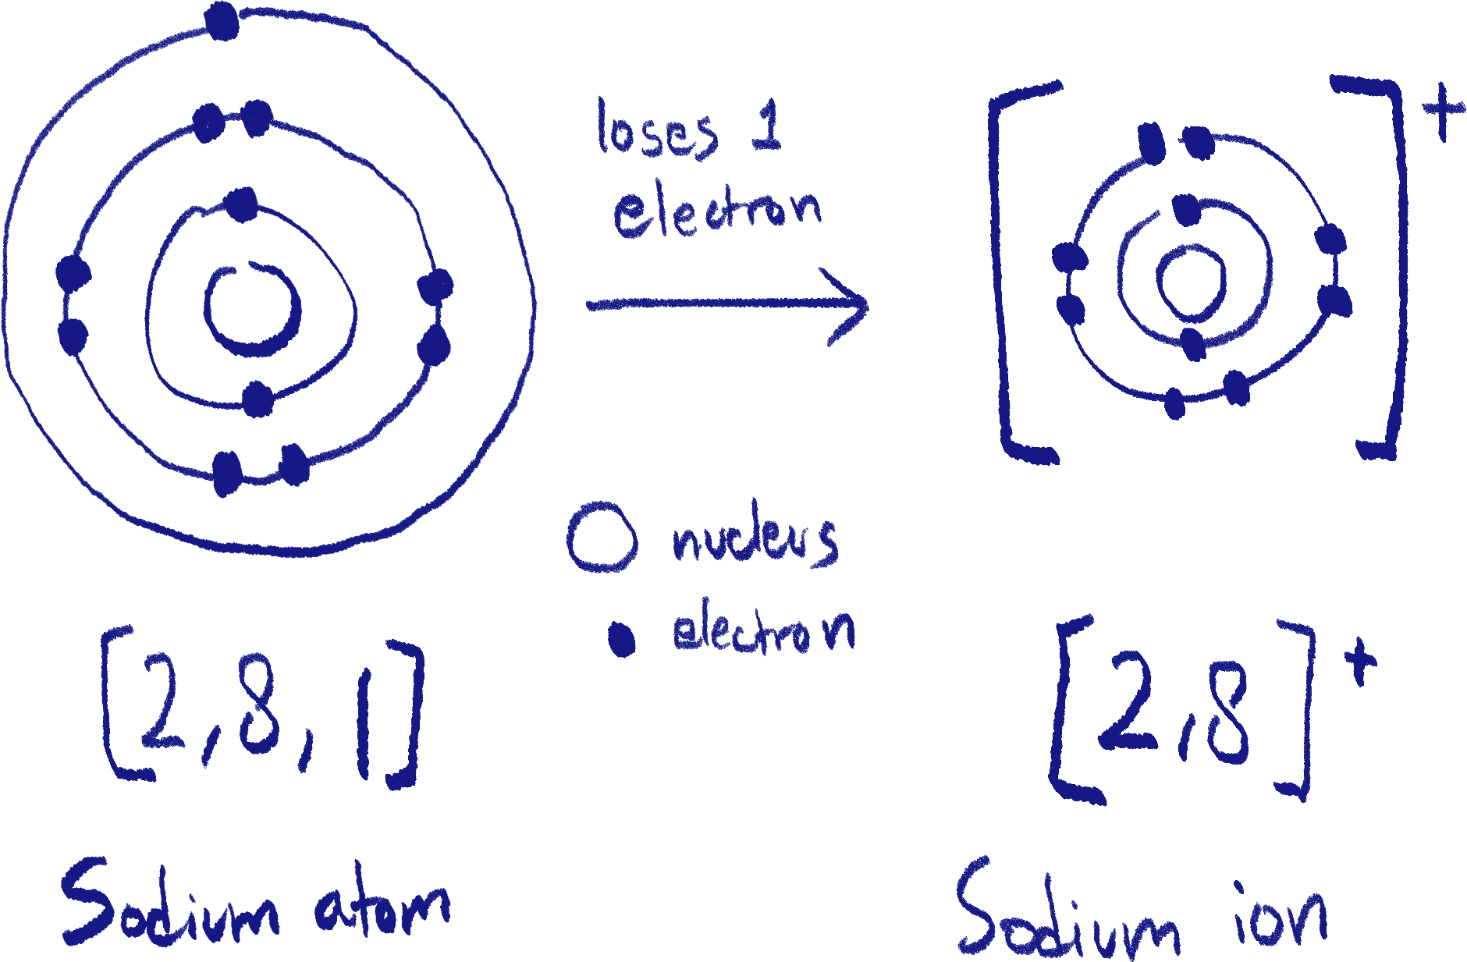

There are also instances where it is easier for an atom to gain electrons to reach a full shell. The example shown below is of chlorine, group 7, becoming a negative ion.

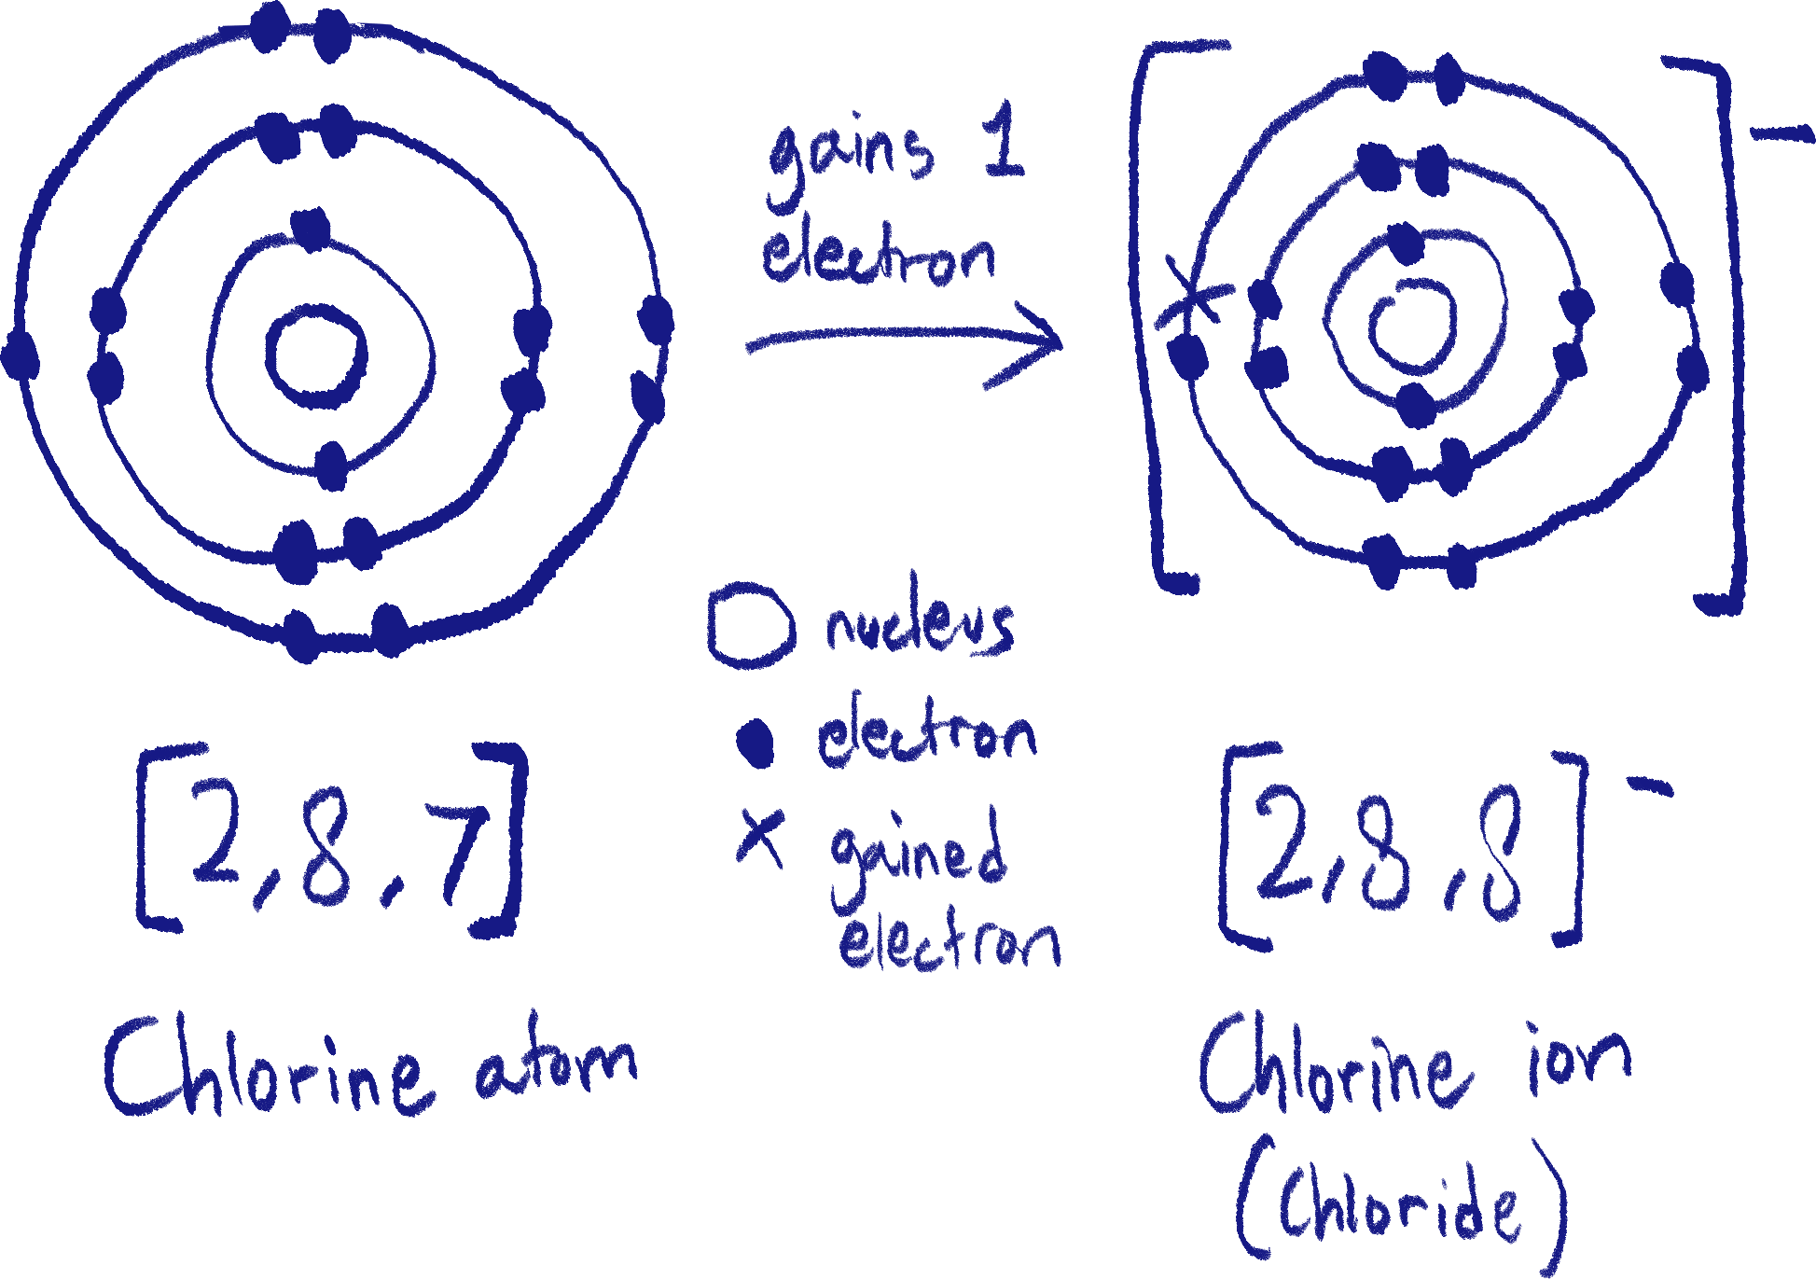

Pay attention to the difference in electron symbol when electrons are gained. This drawing rule will apply for ionic and covalent bonding.

You can notice that according to their valence electrons, metals always lose electrons and non-metals always gain electrons to gain a full outer shell (we are excluding group 4 here).

Ionic bonding

In order for an element to gain or lose electrons, other elements must be present to receive or give the electrons.

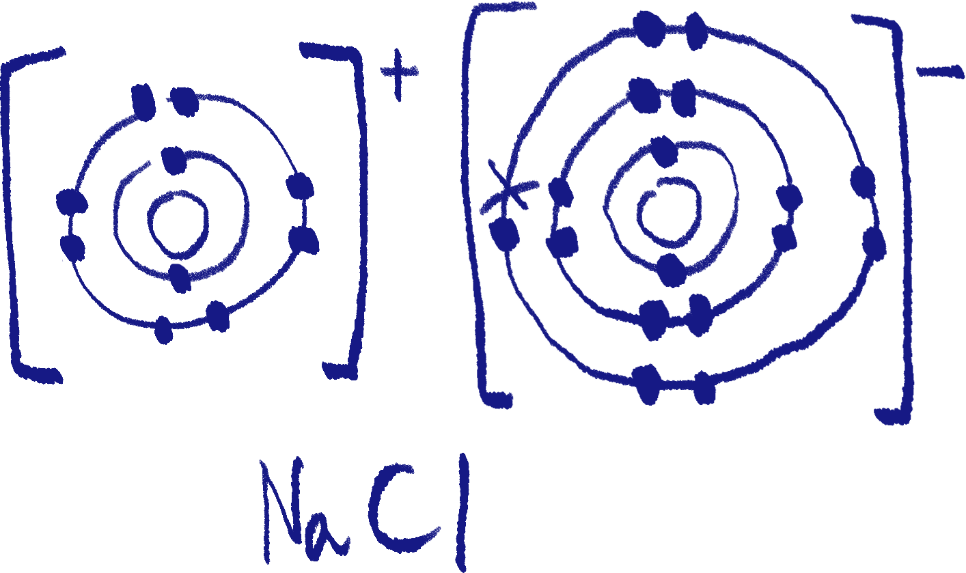 Using the example of sodium chloride, we can see that sodium needs to lose one electron and that chloride needs to gain one. Once that happens, both the elements will become ions.

Because they have opposite charges – positive and negative, the ions are attracted to each other by electrostatic forces, forming an ionic compound. This entire process is ionic bonding.

As metals always lose electrons (becoming positive) and non-metals always gain electrons (becoming negative), ionic bonding always happens between metals and non-metals.

Another point to make here is the relation of an element’s valency[20] to its reactivity. Alkali metals are known as the most reactive of the metals, and that is because it is very easy to lose a single electron. This also applies to halogens only need to gain 1 electron. Noble gases are inert as their valence shells are already full, so they cannot react with other elements.

Thus, the lower an element’s valency, the more reactive it is.

Ionic bonding can also happen with multiple ions, magnesium chloride being an example:

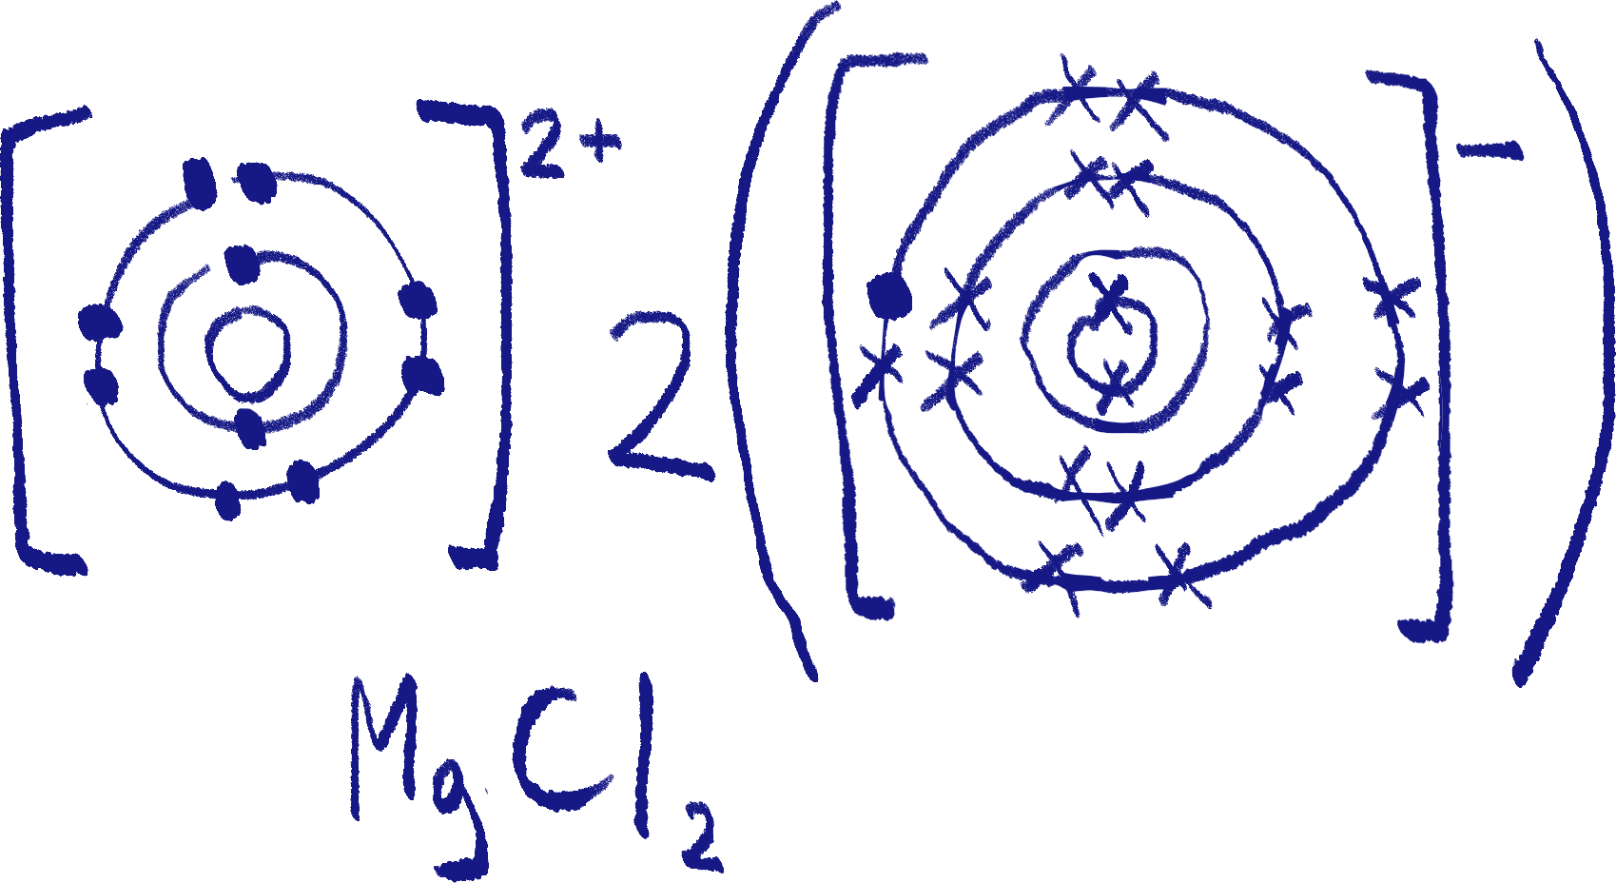

Magnesium needs to lose 2 electrons to attain stability, but a chlorine ion only needs to gain one. So, two chlorine ions receive an electron each from a single magnesium ion.

If you want to be fancy, cation is the term for a positive ion and anion is the term for a negative ion.

Covalent bonding

However, bonding doesn’t only happen between metals and non-metals. Non-metals can bond with themselves through covalent bonding.

Because non-metals always have to gain electrons, they can share electrons with other non-metal atoms to achieve that.

A well-known example of covalent bonding is water, A.K.A. H2O.

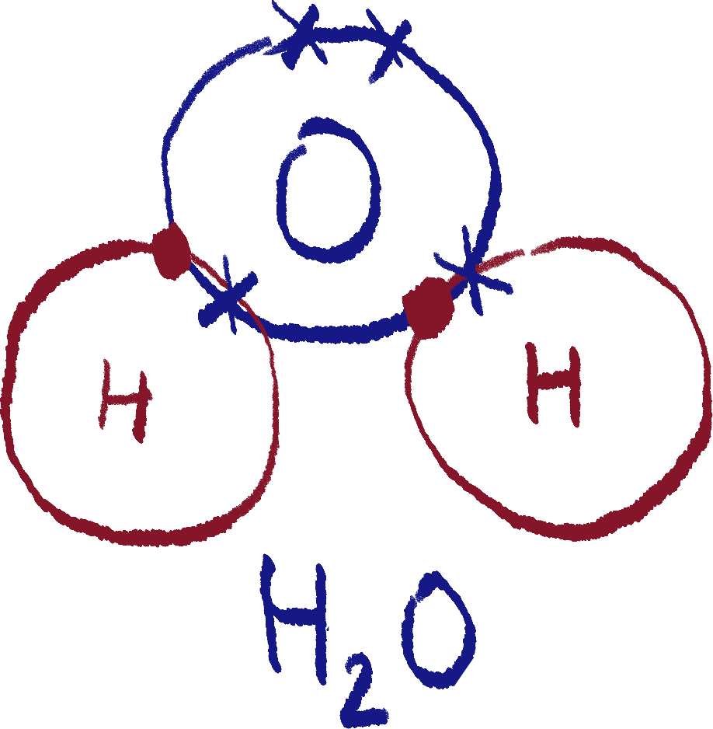 You can see that oxygen has shared 2 of its valence electrons with the two hydrogen[21] atoms in order for all of them to have a full outer shell. And so, the atoms are now strongly bonded.

Elements involved in covalent bonding are still called atoms because the overall charge is still neutral.

Just so you know, this type of diagram only shows the outermost shells of the atoms, called a dot-and-cross diagram.

Something like water is called a simple covalent molecule, but not all covalent structures are like this.

Before we move on – drawing diagrams

There are different types of diagrams you may be asked to draw. I’ll try to explain all of them here.

1. Electron configuration

Electron configuration can be interpreted differently depending on whether you are asked to draw it or write it.

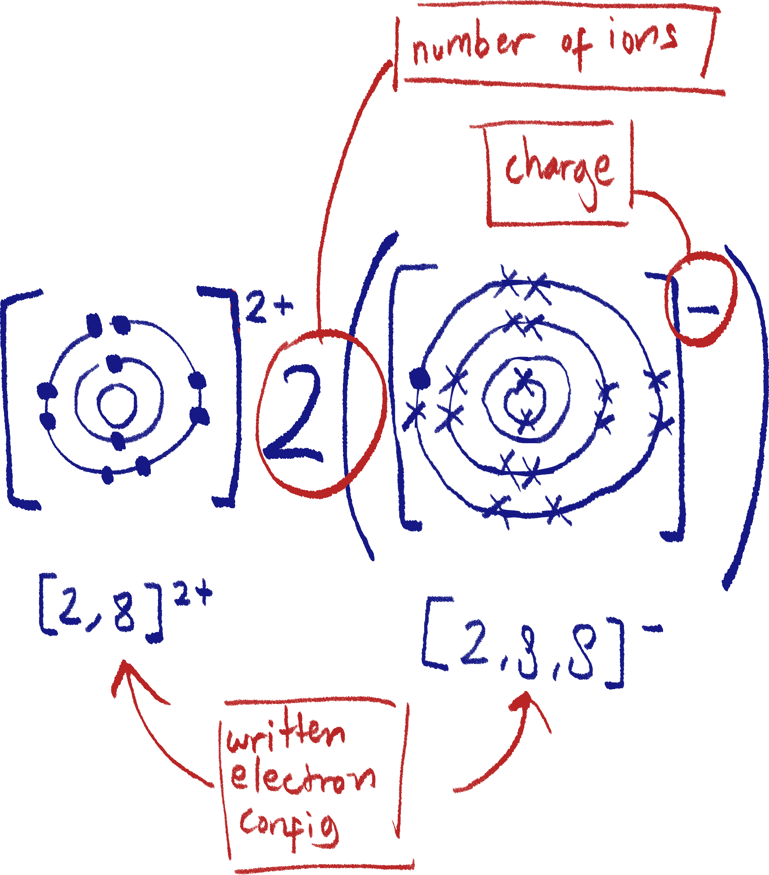

If asked to write, simply write the number of electrons in each shell, starting from the first shell and separating the shells with commas.

Remember that when drawing the configuration for an ionic compound, the electron symbols for the different elements must be different (I got this part wrong while making this document).

You can see that magnesium’s electrons are drawn as circles, and chlorine’s as crosses.

1. Dot-and-cross

It can be for ionic and covalent bonds. If the compound is ionic, then it should work just the same as the electron configuration diagram, except that only the valence shells are drawn.

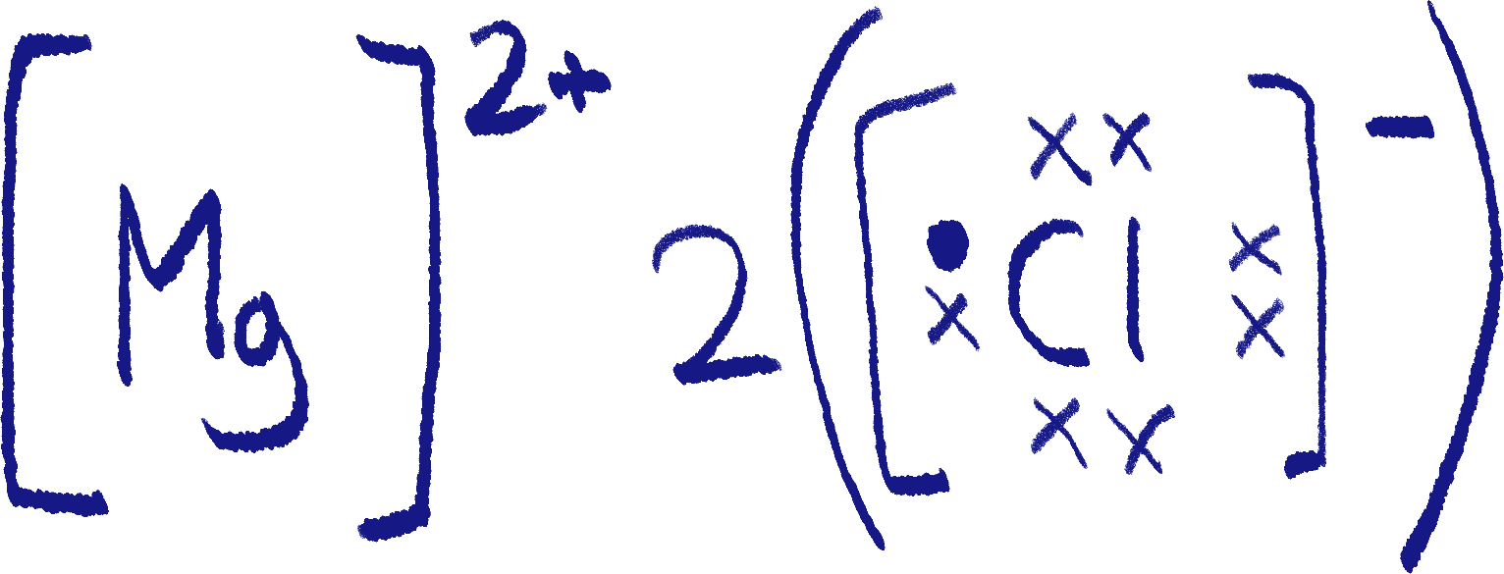 Only the valence shells. Not necessarily the outermost shell. If a magnesium atom lost electrons and lost its original valence shell in the process, nothing is drawn around it.

 For a covalent molecule, the atoms’ shells should be drawn overlapping each other.

1. Lewis structure/electron dot

This one is exclusively for covalent molecules. Unbonded valence electrons are drawn as dots, while 1 line represents a pair of shared electrons. There can be multiple lines to represent a double bond, for example.

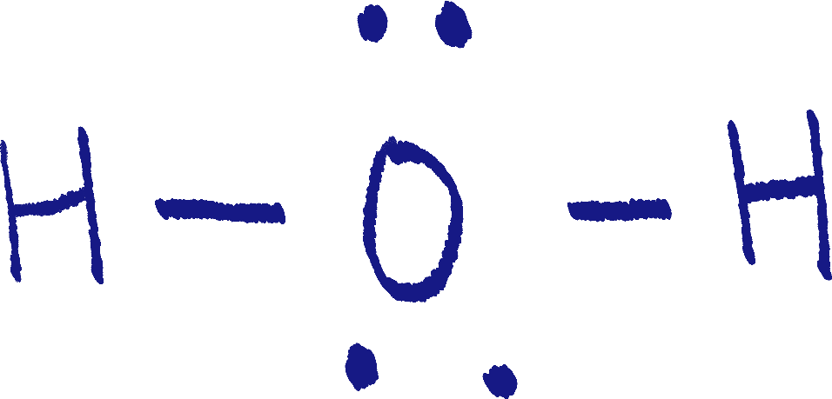

Metallic bonding

Metallic bonding, as the name implies, happens between metals. To understand metallic bonding, we need to discuss electron delocalization.

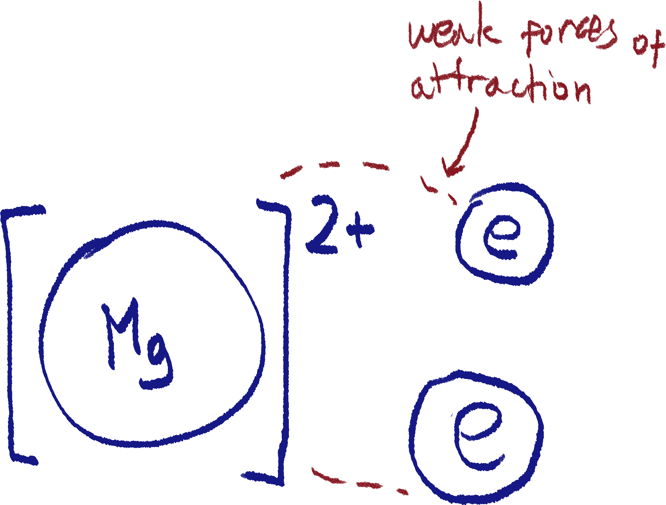 All metals’[22] valence electrons get delocalized, meaning they aren’t really in the atom, but are more roaming near it. Of course, this results in the atom becoming a cation as well.

This means that these electrons can freely move, going to other ions or carrying an electric charge, which is why metals are conductive.

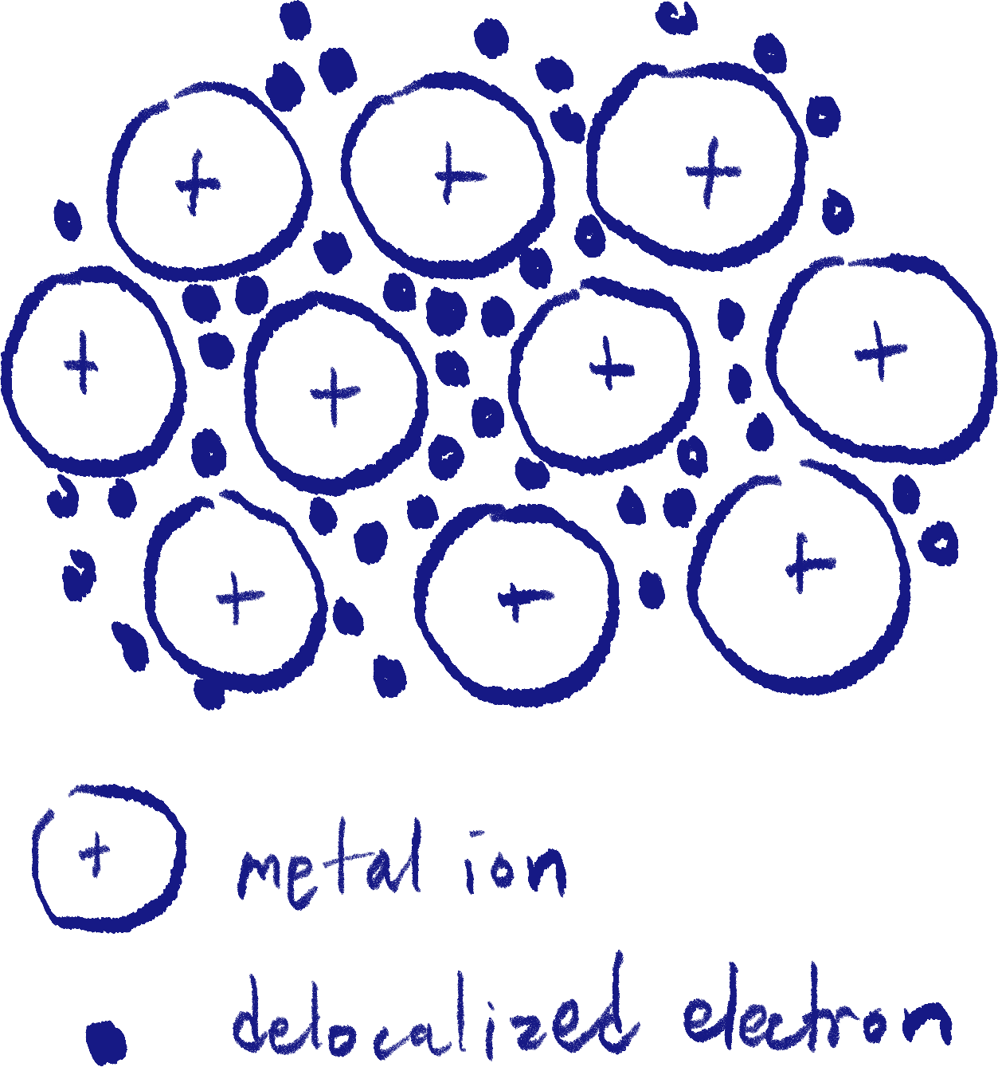 Metallic bonding works by having these delocalized electrons surround the metal cations, which one can call a ‘sea of electrons’

This sea of electrons keeps the metal ions together by electrostatic forces, and can move through the structure freely.

The metal ions are arranged in a lattice.

Structure and physical properties

First up; ionic lattices. Ionic compounds[23] always form ionic lattices, which have the ions alternate between each other in layers. The diagram illustrates this.

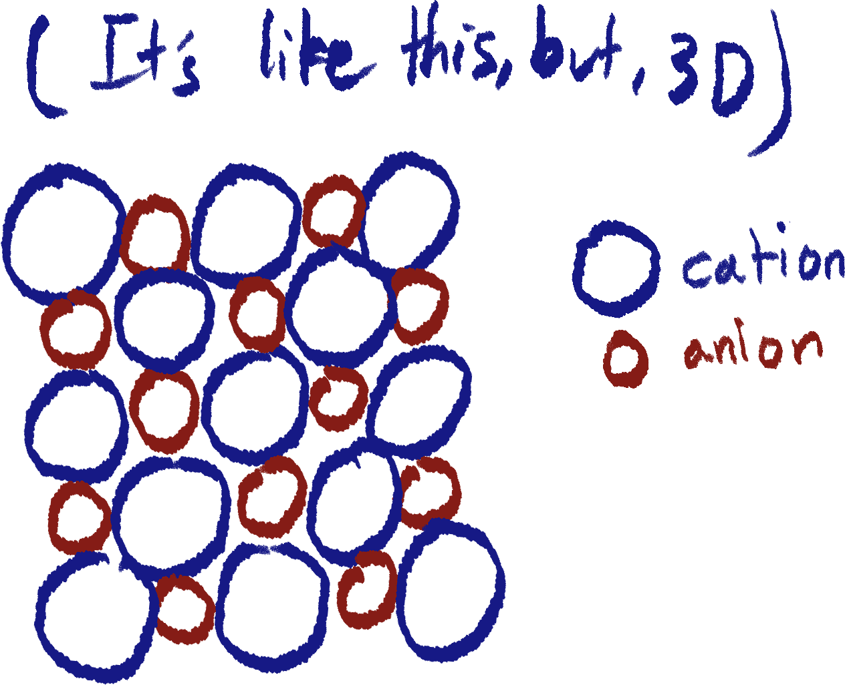

Because of this lattice structure, ionic solids usually form crystals.

Ionic compounds are very hard, and usually have a very high melting and boiling points, due to the electrostatic forces between the ions being so strong. However, they are brittle and can shatter, as when the layers of ions are shifted, they can repel each other.

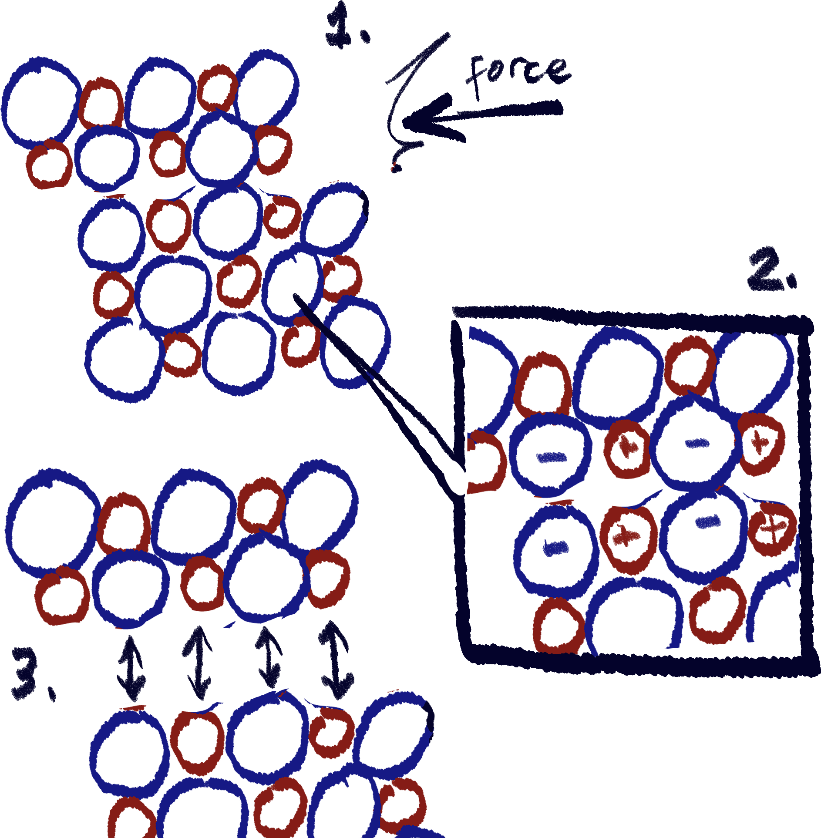

Ionic lattices are conductive, but only when dissolved[24] or molten, as the ions are charged. When the ions are free to move, they are able to carry an electrical charge.

Next are covalent structures. There are two types; simple covalent molecules and macromolecules/giant covalent structures. Both of them are not conductive[25] due to lack of charged particles, but besides that they are quite different.

Simple covalent molecules have very low melting and boiling points, being liquids or gases at room temperature, because the intermolecular forces of attraction between them are very weak.

However, the intramolecular[26] forces between the atoms in the molecule are very strong covalent bonds.

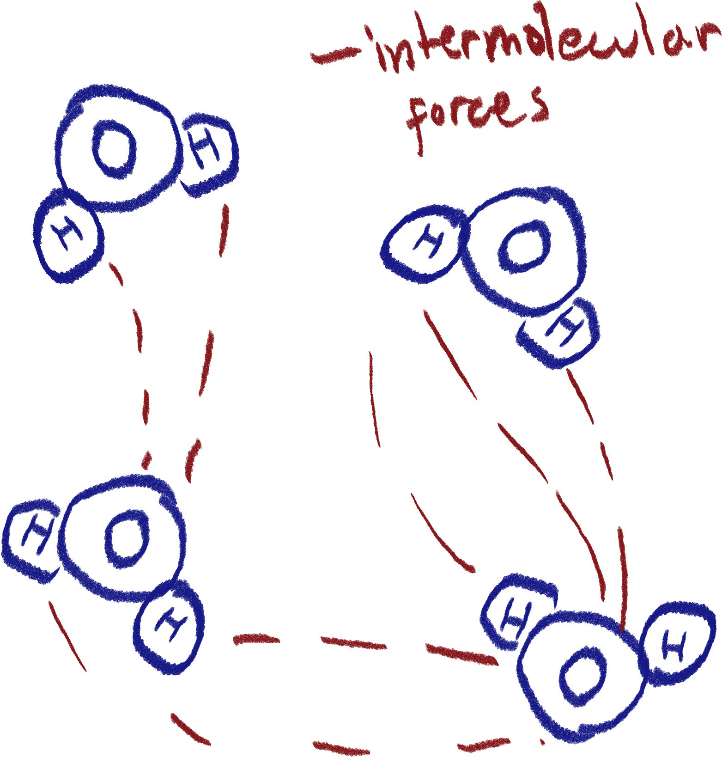

Note: I do not know how Van der Waals forces work yet.

Macromolecules on the other hand, are very hard and have very high melting and boiling points, as the entire structure is bonded together by strong covalent bonds, usually in a lattice structure. An example of this is diamond, where every carbon atom is covalently bonded to 4 other carbon atoms.

Usually, these structures are insoluble due to how strong the bonds are.

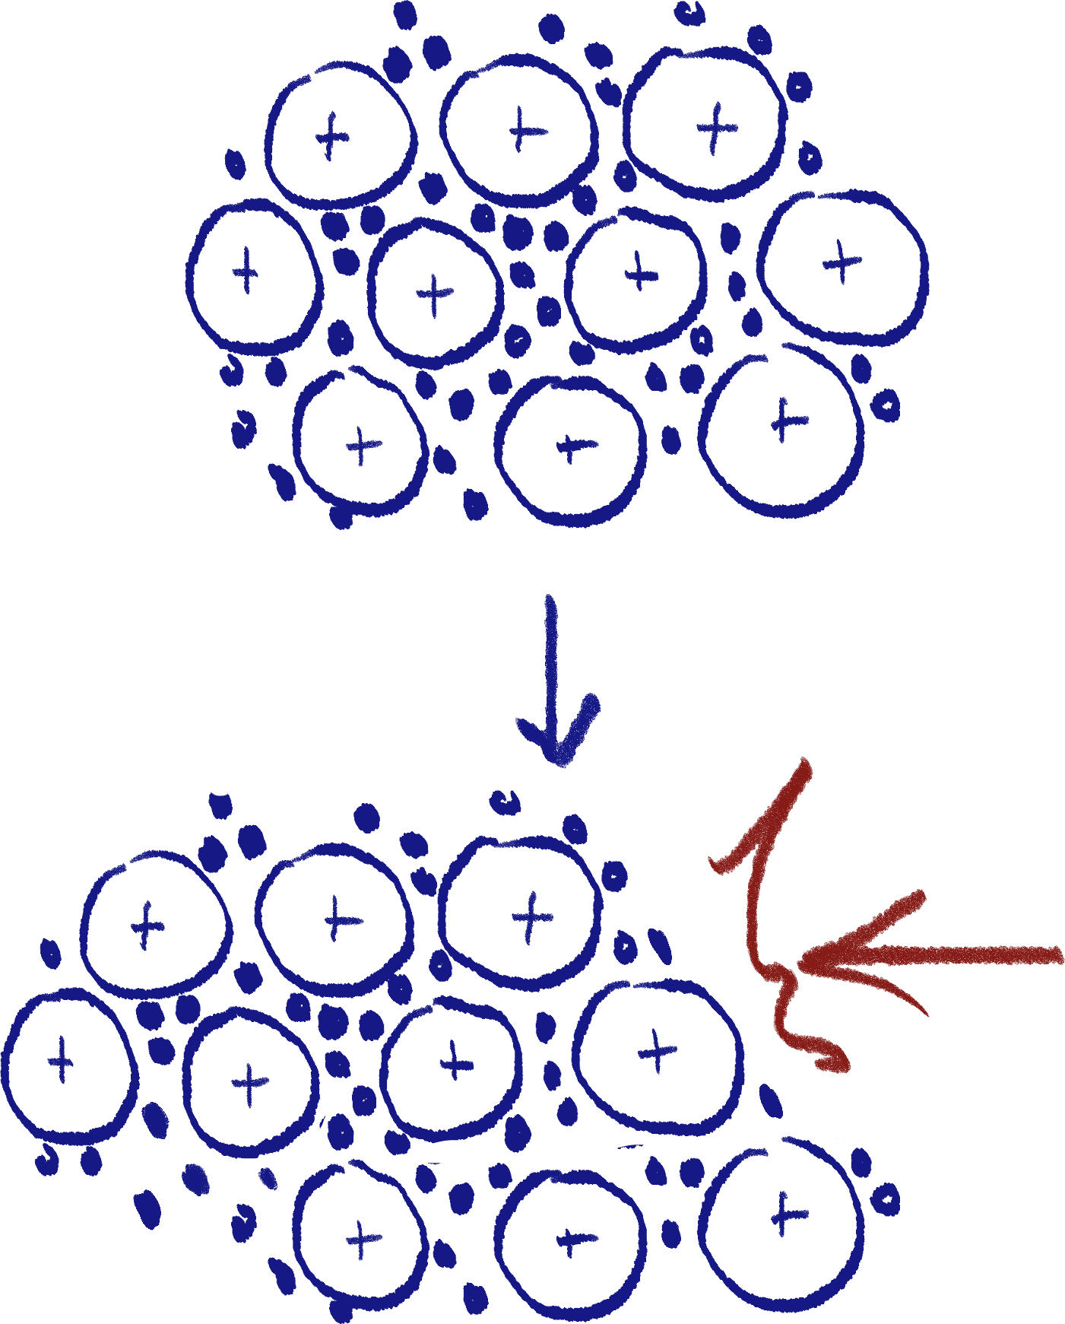 Finally, metallic lattices. These structures are often very ductile and malleable – meaning that they can be easily shaped, bent and stretched. This is because the sea of electrons can move to follow the shape of the ions while still keeping the lattice together.

However, the hardness of a metallic structure depends on the components of it. Usually, pure metal structures are very soft, but when mixed into alloys[27], the substance becomes harder. This is because the varying sizes of the ions makes it harder to move them around.

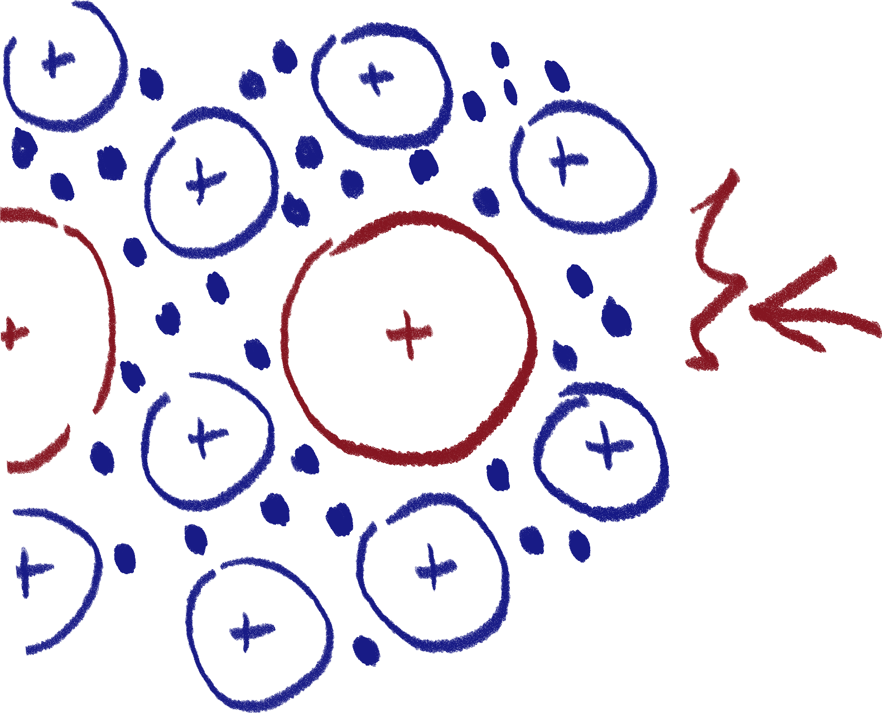

Metallic lattices are great conductors of electricity in any form, even as solids, because the electrons are free to move and carry an electrical charge through the substance.

Allotropes of carbon

Allotropes are different forms of the same element. Carbon has many due to its versatile valency.

1. *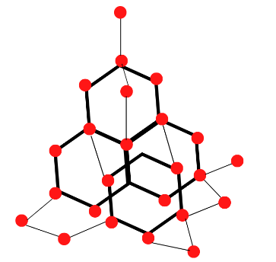Diamond*

Sorry I'm not drawing this myself

Diamond is known as the hardest natural substance, and this is because every carbon atom in its structure is bonded to 4 other carbon atoms, forming a strong, covalently bonded lattice.

As a macromolecule, it has a very high melting and boiling point. Because of its lattice structure, it forms crystals and can shatter.

1. *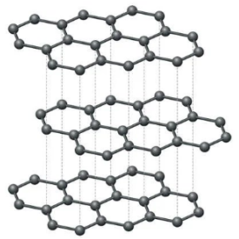Graphite*

Graphite’s structure consists of atom-thin layers of hexagonal carbon, each atom covalently bonded to three others. Due to this kind of structure, each carbon atom will have one free, delocalized electron. This is why graphite is one of the only electrically conductive covalent structures.

Since it is also considered a macromolecule, graphite has a high melting and boiling point. However, it is soft and slippery because its layers are only held together by weak intermolecular forces, and thus can slide off easily.

Due to these properties, graphite is used as a lubricant, marking tool, and can also be used developed into a very effective electrical conductor, graphene.

1. *Buckminsterfullerene*

Otherwise known as ‘bucky balls’, Buckminsterfullerene is an artificial carbon allotrope made up of 60 carbon atoms, each bonded to 3 other carbon atoms. The structure forms a sphere which is hollow inside. You can think of it as a graphite layer balled up.

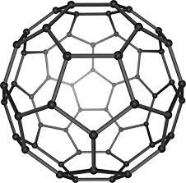

Because they have a specific number of atoms per molecule, Buckminsterfullerene is considered a simple covalent molecule. The molecules themselves are very strong and tensile.

It has been used to combat HIV in the field of medicine. Due to its strength, lightweight yet bulletproof material has started to be developed using fullerene as a base.

Silicon dioxide

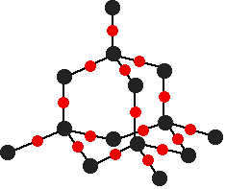 Also known as silica, it is a giant covalent structure with a ratio of two oxygen atoms for each silicon atom, as the name implies. It is often compared to diamond due to its very similar structure. Due to these similarities, silica has similar properties to diamond in that it is very hard and has a high melting and boiling point.

Writing chemical formulae

Here are the different terms as well as their features:

* Chemical formula

Representation of any chemical compound in symbols

* Formula unit – ionic compounds
  + Simplest ratio of ions to each other in an ionic compound
  + Binary compounds – two elements

Always 1 metal and 1 non-metal

* + Tertiary & quarternary compounds – 3/4 elements

Always includes polyatomic ion(s)

* Molecular formula – covalent molecules
* Empirical formula
  + Smallest ratio of atoms to each other in a molecule, usually used for covalent molecules.
* Chemical equation

Shows reactants and products of a chemical reaction. Remember to use arrow instead of equal sign to show chemical reaction.

Usually, these equations are balanced, meaning it shows the exact number of reactant molecules/elements to get the exact number of each product.

* Word equation

Chemical equation, but uses word names of molecules and elements and isn’t balanced.

* Polyatomic ion

A covalent molecule with a net charge that isn’t neutral. Most are negatively charged, but there are some that are positive.

* Word formula

Rules that one must follow when writing formulae are:

1. In a binary ionic compound, the cation is written first and the anion is written second.
2. For word formulae of anions, they use the suffix ‘-ide’. In a binary covalent compound, the last element is also given the suffix ‘ide’.
3. In a binary covalent compound, the element with a lower group number is written first, exception being between a halogen and oxygen, where the halogen is written first.

If both elements are in the same group, the one with a higher period number is written first.

1. Subscripts are used immediately after an element’s symbol to indicate the number of atoms of said element. For example, SO4 means that there is 1 sulfur atom and 4 oxygen atoms.
2. Normal-sized numbers before a molecule/element’s formula indicate the number of that entire molecule/element. For example, 2SO4 means that there are 2 SO4 molecules.
3. Brackets are used with subscripts to indicate the number of a molecule within the same formula. For example, Mg(ClO3)2  means that there is one magnesium atom, but 2 chlorate molecules.
4. Greek prefixes (mono-,di-,tri-,tetra…) are used in word formulae to indicate how many of each element/molecule there are. For example, Carbon monoxide means that there is one carbon and one oxygen, and carbon dioxide means there are 2 oxygen atoms.

However, the ‘mono-‘ prefix does not apply when there is one atom of the first element in the name.

Stoichiometry

Stoichiometry is the ratio between reactants and products in chemical reactions.

Relative mass

There are 3 types of masses you should know in stoichiometry:

* Relative atomic mass (Ar)

An atom’s mass relative to carbon-12.

* Relative formula mass (Fr)

The total mass of all atoms in a formula unit.

* Relative molecular mass (Mr)

Fr but for simple molecules.

All of these values are measured in a.m.u. (atomic mass unit)

Moles

A mole of a substance is equal to:

* The molar mass of the substance

The molar mass of a substance is how many grams there are per mole, and is equal to its Fr in grams. For example, oxygen’s atomic mass is 16 a.m.u., so it’s molar mass is 16g/mol.

* 6.02 * 1023 particles of the substance

The name of this number is Avogadro’s constant, and is true for 1 mole of any substance. For example, 1 mole of lead contains 6.02 * 1023 atoms of lead.

* And if gas – 24dm3 in volume at r.t.p. (room temperature)

Like Avogadro’s constant, it is the same for any gas. Doesn’t work for solids and liquids.

This way, one can accurately calculate the exact ratio of reactants to each other, or distribution of mass from reactants to products, as well as accurately use these measurements in experiments involving reactions.

Chemical reactions

There are 5 types of chemical reactions:

Synthesis reactions

As the name suggests, it involves synthesizing reactants into a more complex product. A simple way of showing it will be like this:

A + B -> AB

An example of a synthesis reaction is:

2Na + Cl2 -> 2NaCl

However, it is possible for more than two reactants to have a synthesis reaction, or to have more than one product in a synthesis reaction. The main aspect to keep in mind regarding synthesis reactions is that the product should be more complex than its initial reactants.

Example:

CO2 + H2O -> C6H12O6 + O2

Decomposition reactions

The opposite of a synthesis reaction, essentially, where a complex reactant breaks down into multiple, less complex products.

AB -> A + B

Unlike synthesis reactions, decomposition reactions usually need energy input in order to react, forms including light, heat, and electricity. This is because energy is needed to break chemical bonds, while energy is lost when creating bonds.

2H2O -> (by electrolysis) 2H2 + O2

CaCO3 -> (by heating) CO2 + CaO

You can see here that calcium carbonate breaks down into two compounds. When writing decomposition reactions, make sure the products make sense; CO3 isn’t a possible product as it is a compound ion and is not stable by itself.

Single displacement reactions

Single displacement reactions are reactions where a reactant takes the place of a component of the second reactant, the second reactant being a compound.

A + BC -> AC + B

Examples:

Mg + CuO -> MgO + Cu

NaCl + F -> NaF + Cl

You can see here that it can work for both metals and non-metals.

Double displacement reactions

Just the same as single displacement reactions, but now there’s two compounds and they totally swap components.

AB + CD -> AD + CB

Example:

2KI + Pb(NO3)2 -> 2KNO3 + PbI

Combustion reactions

Theres others

The Periodic Table

Periods and groups, etc.

This is how the periodic table is arranged. Periods are the horizontal rows of elements, while groups are the vertical columns.

The elements on a single period all have the same number of electron shells, while elements in the same group will have the same number of valence electrons.

Another thing is that the periodic table’s elements are sorted left to right, top to bottom in ascending order of atomic number. Generally, their atomic masses also increase in order.

Metals, metalloids and non-metals

Metals take up the majority of the periodic table, starting from the left. Their properties are:

* Soft. Alkali metals are the softest.
* Malleable and ductile
* Conductive of electricity and heat
* Shiny
* Corrosive – easily reacts with oxygen to produce metal oxides.

A majority of metals are transition metals, which often have varying valency.

Non-metals take up much less of the table, starting from the right of it.

* Brittle and easy to shatter as solids
* Poor conductors of electricity and heat
* Dull
* Most are gases at r.t.p.

Metalloids generally have a mix of both metal and non-metal properties. Examples include silicon and boron.

* They can be either shiny or dull
* They are ductile and malleable
* They are good conductors of both heat and electricity, but not to the same extent as metals.

Hydrogen

Hydrogen is placed above group 1 as it follows the group according to the number of valence electrons, but is still considered a non-metal (and thus not an alkali metal) due to its non-metal properties, such as being a gas at r.t.p.

Since it has an atomic mass of 1 and an atomic number of 1, that means it has no neutrons, and only a single proton in its nucleus. That means, a positive hydrogen ion is just a proton. It is also possible for hydride to exist as it only needs to gain 1 electron to fill its single valence shell.

Properties of alkali metals (group I)

We’re gonna have to memorize this. :(

Alkali metals have these general properties, with exceptions, unfortunately:

* All properties of metals aforementioned
* Tarnish quickly in air
* Can be cut easily with a knife. The lower down the group, the softer.
* Less dense than other metals. Density increases as we go down the group, except for potassium for some reason
* Low melting and boiling points, gets lower as you go down the group.

As for chemical properties:

* Most reactive of the metals, reactivity increases as you go down the group.
* React very vigorously with water to produce alkaline solutions (that’s why they’re called alkali metals). Practically, this can be tested using pH indicators. (Alkali = Metal hydroxide)
* All compounds they form are ionic.

|  |  |  |  |  |
| --- | --- | --- | --- | --- |
| Alkali metal | Appearance | Reaction with water | Forming alkaline solution | Production of flame in water reaction |
| Lithium | Silvery white | Metal moves slowly on surface | Metal disappears slowly | None |
| Sodium | Metal melts into a ball on the surface, moves fast | Metal disappears quickly | None |
| Potassium | Same but more rapid | Metal disappears rapidly | Hydrogen ignites, potassium makes flame lilac |

Properties of alkaline earth metals (group II)

Since they’re quite close, they have similar properties and patterns to alkali metals, just less extreme. One thing to note is that they are more dense than alkali metals.

Properties of transition metals

These are the 30 metal elements in the middle of the table. Physical characteristics include:

* Hard and strong
* High melting and boiling points
* Some are magnetic
* High density
* All the other properties of metals

Chemical properties:

* Less reactive than group I and II
* Don’t corrode easily, exception is iron
* Often form colored compounds
* Variable valency
* Many are catalysts.

Properties of halogens (group VII)

* Has all properties of non-metals as aforementioned
* Most are poisonous
* Never found in nature

Chemically:

* Are diatomic
* Most reactive of the non-metals
* Reactivity decreases as you go down the group
* Their compounds are called halides

|  |  |  |  |
| --- | --- | --- | --- |
| Halogen | Appearance | Smell | Found as |
| Iodine | Grey, sublime solid. Gas is purple | Smelly and poisonous | Iodides and iodates in certain rocks and seaweed |
| Chlorine | Green gas | Chlorides, often sodium chloride in the ocean |
| Bromine | Deep red liquid, red-brown vapor. | Bromides, often magnesium bromide in the ocean |

Uses of transition metals

1. Gold

* Used in jewelry as it does not react with water/air at r.t.p. and is malleable.
* Used in electrical connectors, being a good conductor.

1. Silver

* Used in jewelry for reasons same as gold.
* Used in electrical contacts and circuit boards, similar reasons to gold.

1. Copper

* Made into electrical wires and used in circuit boards, being a good electrical conductor and being ductile.
* Used to make water pipes as it does not react with water at r.t.p. while being malleable

1. Iron

* Often mixed with other metals to make strong but malleable alloys called steels at inexpensive prices
* Catalyst in processes such as the Haber process

1. Chromium

* Used to coat corrosive metals such as iron and steel to keep them shiny, often used on cars and bikes
* Catalyst in the chemical industry.

Uses of metalloids

Silicon and boron are both metalloids that play a major role in electronics, used to create electrical semi-conductors – silicon is a very good electrical conductor used as the base for these semi-conductors, while boron is used in the process of P-doping the conductors.

Acids and Alkalis

Defining acids, bases and alkalis

Acids

Acids are just compounds that give away H+ ions. They are usually made up of an anion + hydrogen. Examples include HCl and H2SO4. Non-metal oxides like CO2 are also acidic.

Bases

Bases are compounds that give away OH- ions. They are usually made up of a cation (often a metal) + hydroxide or oxide. Examples include NaOH, K2O and Mg(OH)2.

Alkalis

Alkalis are bases that can dissolve in water. So, Mg(OH)2 isn’t an alkali since it’s insoluble, but NaOH is.

If you’ve noticed, H+ ions given by acids and OH- ions given by bases can form H2O. And it is also noticed that acids contain anions while bases contain cations, so when they react, it is mostly safe to say they form a salt and water.

Reactions

Neutralization reactions

This is the same reaction stated earlier.

Acid + base -> salt + water

An example is:

HNO3 + NaOH -> NaNO3 + H2O

Acid + metal reactions

Basically, because there is no hydroxide ion to form water, the hydrogen ion just forms hydrogen gas. Also, this only works if the metal involved is more reactive than hydrogen, since it’s basically a displacement reaction.

Acid + metal -> salt + hydrogen

Example:

2HCl + Zn -> ZnCl2 + H2

Acid + metal carbonate reactions (OR bicarbonate[28])

Think of it as the carbonate ion losing one of its oxygen to hydrogen, forming carbon dioxide and water.

Acid + carbonate -> salt + carbon dioxide + water

2HCl + CaCO3 -> CaCl2 + CO2 + H2O

pH

pH can be considered as ‘hydrogen potential[29]’ and represents how acidic or basic a solution is, the main scale going from 0 to 14, from acidic to basic.

The pH can also be seen as an inverse indication of the substance’s hydrogen ion concentration; the higher the pH, the less hydrogen ions/more negative space there is for hydrogen ions, and vice versa for lower pH. pH 7 is considered neutral.

The strength of acids and alkalis

The strength of an acid or alkali corresponds to their pH; the further away from neutral it is, the stronger it is.

But what actually makes two acids’ pH different from each other is how well they disassociate or ionize in water.

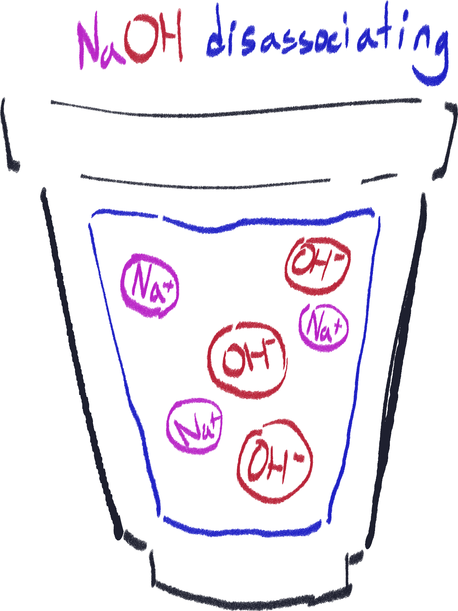Disassociation

Disassociation is when an ionic compound breaks up into scattered ions, usually when dissolved in water. Note that disassociation only happens when the compound is already made up of ions.

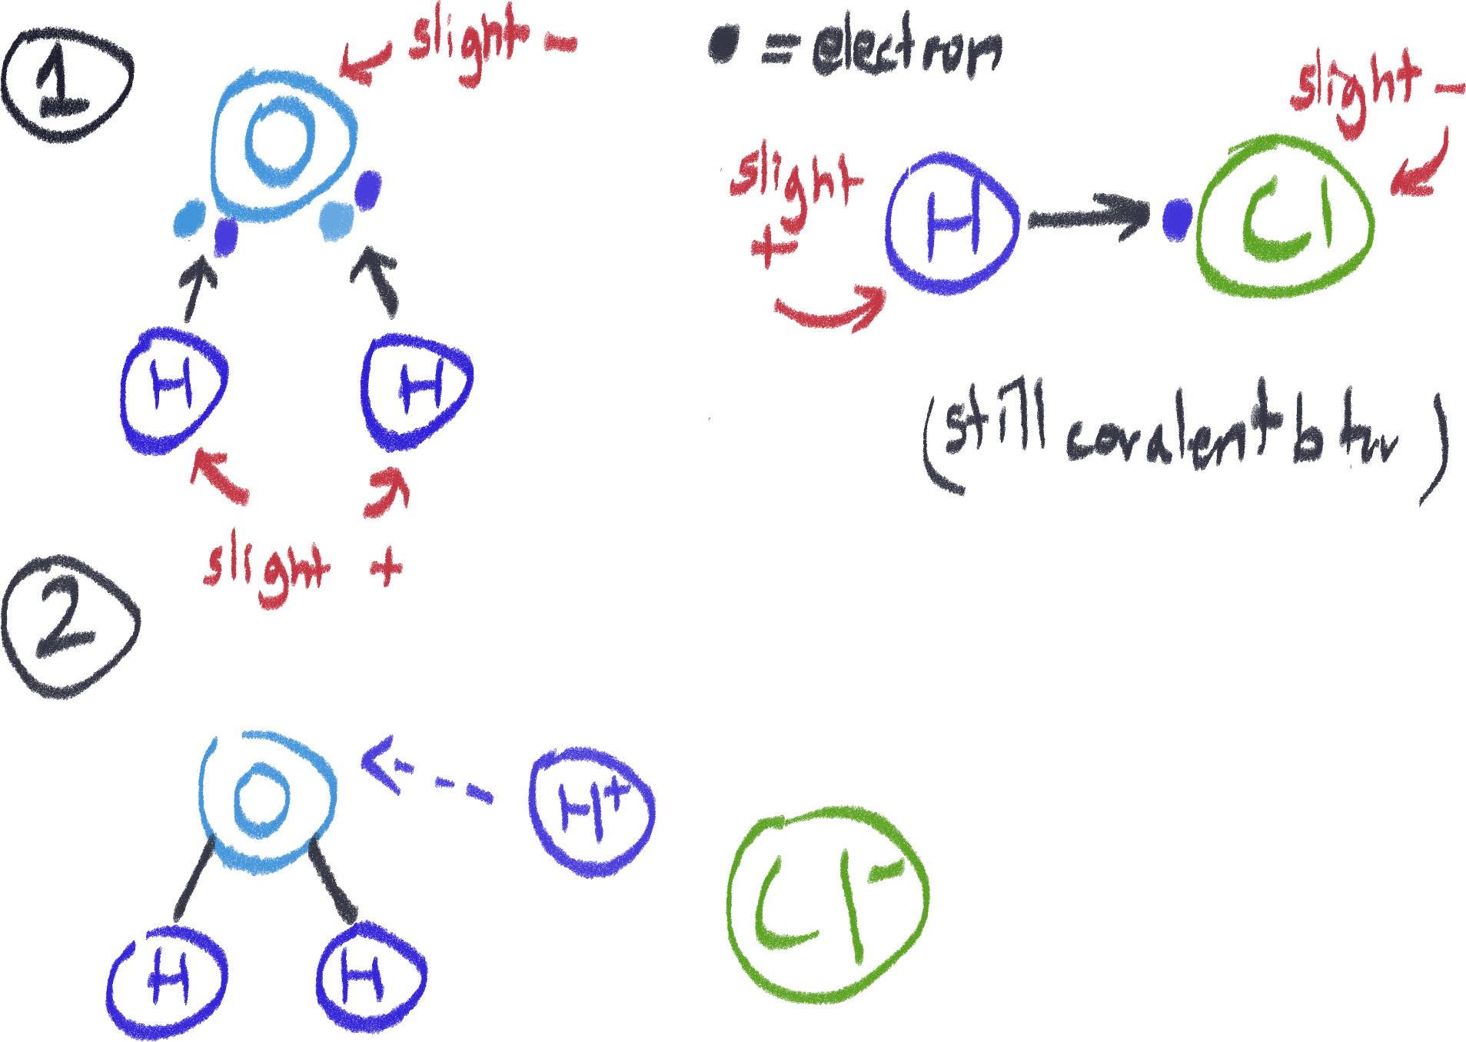Ionization

Ionization happens when a covalent compound’s atoms turn into ions. Polar covalent compounds such as the ones shown in the diagram do not have the shared electrons equidistant to each other[30], which results in slight charge differences. Think of the electron being closer to chlorine than hydrogen.

Because of this, this allows covalent compounds like HCl to dissolve in water and turn into ions.

Some compounds ionize less effectively than others. This means that acids that ionize less effectively release less H+ ions, reducing their pH and defines them as a weak acid. For example, HCl almost completely ionizes in water (100%) while acetic acid only partially ionizes in water (<100%).

CH3COOH + H2O ⇌ CH3COO- + H3O+

This equation shows how acetic acid ionizes; it can always go on either side of the equation.

This applies for bases and alkalis as well. Also, since some bases are not soluble, those are automatically weaker as well.

By the way, this (shown in probably unscientific diagram) is called a hydronium ion, the H3O+ mentioned earlier.

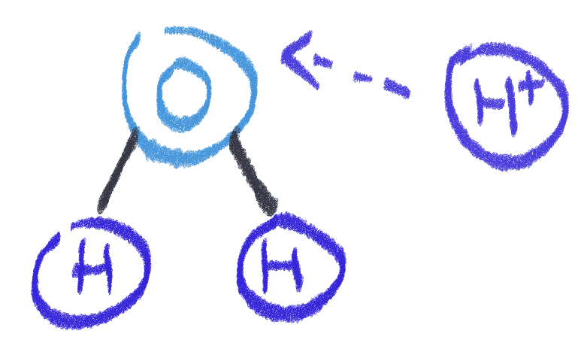

Testing the strength of an acid/base

There are a bunch of ways to determine the strength of an acid or base. I will be separating them into two categories.

Qualitative

* Seeing how vigorous the substance’s reaction is when neutralized
* Seeing how well it conducts electricity

Quantitative

* Measuring change in temperature during neutralization reaction
* Measuring how much of the substance is needed to neutralize a controlled amount of acid/alkali, the less needed, the stronger it is[31].
* Measuring how much of a known acid/alkali is needed to neutralize the substance you’re testing the strength of, the more needed, the stronger it is.

Ammonia

Ammonia is a special case when it comes to acid/base reactions because ammonium has an H+. It is generally basic in solutions.[32] (Because in water, an NH3 attracts water’s H+ to make NH4+ and OH-. So even though it doesn’t have OH, it turns water into OH, kind of.)

Ammonia solution + acid reactions

Ammonia + acid -> Ammonium salt + water

NH4OH(aq) + HCl -> NH4Cl

It’s just a synthesis reaction, because the H+ ion from the acid goes to the ammonia to make an ammonium ion and non-metal ion.

Ammonium salt + alkali reactions

Ammonium salt + base -> salt + ammonia + water

NH4Cl + NaOH -> NaCl + NH3 + H2O

|  |  |  |  |  |
| --- | --- | --- | --- | --- |
| Type | Name | Formula | Strength | Uses |
| **Organic**  Most have biological origin and are generally weak.  They always have carbon in them.  They mostly don’t dissolve well. | Lactic acid | CH3CH(OH)CO2H | Weak | Found in sour milk |
| Methanoic acid | HCOOH | In ant and nettle stings, used in kettle descaler[33] |
| Ethanoic/acetic acid | CH3COOH | In vinegar |
| Citric acid | C6H8O7 | In citrus fruits (orange, lemon, etc.) |
| **Inorganic**  Most are strong.  They mostly dissolve well. | Carbonic acid | H2CO3 | Weak | In fizzy drinks |
| Sulfurous acid | H2SO3 | - |
| Nitrous acid | HNO2 |
| Sulfuric acid | H2SO4 | Strong | Used in car batteries, fertilizer, paint and detergent |
| Hydrochloric acid | HCl | Used to clean metal and is in the stomach to digest food |
| Nitric acid | HNO3 | Used in fertilizers and explosives |
| Phosphoric acid | H3PO4 | In fertilizer and anti-rust paint |

Common acids, alkalis and amphoteric stuff

Acids

To remember easier, most of these inorganic acids have the compound ions you’ve memorized as anions, so you just need to remember the anions and fill in their charges with H+ ions.

Bases

I wouldn’t say you’d need to memorize these (besides lime) since you can figure them out yourself using the metals’ charges with hydroxide, so just remember their uses.

|  |  |  |
| --- | --- | --- |
| Name | Formula | Uses |
| Lime (not the fruit, some other thing) / Calcium carbonate | CaCO3 | Inside limestone. When lime or limestone is heated, produces CaO and CO2. |
| Sodium hydroxide | NaOH | In lye (used in soapmaking) |
| Ammonia solution | NH4OH | Cleaning products |
| Potassium hydroxide | KOH | Liquid soap |
| Barium hydroxide | Ba(OH)2 | Plastic stabilizer |
| Magnesium hydroxide | Mg(OH)2 | Milk of magnesia |
| Aluminum hydroxide | Al(OH)3 | Maalox (antacid) |

Amphoteric compounds

I should have put this at the start of the chapter but I forgot. Amphoteric substances can act as both an acid and base at the same time. So, if you were to react the same amphoteric compound with an acid and a base, they would react with both. These are the two most common examples of amphoteric compounds – I don’t believe you need to know anything else for now.

|  |  |
| --- | --- |
| Oxide | Formula |
| Zinc (II) oxide | ZnO |
| Aluminum (III) oxide | Al2O3 |

pH indicators

pH indicators are just chemicals that are used to determine the pH of another substance by reacting with it while not causing and large change in the substance itself.

Common pH indicators

|  |  |
| --- | --- |
| Name | Use |
| Blue litmus paper | Turns red when exposed to acid |
| Red litmus paper | Turns blue when exposed to a base |
| Universal indicator | Goes through the whole rainbow – red at most acidic and violet at most basic |
| pH paper | Multicolored like the universal indicator |
| pH meter (machine) | Gives exact pH number value so cool |
| Phenolphthalein | Colourless in pH below 8.5, turns pink above pH 9 |
| Thymolphthalein | Similar to phenolphthalein, except it’s blue and it reacts at slightly higher pH |
| Natural indicators like hydrangea for soil pH, and red cabbage and radishes | Only if you’re POOR and you’re only looking for qualitative value |
| Methyl orange | Red below pH 3.1 and gradually turns yellow up to pH 4.4 and over. |

pH strips/paper

You can either drop solution samples onto them (using a dropper or the end of a stirring rod) or dip an end of a strip into the solution. It’s recommended not to use the whole strip at once since you can use untouched parts later.

Litmus paper

When answering practical questions, please specify using damp litmus paper.

Universal indicator

The universal indicator is a mixture of multiple indicators that each have their own range of pH they can react in. All these indicators stay colorless unless exposed to their specific pH range.

Phenolphthalein

Phenolphthalein is often used in titration due to it having an easy to distinguish change in color from colorless to pink when the pH of the medium becomes basic, meaning that it makes it easy to immediately tell when the base is in excess.

Methyl orange

Methyl orange is also used in titration reactions like phenolphthalein for similar reasons.

Acidity of soils

Testing the acidity of a soil sample

If, when baking soda (sodium bicarbonate) is added to the sample, bubbles form, the soil is acidic (confirms the presence of acid that reacts with the sodium bicarbonate).

If it bubbles when vinegar is added (ethanoic acid) that means the soil is basic.

Controlling the pH of soil

Usually, the problem is that soil becomes too acidic for plants that are sensitive to pH; this can happen due to acid rain, rot or constant use of ammonium fertilizers.

Adding a base to the soil can help neutralize it. A common base used in this case is limestone/calcium carbonate (CaCO3).

Acid-base titration

Titration is a type of laboratory method that is used to determine the concentration of a solution. There are multiple types of titrations but we’re only dealing with acid-base at the moment.

The main logic acid-base titration goes by is that if we have a known reactant with a known concentration and a known reactant with an unknown concentration, we will be able to calculate the unknown concentration by the amount of each substance needed to complete neutralization.

That was a long sentence but the whole thing is pretty simple. We’ll run through the steps of an example titration experiment.

Remember, this example is not the only way it can go. It can also be an alkali being added to an acid.

1. Starting point

We are given 10dm3 of sulfuric acid of an unknown concentration and sodium hydroxide of concentration 1M in excess (this means unlimited). We need to find the concentration of the sulfuric acid. We will assume we won’t be doing more trials (though practically, irl, it’s better to do multiple trials).

1. Preparation

First, we prepare a burette and fill it with the sodium hydroxide, held up by a clamp while a beaker under it is filled with the 10dm3 of sulfuric acid.

We will need a liquid indicator – do not use a pH strip or anything like that, since we need to immediately know when the solution is neutralized. In this case, we will use phenolphthalein. Methyl orange is also recommended. The indicator is dropped and stirred into the beaker using a glass stirring rod.

Remember to record the original amount of sulfuric acid as it is a controlled value.

1. Doing it

The burette is opened slightly to allow drops of sodium hydroxide to fall into the beaker. It’s important to drop it in minimal amounts to get the most accurate amount as possible when it reaches neutralization.

Meanwhile, the solution in the beaker is stirred using the stirring rod.

1. Neutralization

When the phenolphthalein turns pink, immediately close the burette. The phenolphthalein turning pink means that the solution has become basic, which means it has just passed neutralization. Remember that this cue will depend on what indicator you’re using or if adding an acid to a base.

Record the amount of sodium hydroxide that has exited the burette. To be a bit more accurate, reducing the amount slightly when written can negate some of the extra sodium hydroxide that exited after neutralization.

1. Calculation

Let’s say that it took 4dm3 of sodium hydroxide to neutralize the 10dm3 of sulfuric acid.

We must first write down the balanced chemical equation of sodium hydroxide and sulfuric acid:

*2NaOH(aq) + H2SO4(aq) -> Na2SO4 + 2H2O*

Using this equation, we can deduce that it requires 2mol of NaOH to neutralize 1mol of sulfuric acid, a ratio of 2:1.

To find out the number of moles of sulfuric acid that were involved, we find how many moles of sodium hydroxide there is in 4dm3:

*4dm3 of 1M concentration of NaOH*

*= 4mol of NaOH*

And using that and the ratio, we can find the moles of sulfuric acid:

*NaOH : H2SO4*

*2:1*

*So 4mol/2 = 2mol of H2SO4*

Finally, we can get the concentration by dividing our result by the volume of sulfuric acid:

*2mol/10dm3*

*= 0.2M*

Interesting thing

Salts are a product of an acid and base; and are also defined as an ionic compound of cations and anions. However, there are also acids and bases that are ionic compounds themselves.

By technicality, an acid can also be a salt. A base can too. A compound like KH2PO4 is a salt, base and acid all at once.

Things to memorize

Common transition metal ions

Always remember; when writing the word formula or name of a transition metal, ALWAYS write its valency number!

The ones in yellow are the most important ones, I haven’t seen the ones in orange all that much.

|  |  |
| --- | --- |
| Name | Formula |
| Iron (II) | Fe2+ |
| Iron (III) | Fe3+ |
| Zinc (II) | Zn2+ |
| Copper (I) | Cu+ |
| Copper(II) | Cu2+ |
| Lead (II) | Pb2+ |
| Lead (IV) | Pb4+ |
| Aluminium (III) | Al3+ |
| Mercury (II) | Hg2+ |
| Tin (II) | Sn2+ |
| Tin (IV) | Sn4+ |
| Chromium (III) | Cr3+ |
| Manganese (II) | Mn2+ |

Diatomic elements

Diatomic elements cannot exist by itself alone without bonding with another atom of itself. For example, chlorine is always covalently bonded with another atom of itself when in element form.

When writing a chemical equation and the reactant or product includes something like hydrogen or chlorine gas, always make sure you write them correctly; write H2 instead of H, because otherwise, the entire equation will be messed up.

Diatomic elements include:

* All halogens[34]
* Hydrogen
* Nitrogen
* Oxygen

Common compound ions

Compound ions are compounds that are ions. We need to memorize them since for longer ones, there isn’t any other way to deduce their charges.

|  |  |  |  |
| --- | --- | --- | --- |
| Ion | Formula | Ion | Formula |
| Nitrate | NO3- | Permanganate | MnO4- |
| Nitrite | NO3- | Silicate | SiO44- |
| Sulfate | SO42- | Chlorate | ClO3- |
| Sulfite | SO32- | Chlorite | ClO3- |
| Carbonate | CO32- | Cyanide | CN- |
| Phosphate | PO43- | Chromate | CrO42- |
| Acetate[35] | CH3COO- | Dichromate | Cr2O72- |
| Ammonium[36] | NH4+ |  |  |

Also, this is easy to get wrong; for names like nitrite and nitride, these are two totally different things. ‘-ite’ means it’s an oxide but with less oxygen atoms than that element’s ‘-ate’ version, while ‘-ide’ is just the ion of an element.

Practical things to memorize

Salt solubility rules

Not a fan of this, but it is very VERY necessary for precipitation reactions. This is mainly for salts (ionic compounds) but soluble covalent compounds do exist.

There are more rules than this, but these are just the most relevant and probably all you’ll need for now.

|  |  |  |
| --- | --- | --- |
| If it contains… | Solubility | Exceptions (opposite of regular solubility) |
| Alkali metals | 100% totally soluble | none |
| NH4+ (Ammonium) |
| NO3 (Nitrate) |
| Halides | Soluble with exceptions | With Ag+, Hg2+, and Pb2+ (although AgF is soluble) |
| SO42- (Sulfate) | Soluble with exceptions | With Ba2+, Sr2+, and Pb2+ |
| O-2 (Oxide) | Insoluble with exceptions | Only soluble if salt contains the 100% totally solubles, Sr2+ or Ba2+ |
| OH- (Hydroxide) |
| PO43-(Phosphate) | Insoluble with exceptions | Only soluble if salt contains the 100% totally solubles |
| CO32- (Carbonate) |

Qualitative testing for anions

These tests are based off the precipitate of these anions with the reactant. Any compound containing that anion should result according to this.

|  |  |  |
| --- | --- | --- |
| Anion tested for | Test | Result |
| Carbonate | Add any dilute acid | Effervescence (fancy word for gas seen coming off); carbon dioxide produced |
| Chloride | Acidify using dilute nitric acid, then add silver nitrate solution | Forms white precipitate |
| Bromide | Forms cream precipitate |
| Iodide | Forms yellow precipitate |
| Nitrate | Add sodium hydroxide solution and catalyze by adding aluminum foil and warming gently | Pungent ammonia released, can be tested using litmus paper |
| Sulfate | Acidify and then add barium nitrate | Forms white precipitate |
| Sulfite | Add dilute hydrochloric acid and warm gently. | Will produce sulfur dioxide gas (should be tested) |

Qualitative testing for cations

Also based off precipitates. Some cations must also be tested using ammonia solution because their precipitates look the same.

A lot of these are based off solubility in excess amount of the second reactant. That means that a precipitate like aluminum hydroxide dissolves when more sodium hydroxide is added to it.

|  |  |  |
| --- | --- | --- |
| Cation tested for | Sodium hydroxide solution added | Ammonia solution added |
| Calcium | White precipitate, insoluble in excess | No precipitate, or only a very light white one. |
| Aluminum | White precipitate, soluble in excess | White precipitate, insoluble in excess |
| Zinc | White precipitate, soluble in excess |
| Iron (II) | Green precipitate, insoluble in excess | |
| Iron (III) | Brown-red precipitate, insoluble in excess | |
| Copper (II) | Light blue precipitate, insoluble in excess | Light blue precipitate, soluble in excess, giving a dark blue solution |
| Chromium (III) | Green precipitate, soluble in excess | Green precipitate, insoluble in excess |

Flame test for cations

Method

To do this, one will need to use a clean nichrome wire loop, and dip it in dilute hydrochloric acid to further wash it off. The loop is held into a roaring blue flame of a Bunsen burner, and it is made sure that there are no color changes in this state. After that, the loop can be dipped into the solution to be tested for, then held into the flame again. The flame will change color, according to what metal is in the solution.

|  |  |
| --- | --- |
| Anion tested for | Test |
| Sodium | Yellow |
| Copper(II) | Blue-green |
| Magnesium | White, really bright |
| Potassium | Lilac |
| Lithium | Red |
| Calcium | Orange-red |

Testing for presence of chemicals

|  |  |
| --- | --- |
| Substance tested for | Test |
| Carbon dioxide | Turns limewater milky when bubbled into it |
| Oxygen | Relights a glowing splint |
| Hydrogen | Pops a lit splint |
| Ammonia | Turns damp red litmus paper blue |
| Sulfur dioxide | Turns acidified potassium manganate (VII) solution from purple to colorless |
| Chlorine | Bleaches blue litmus paper |
| Water | Turns cobalt (II) chloride paper from blue to pink |

Reversible Reactions

Reversible reactions are reactions that can go both ways. The reactants can make the products, and the products can make the reactants. Although it’s probably possible for a lot of reactions to be reversed under very theoretical conditions, reactions that are considered reversible are those that have simple enough conditions to reverse.

Here is an example of a reversible reaction:

3H2(g) + N2(g) ⇋ 2NH3(g)

This is a synthesis reaction between hydrogen and nitrogen that produces ammonia, but ammonia can also decompose into hydrogen and nitrogen.

Usually, reversible reactions are synthesis and decomposition reactions like this. Reactions such as combustion for example, are irreversible.

Regarding the specifics when discussing reversible reactions, you should know that in a reaction, there is a forward and reverse direction. Forward is the reaction occurring from left to right, and reverse is the opposite. You can think of the forward reaction as how you would usually read a chemical equation. Most of the time, you will be referring to the reagents on the left as reactants, and on the right as products, no matter which direction you’re talking about.

Here, the forward reaction is the production of ammonia. You will always be given the written equation (except when talking about the Haber process and contact process) so you don’t need to memorize which is forward and reverse.

Equilibrium

Equilibrium is the state where a reversible reaction has its forward and reverse reaction happening at the same time, at the same rate. In the case of the ammonia example, as hydrogen and nitrogen are reacting to produce ammonia, ammonia is decomposing to produce hydrogen and nitrogen.

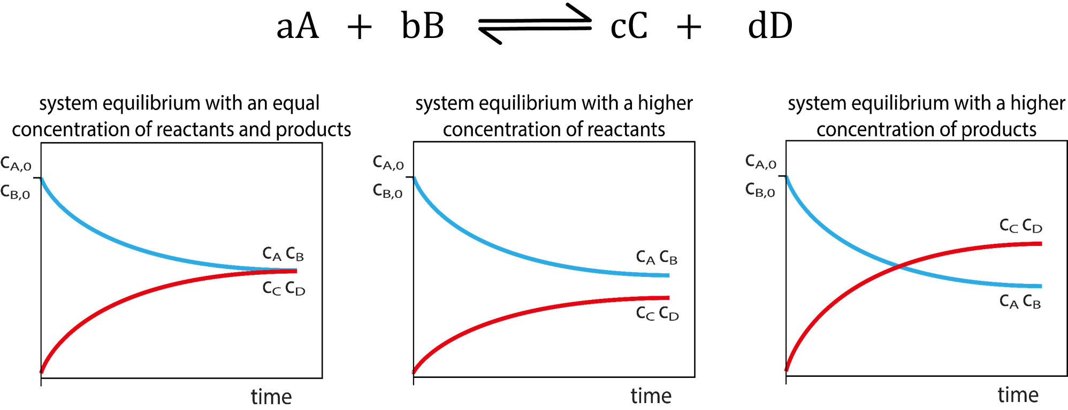 At equilibrium, because the rate of reaction of both reactions are equal, the reaction never ends. Do not confuse ‘equal rate of reaction[37]’ with ‘equal concentration of reactant and product’, because reactions can have inequal molar ratios of product and reactant. For example, there are more moles of reactant hydrogen + nitrogen than moles of produced ammonia in the ammonia reaction.

The picture above shows how the graph of the rate of reactions of two reactions look in equilibrium. One line represents the rate of the forward reaction, and the second represents the rate of the reverse reaction.

See that all of them reach a point where both rates plateau and are parallel to each other. Where the lines are horizontal like this, is when the reaction is in equilibrium. It is *not*  necessarily where the lines intersect, however. All the cases above show equilibrium.

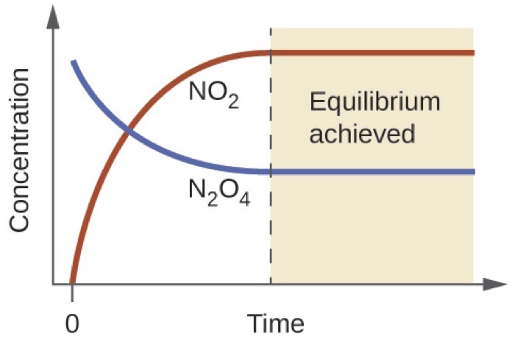Here is an extended image.

The picture below is a rate of reaction graph for a normal reaction, not in equilibrium. Notice that the reactants are reduced to 0, and the reaction ends.

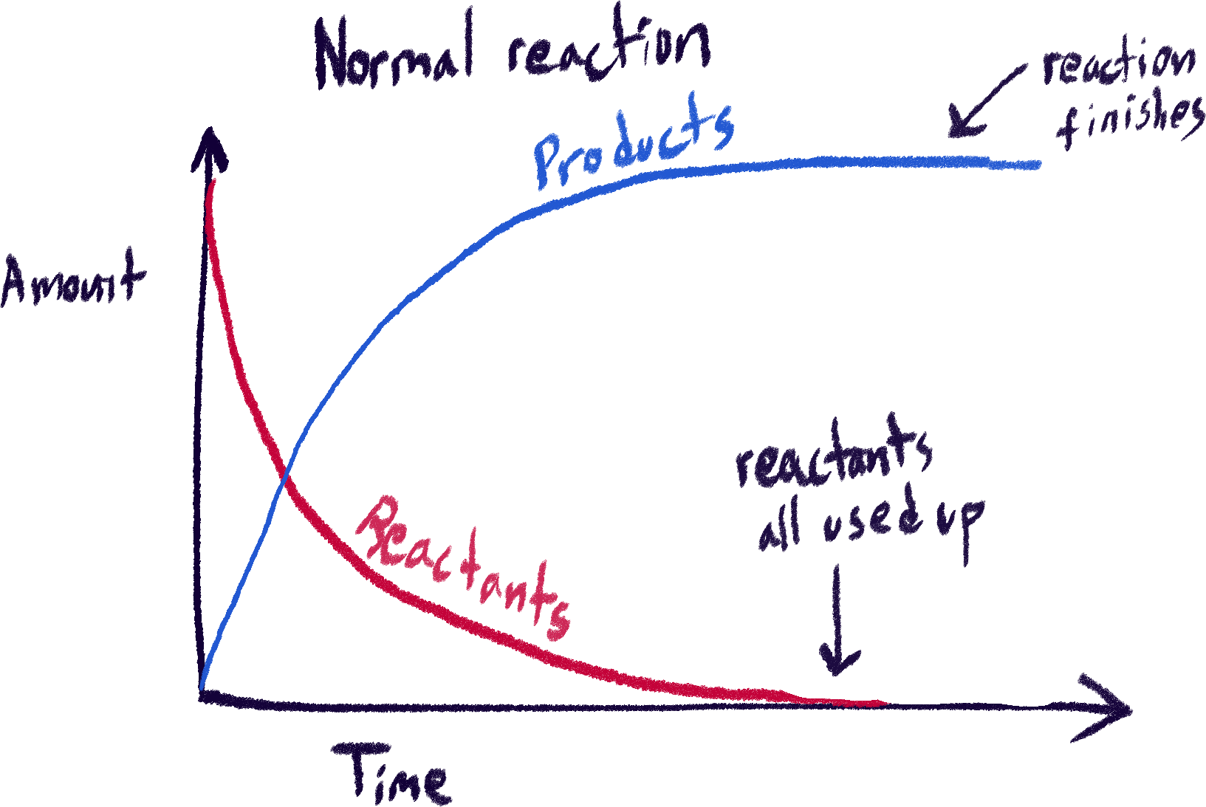

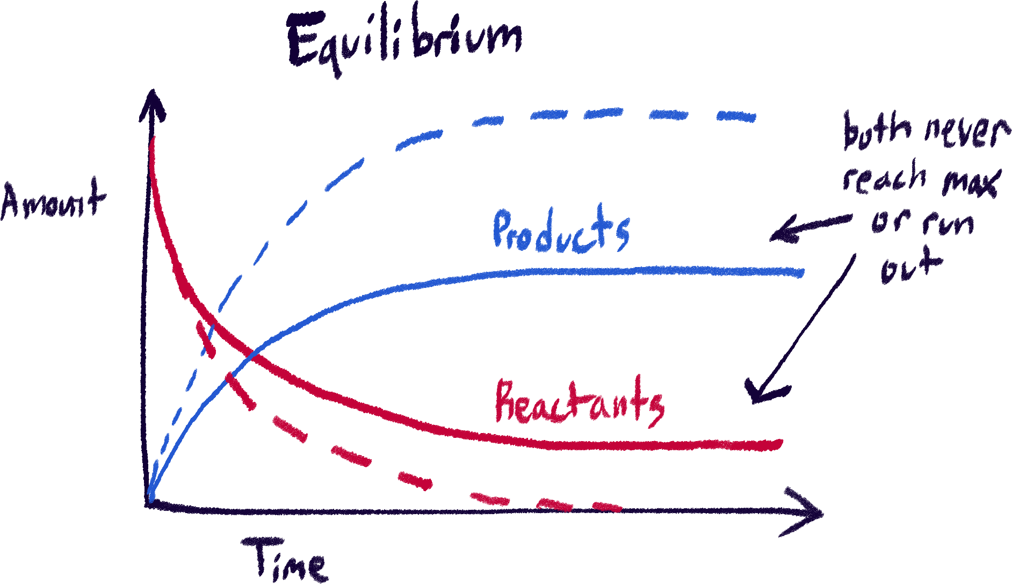 In equilibrium, no reagent ever runs out, because otherwise the reaction would simply not be able to continue. I drew dotted lines here to compare the normal reaction to the equilibrium reaction. Even though they do plateau like in a normal rate of reaction graph, this doesn’t mean the reaction has ended. Instead, this means that because the reactions are constantly happening and are equal in rate, the amount of product and reactant stays the same throughout.

So, we can say that in equilibrium:

* The rates of reaction for the forward and reverse reaction are equal.
* The concentrations of reactants and products remain constant.

Conditions for equilibrium

You can’t reach equilibrium in just any condition.

Reaction is reversible

Mentioned this earlier. Of course it must be reversible, because otherwise no simultaneous reactions would be possible in the first place.

Occurs in a closed container

When we say ‘closed container’ we mean that nothing can enter or leave, and nothing else such as heat or any other form of energy can escape either. This is necessary as, for example, if the products could escape, the reactants would just be constantly be used up until everything turned into product and escaped.

Same goes for things such as heat, because heat can be considered a kind of reactant or product as any reaction will be endothermic or exothermic.

Dynamic equilibrium

The only kind of equilibrium we will ever be discussing in chemistry is dynamic equilibrium, so it’s a bit redundant saying ‘dynamic equilibrium’ here. This section is just talking about *how* chemical equilibrium is dynamic/the meaning of *dynamic* in dynamic equilibrium. I guess it’s because there is static equilibrium in other parts of science, like physics? And they[38] just want to know that we know that chemical equilibrium is dynamic?

*Dynamic* in dynamic equilibrium refers to the fact that two reactions are constantly happening at the same time. Static equilibrium would mean that nothing is happening and thus nothing is changing, which is impossible when we’re talking about chemistry and reactions. Dynamic equilibrium, on the other hand, means that both directions are constantly happening at the same time, at the same rate and thus there is no resultant out of it.

In equilibrium, nothing happens in the end, but *dynamic* and *static* refers to how the equilibrium works.

Also, dynamic equilibriums (in any science I believe) will respond to any disturbances done upon it to maintain its equilibrium, while static equilibriums will do nothing because nothing was happening in the first place. How chemical equilibrium responds to disturbances will be discussed in the section about Le Chateliér’s principle, it’s a very important concept.

Position of equilibrium

Let’s say we have a reaction at equilibrium. We already said that only the *rate* of the reactions have to be the same, the amount of reactants and products can be different. So, it is possible to have more moles of products than reactants in this mixture of reagents, or more reactants than products.

Looking at these examples again, these show the same concept.

* The first graph has the reactants and products at the same amount.
* The second graph has more reactants than products at equilibrium.
* The third graph has more products than reactants at equilibrium.

The ratio of amounts of reagents like this can vary for the same reaction. When equilibrium favors the forward reaction and more product is made, we say equilibrium has shifted to the forward reaction, or to the right.

When equilibrium favors the reverse reaction and more reagent is made, we say equilibrium has shifted to the reverse reaction or to the left. This is called the position of equilibrium.

Le Chateliér’s principle and shifting equilibrium

So how do we shift the position of equilibrium? Being able to shift equilibrium is important. If the reaction of hydrogen + nitrogen -> ammonia had its equilibrium always shifted to the left, it would be insanely hard to get any good yield of ammonia out of it.

We change the conditions of the equilibrium so it will shift to our needs according to Le Chateliér’s principle. It states:

*If a system at equilibrium is subjected to a change of pressure, temperature, or the number of moles of a component, there will be a tendency for a net reaction in the direction that reduces the effect of this change.*

In easy words, it means:

*If a system at equilibrium is subjected to any change, it will shift its equilibrium to oppose or counter that change.*

We must think of this principle in terms of external factors we can inflict onto the reaction.

Changing temperature

Again, we will be using this reaction.

3H2(g) + N2(g) ⇋ 2NH3(g)

It is given to us that the forward reaction is exothermic, and that we want conditions that will give us the highest yield of ammonia possible. So, we want the equilibrium to shift to the forward reaction.

If we decrease the temperature of the mixture, according to Le Chateliér’s principle, equilibrium will want to oppose that change, and thus try to increase the temperature. Thus, it will shift to the exothermic reaction, which is the forward reaction. This will produce more ammonia.

This can also work vice versa. By increasing the temperature, the equilibrium will shift to the endothermic reaction, which is the reverse. That will produce more hydrogen and nitrogen.

Changing pressure (for gases)

Changing concentration (for solutions)

The Haber process

The Haber process is an industrial process that is very important as it is used to produce ammonia, a chemical used in many processes and products, especially fertilizers.

3H2(g) + N2(g) ⇋ 2NH3(g)

Yes, it’s the same reaction from earlier.

Theoretical conditions and compromise conditions

When using the Haber process to produce ammonia, these are the conditions that are manipulated to get a higher yield of ammonia:

1. Lower temperatures - 450°C compromise temperature
2. Higher pressure – 200atm compromise pressure
3. Ammonia is being constantly taken out, so that also shifts the equilibrium forward

Process in stages

1. The hydrogen and nitrogen gas is entered into a reaction chamber, with the conditions that favor the production of ammonia – lower temperatures and higher pressure.
2. The reaction chamber is connected to a condensing chamber. Ammonia has a higher boiling point, so it will condense at higher temperatures compared to nitrogen and oxygen. The condensing chamber is kept at the boiling temperature of ammonia, so it will condense into a liquid. This is how ammonia and the reactant gases are separated.
3. The liquid ammonia is collected, while the remaining reactant gases in the condensing chamber is transferred back into the reacting chamber.

Compromises

You probably looked at that 450°C number and thought it was a typo, because that does not look low at all. Yeah, it really isn’t. But the standard temperature for the Haber process *is* 450°C, because any lower than that will make the rate of reaction too slow for efficiency or to reach equilibrium. 450°C is the temperature where the rate of reaction isn’t too slow but is also low enough that it gives a good enough yield.

Points like this are called compromises, and are influenced by factors such as plausibility, time, efficiency and hazard.

200 atm is pretty high, but isn’t usually made higher than that in real ammonia production, because maintaining high pressures is expensive and dangerous.

Raw material

You will have to know where they get the raw material for the Haber process.

* Nitrogen

Nitrogen is abundant in the air of our atmosphere, so it is extracted from there.

* Hydrogen

Hydrogen is obtained from the steam-reforming of natural gases or the breakdown of hydrocarbons.

Uses for ammonia

* Important for the production of nitrogen-based fertilizers
* Used in cleaning products

The contact process

The contact process also an industrial process, used to produce sulfuric acid. It’s similar, but a bit more complex with more steps.

Process in stages

1. Sulfur is first burned with oxygen or sulfide ores are roasted to produce sulfur dioxide.
2. Sulfur dioxide and oxygen is reacted with vanadium (V) oxide as a catalyst, to produce sulfur trioxide in this reaction:

SO2(g) + O2(g) ⇋ SO3(g)

Like in the Haber process, these processes are done in chambers, and unreacted reactants are recycled back.

1. The sulfur trioxide obtained is then dissolved in dilute sulfuric acid obtained by other means – it cannot be pure water, because directly using water can cause a highly dangerous reaction to happen. Dissolving the sulfur trioxide in dilute sulfuric acid produces oleum, a type of sulfuric acid that has excess sulfur trioxide in it.
2. The oleum can be distributed and diluted with water as needed to produce sulfuric acid of different concentrations.

Theoretical and compromise conditions

The conditions will be pretty similar to that for ammonia, except for the pressure. The pressure needed for the contact process is much lower.

1. Lower temperatures - 450°C compromise temperature

The forward reaction is exothermic, in case it wasn’t obvious seeing it being synthesis.

1. Higher pressure – 2 atm compromise pressure

This is actually pretty close to atmospheric pressure – 100atm.

1. Sulfur trioxide is constantly being taken out, which shifts the equilibrium forward.

Raw material

* Sulfur

Obtained through mining of zinc blende or extracted from fossil fuels through desulfurization. Latter more common.

* Oxygen

Obtained from the air.

* Water

Uses of sulfuric acid

* Making fertilizers
* Bleaching wood pulp to make paper
* Making food preservatives

Read in more detail

I recommend reading this: <https://chem.libretexts.org/Bookshelves/General_Chemistry/Chem1_(Lower)/11%3A_Chemical_Equilibrium>

It is a great resource, along with everything else in libretexts. Very understandable and has detail and intensity that our school textbooks cannot compete with. I do not like school textbooks.

Redox reactions

Reduction and oxidation

Oxidation states vs charge

Reducing agents and oxidizing agents

Key difference when it comes to atoms and ions of an element

Testing for reduction and oxidation

Testing for oxidizing agents – potassium iodide

Potassium iodide is a strong reducing agent, so adding it to an oxidizing agent will result in the iodide being oxidized into iodine, turning from colorless to purple.

Testing for reducing agents – potassium manganate (VII)

Potassium manganate, on the other hand, is a strong oxidizing agent. Its original appearance is purple, but when adding it to a reducing agent, the manganate (VII) is reduced to manganate (II) which turns the potassium manganate colorless. So, the change would be from purple to colorless.

Electrolysis

Starting with an example

Rather unorthodox, rather bold, I know, I know. However, I think doing it this way makes the process much easier to see – start with results, end with explanation.

So, here’s the setup:

* There are two inert electrodes (know as electric conductors for now) connected to an electric power source by wire. That source is on.
* The electrodes (not including the wires) are submersed in a beaker of molten potassium chloride, continuously being heated to stay molten.

After power is turned on, this is observed:

* Chlorine gas is seen coming out of the mixture where one of these electrodes are.
* Although you can’t see it through the opaque molten mixture, removing the rest of the mixture shows that there is pure potassium that has formed under the other electrode.

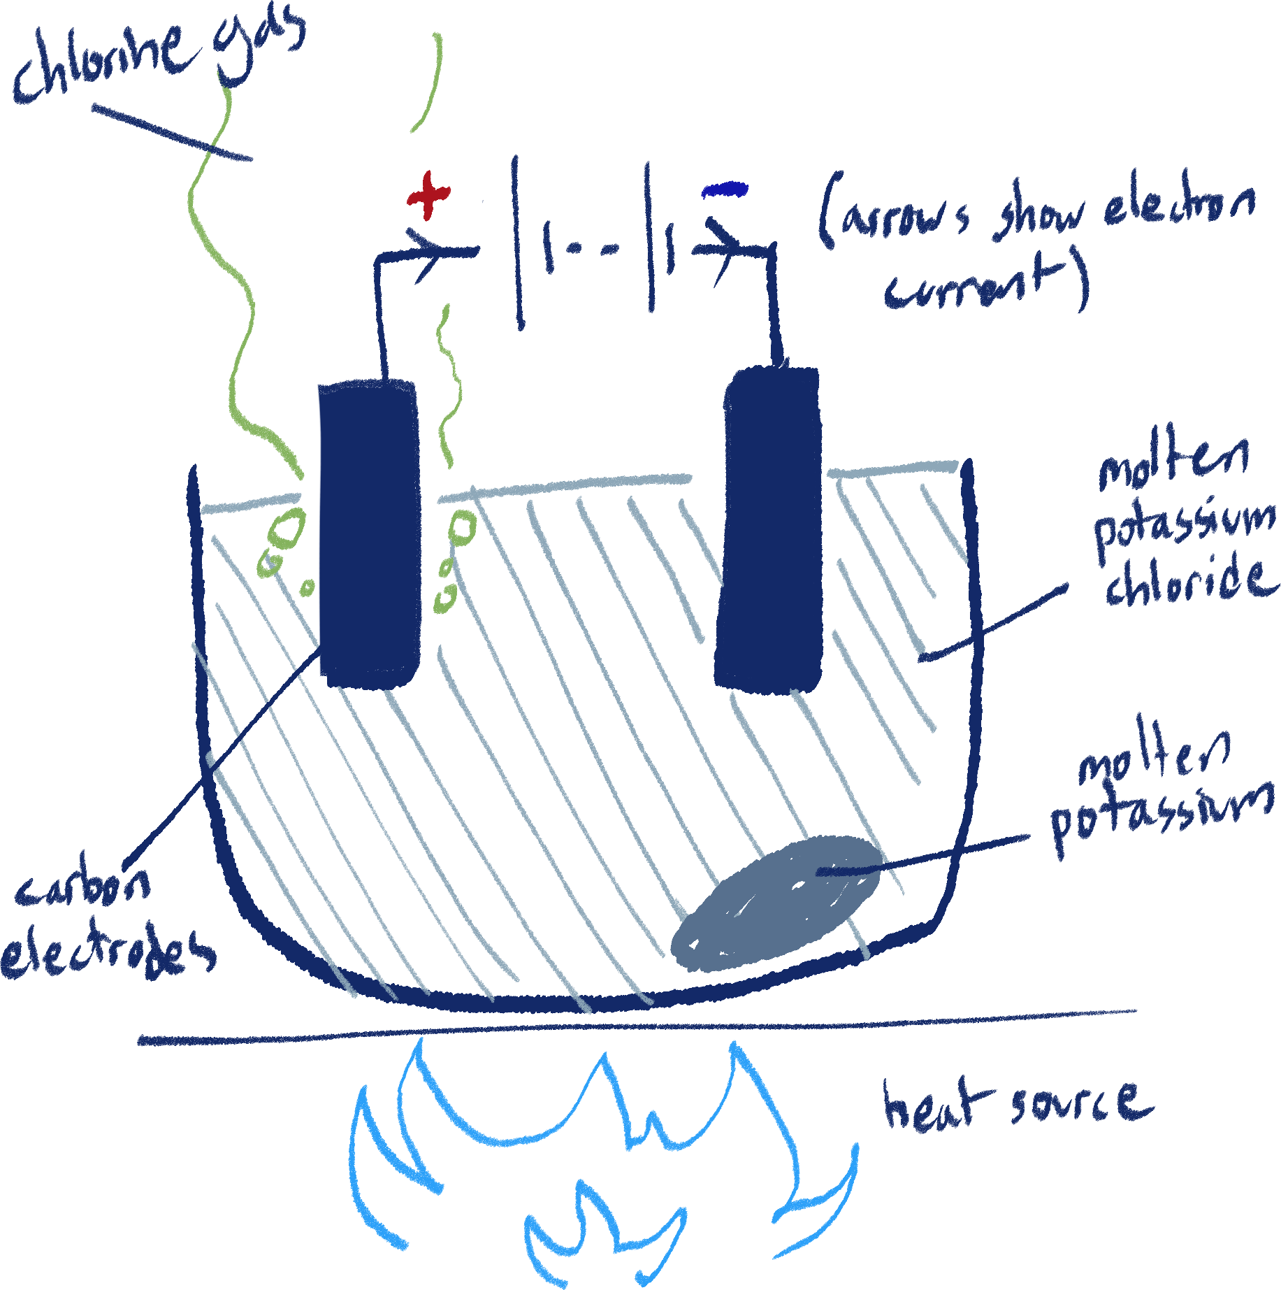Part 1: Electrodes

We know that ionic compounds, when molten, can conduct electricity, as their ions can move freely and carry charge, thus allowing a current to flow. So, submerging the electrodes with a power source into the molten salt completes the circuit.

An electric current flows due to charges moving. This is usually electrons moving towards positive charge, but a current can involve positive charges (such as cations) moving towards negative charge. This all happens due to the attraction between charges.

By imagining the current in this diagram, we can think of the electrons moving up and away from the molten salt in one electrode, and moving down into the molten salt in the other.

If moving electrons down into the molten salt can be considered *giving* electrons, then moving the electrons up and away can be considered *taking away* electrons. Like how a negative ion attracts a positive ion due to its extra electron, the electrode giving away electrons attracts positive ions in the same way (albeit with a quite stronger force of attraction).

So, the electrode giving away electrons is the negatively charged electrode which attracts cations, known as the cathode. The electrode taking away electrons, the positively charged one, is the anode.

Electrodes are separate from the wires because they are usually made out of different material depending on the experiment, and it is important to specify. Right now, we are using inert carbon (graphite, specifically) electrodes. If we were using something like copper electrodes, they could react in the process.

Part 2: Redox

Let’s think of one of the chloride anions in this reaction and follow it. The ion will be attracted to positive charge, and move towards the anode. When it reaches it, it will lose its extra valence electrons, turning back into an atom. This is how the chlorine gas is formed, and why it forms near the anode. We can say that the anode oxidizes the chloride ion, and write a half-equation like this:

2Cl1- -> Cl2 + 2e-

Now, the same applies to the potassium cation. It goes to the cathode, and gains electrons. It turns into a potassium atom.

2K + 2e- -> 2K

Completing the equation by combining the two half-equations, we get:

2KCl -> Cl2 + 2K

Now we can see that the result of electrolysis is really just a decomposition reaction.

The definition of electrolysis

So, electrolysis is defined as the decomposition of ionic compounds by passing a current through them.

Hydrogen fuel cells

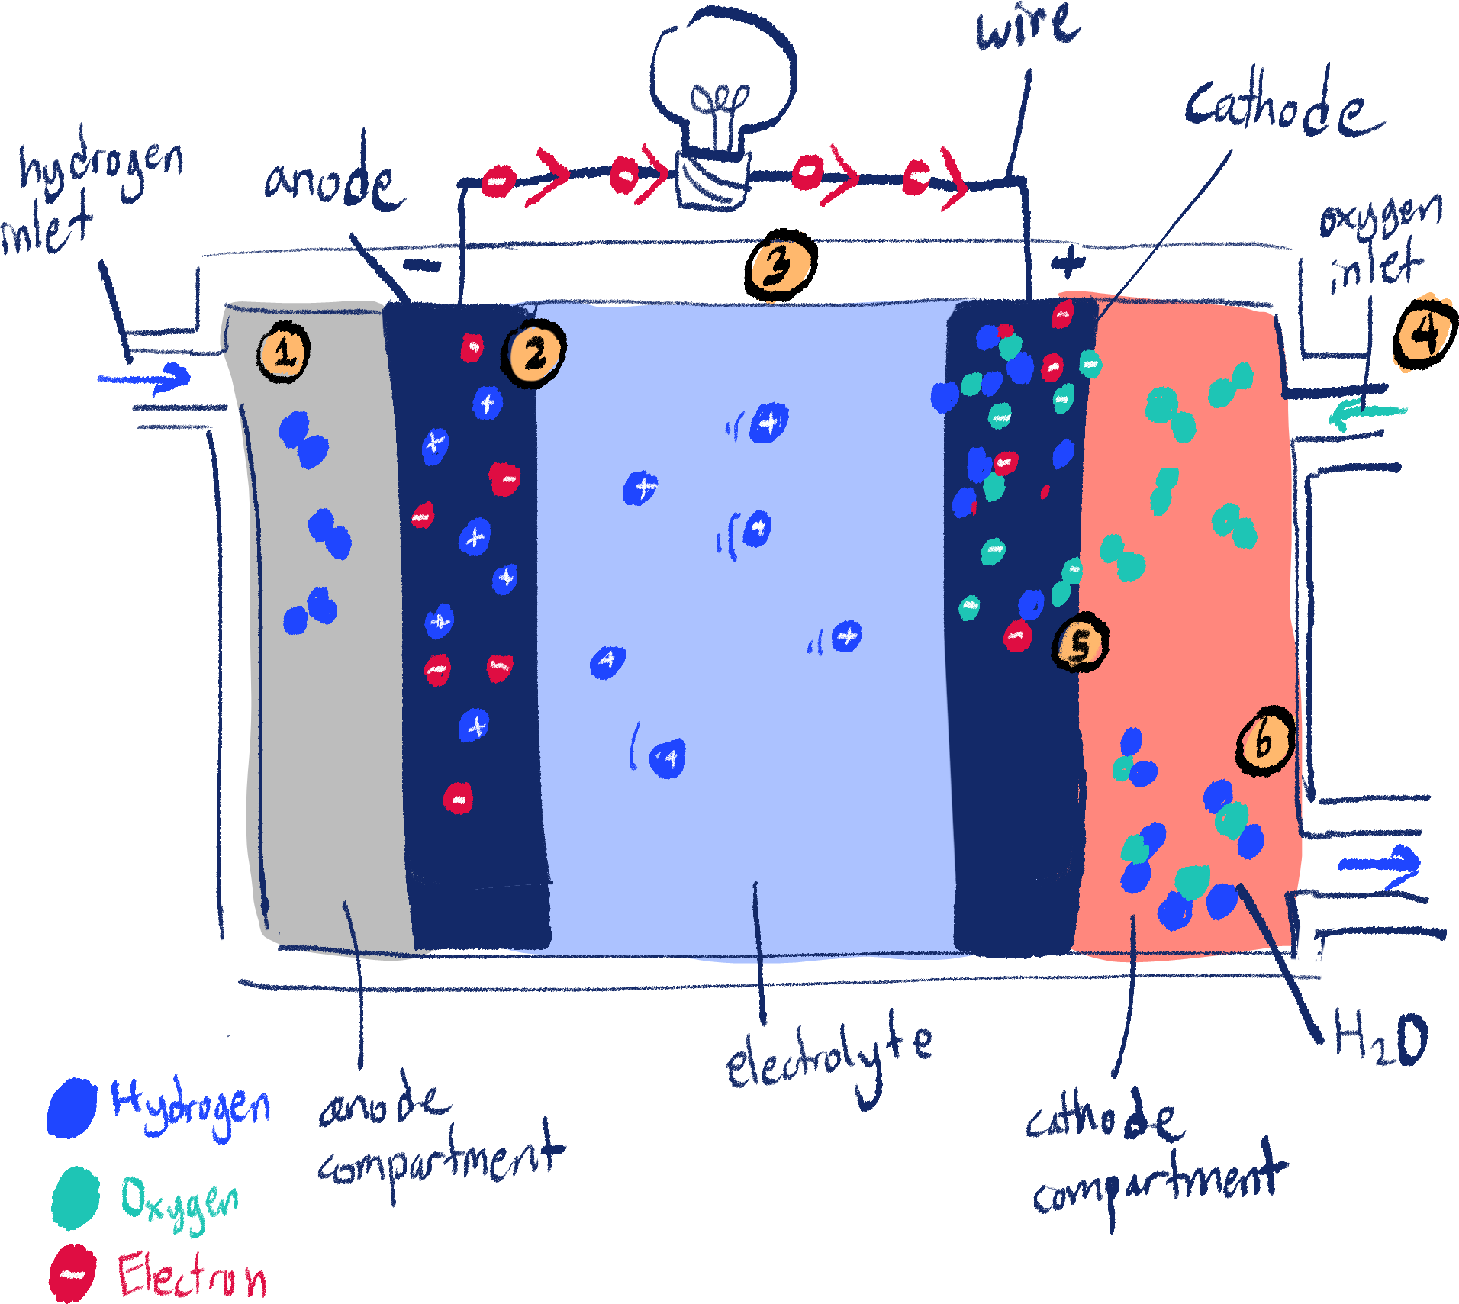 Fuel cells are sort of the opposite of electrolysis. They essentially use synthesis reactions to generate electricity. This is done through using fuel (in this case, we will be using hydrogen) and oxygen.

1. The fuel (hydrogen) is brought into the anode compartment through the fuel inlet.
2. The hydrogen turns into H+ + e- in the negative anode as it is oxidized.
3. The electrons flow from the anode to the positive cathode through a conducting wire, while the hydrogen ions move there through the electrolyte, which is usually sodium hydroxide.
4. Oxygen enters the cathode compartment through the oxygen inlet.
5. The oxygen reacts with the hydrogen and electrons to form H2O.
6. The water is sent out through a waste outlet.

To briefly explain *how* electrical energy is produced from fuel cells, you can say it is due to the potential difference produced by the oxidation and reduction reactions happening at the electrodes. The potential difference is what causes the electrons to move from the negative electrode to the positive electrode.

Also, notice that here the anode is negative, and the cathode is positive. To be honest, I don’t really care enough right now to think about how or why the naming changes here.

Half reactions and full reactions

At the anode:

2H2 -> 4H+ + 4e-

At the cathode:

O2 + 4e- -> 2O2-

And the complete reaction:

2H2 + O2 - > H2O

You may find that some sources (like SaveMyExams) will have OH- ions in the half reactions. Don’t worry, the reaction is still essentially the same, they are just including OH- as the carrier of the ions. The OH- comes from the sodium hydroxide, remember? The complete reaction will always be the same, however.

Reactive electrodes

Electroplating

How it’s done

Reasons electroplating is used

* To improve object appearance
* To provide resistance against corrosion

Overall, electroplating is a very efficient process as it uses very little metal to cover the object (only a thin layer) and does it in a consistent way, ensuring the plating is smooth and thin.

Metal purification

More Extra Things

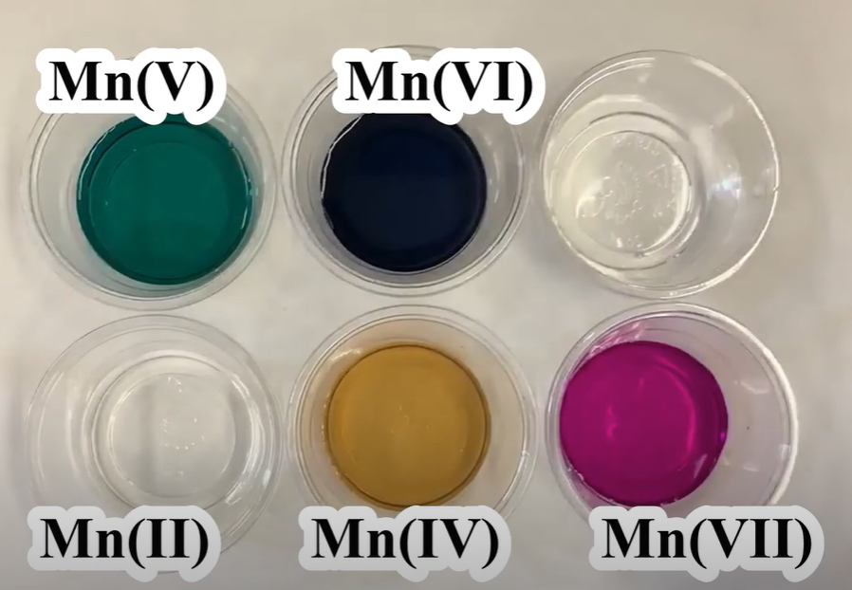Colors of manganate oxidation states

I see the manganate ion in enough indicators here that I think seeing what color a manganate solution will be according to its oxidation state is useful, because oftentimes the indicators rely on manganate’s color-changing properties when it comes to its oxidation state.

Metals

Properties of metals

These are mostly talking about properties of metals relative to non-metals.

* Shiny
* Soft
* Malleable

This means they can easy be hammered into shape without breaking.

* Ductile

This means they can easily be stretched into wires.

* Good electrical conductors
* Good conductors of heat

Uses of metals

Copper

Copper is commonly used for electrical wires, because it is a very good electrical conductor and is ductile, so it can be stretched into wires easily. It is also used in water pipes, due to its malleability.

Aluminium

Aluminium is used in:

* Aircraft, due to its low density and strength
* Overhead electrical cables, due to its electrical conductivity and low density
* Food containers, due to its resistance to corrosion

Alloys

Alloys are a mixture of metals with other elements. The most commonly found example is steel, an alloy of iron and carbon.

Alloys are made to improve certain properties of metals, including:

* Hardness/strength
* Appearance
* Lowering the melting point of metals

This makes it easier to melt them to cast or mold

* Increasing resistance to corrosion

Theory behind alloy strength

The reason adding other elements into a metal makes it harder is because the addition of differently sized atoms within it disrupts the regular lattice structure of the metal, making it harder for layers of metal ions to slide over one another.

This is also why the melting point of an alloy is lower than the metal that makes it up, just like how impurities lower the melting point of a substance, discussed earlier in this document.

Examples and uses of alloys

Mild steel

Steel is an alloy of iron and carbon, often used in building and bridge structure due to its strength. (99.5% iron, 0.5% carbon)

Stainless steel

A type of steel that is more resistant to corrosion. Because of this property, it is used in cutlery and cooking utensils, also due to being a good conductor of heat. It is an alloy made out of nickel, chromium, carbon and iron.

Brass

An alloy of copper and zinc, harder than copper. It is used for electrical connections and decorations due to its gold color. (70% zinc, 30% copper)

Solder

An alloy of tin and lead, used in soldering electrical connections due to its low melting point.

The reactivity series

Please - Potassium

Send - Sodium

Cool - Calcium

Monkeys - Magnesium

And - Aluminium

Cute - Carbon

Zebras - Zinc

Into - Iron

Hot - Hydrogen

Countries - Copper

Signed - Silver

Gordon – Gold

You are expected to memorize this specific series. I hope the mnemonic helps.

From top to bottom, the reactivity series goes from most reactive to least reactive. Depending on two metals’ relative reactivity, one can displace the other in a displacement reaction.

Why is there carbon and hydrogen in here? Having these two elements will be useful since quite a few reactions we will be discussing involves displacing these non-metals as well.

Reactivity

The reactivity of a metal is based off its tendency to form positive ions. For example, alkali metals are the most reactive because it is easiest for them to lose 1 valence electron to form a positive ion.

Reactions of metals

Metal + water

Because the reaction of a metal + water is:

Metal + water -> metal hydroxide + hydrogen gas

It is actually a displacement reaction where the metal displaces hydrogen in H2O. Thus, only metals that are more reactive than hydrogen in the reactivity series are able to react with water.

The more reactive metals, from potassium to calcium, can react with cold water.

* Potassium will be seen to react violently, floating across the water, producing bubbles of hydrogen gas. The heat from the reaction melts the potassium and causes the hydrogen gas to burn, so a lilac flame (from fire + potassium) will be seen. A small explosion may be seen at the end of the reaction.
* Sodium will melt and float as a bead on the water surface, rapidly moving around and fizzing hydrogen around it.
* Calcium very gently reacts with cold water. It is dense enough that it sinks underwater, bubbles of hydrogen only being seen after some time has passed.

Metals under them must be reacted with steam, starting from magnesium. Remember than when metals are reacted with steam, they form metal oxides instead of metal hydroxides.[39]

Metal + steam -> metal oxide + hydrogen gas

Metal + acid

Because acids are a nonmetal + hydrogen, and the reaction between a metal and acid is:

Metal + acid -> salt + hydrogen gas

We can see that this is another displacement reaction with hydrogen, so (theoretically) only metals above hydrogen in the reactivity series can react with acids.

Reactions with acids tend to be more vigorous, the most violent being with the metals that are able to react with cold water. Metals that react with steam can more easily react with acids. Magnesium reacts relatively fast with hydrochloric acid, while others below magnesium but above hydrogen have a slower reaction.

Make sure not to confuse this with the reaction of metal oxide + acid. In those cases, metals below hydrogen in the reactivity series are able to react.

Metals displacing metals

Simple. It goes:

Metal A + metal B nonmetal -> metal A nonmetal + metal B

In order for this to happen, metal A must be more reactive than metal B. Otherwise, no reaction will occur.

Metal oxide + carbon

Carbon does not react here in the usual sense as it forms a covalent bond with oxygen, not an ionic bond, and is a non-metal, so its reactivity does not come from the same place the metals do. Instead, its place in the reactivity series is based off whether it can reduce a metal or not.

The formula for the reaction would be:

Metal oxide + carbon -> metal + carbon dioxide

In order for this reaction to happen, like in a displacement reaction, carbon must be above the metal in the reactivity series. Otherwise, no reaction. Also, the reaction usually needs heating in order to occur.

This reaction is called a carbon reduction reaction, as carbon acts as a reducing agent here.

Metal + oxygen

Metal + oxygen -> metal oxide

Most metals react with oxygen in the air naturally, forming a metal oxide layer on their solid surface. This reaction is called corrosion. The least reactive metals, such as silver and gold, barely react at all with oxygen.

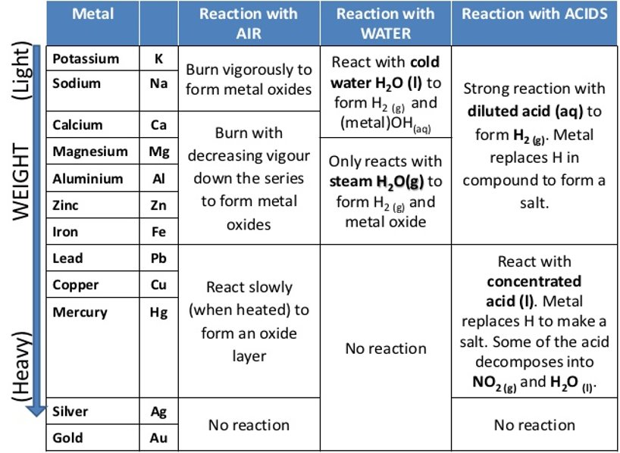 Metals can have different observed reactions when heated in oxygen, however. The most reactive metals, like potassium and sodium burn brightly when heated, magnesium producing a very bright light in its case. Copper on the other hand, gradually forms a black oxide layer over itself when heated.

Corrosion

Corrosion is the process of formation of an oxide layer over a metal due to reaction with oxygen in the air. It tends to happen for most metals (except for the very unreactive, like gold and platinum) and is often considered a bad thing.

Rusting

Rusting is a type of corrosion where iron/steel reacts with water and oxygen to form hydrated iron (III) oxide. You don’t need to know the equation, but you need to know the word equation and conditions needed for rust to form. Besides water and air needed for iron to rust, conditions such as the presence of salt and higher temperature speed up the reaction, which is why rusting is seen a lot in coastal areas.

We try to prevent rusting in a variety of methods as it can ruin appearance and strength of steel and iron, as it is a red-brown powdery solid that can easily crumble.

Barrier methods

Barrier methods aim to protect iron by covering the surface using inert material, so that it does not come into contact with air or water. Such methods include plastic coating, oiling/greasing and painting. However, once a part of the barrier is broken or scratched, exposed iron can easily rust.

Sacrificial protection

[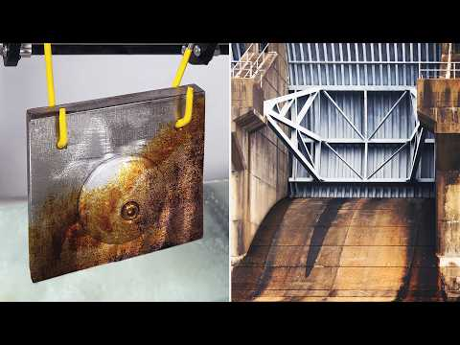](https://www.youtube.com/embed/qFXWjv65JWg?feature=oembed) Sacrificial protection involves attaching a more reactive metal, such as zinc in the case of protecting iron, to the metal object. By doing this, the more reactive metal is corroded instead of the other. Explaining this in terms of electron loss, the more reactive metal will lose its electrons and react instead of the less reactive metal.

Watch this video for a more thorough understanding of sacrificial protection.

This type of protection is often used on the hulls of ships, where blocks of zinc are attached to the steel body.

Galvanizing

Galvanizing iron/steel involves electroplating zinc onto the surface of the object, creating a barrier of zinc between the iron and the outside. It acts like a barrier method in this way, but has further advantages as a type of sacrificial protection, as even if the zinc layer is scratched, the exposed iron will not rust.

Aluminium’s resistance to corrosion

Despite being relatively high up in the reactivity series, it is not very prone to corrosion. This is due to it very quickly reacting with oxygen to form aluminium oxide on its surface, which is very hard and unreactive and acts as protection for the rest of the aluminium.

Extraction

Extracting metal means obtaining the pure form of a metal from its ore. Ores are metal oxides with impurities.

The most unreactive metals, gold and silver, can be found pure in nature. Any oxides of them can be easily decomposed by heating, due to their thermal instability.

Metals under carbon in the reactivity series can be extracted via carbon reduction – heating the metal oxide with carbon to form pure metal and carbon dioxide.

However, metals above carbon in the reactivity series must be extracted using electrolysis.

Blast iron furnace

Carbon reduction is an extremely important process when it comes to extracting iron, because it is the most cost-effective way to get iron, a metal used heavily everywhere. Mass-extraction of iron is done in big blast iron furnaces. The process of it will be discussed in this section.

Raw materials

* Hematite

Hematite is the iron ore used in this process. It is just impure iron (III) oxide, Fe2O3.

A nice way to keep the name in your head is this fun fact: it’s name comes from the Greek word ‘hamatitis’, meaning blood red, due to its red color.

You can further relate this color to remembering the formula, because iron (II) hydroxide formed in the cation tests (hydroxides are very similar to the oxides) is green while iron (III) hydroxide is red-brown.

* Coke

Coke is the form of carbon used in this process, but you will see it just as C in equations.

* Calcium carbonate (limestone)

CaCO3, important to remove other impurities in the ore.

* Hot air

Blown into the bottom of the furnace, oxygen from it is needed to form carbon dioxide with coke as well as react with any carbon impurities in the ore.

Main process

1. The coke is burned in air to produce carbon dioxide and extra heat for the furnace.

C + O2 -> CO2

1. The carbon dioxide reacts with more of the coke as it is heated to form carbon monoxide.

CO2 + C -> 2CO

1. The carbon monoxide reacts with the iron (III) oxide to form iron and carbon dioxide.

3CO + Fe2O3 -> Fe + 3CO2

1. The produced carbon dioxide is reused, while the molten pure iron, sinks to the bottom of the furnace and is collected.

Slag – removing other impurities

The ore will definitely not only be pure iron oxide. It can contain other things such as carbon, phosphorus, sulfur and silicon. The carbon impurities will be removed as the hot air blown into the furnace reacts with it, but the other impurities must be removed by other means.

Calcium carbonate is added to make this possible. It will decompose when heated to produce calcium oxide and carbon dioxide. The calcium oxide will react with the non-metal impurities to form slag, like calcium phosphate and calcium silicate, which can then be easily pulled out of the mixture.

Aluminium extraction

Aluminium is one of those metals that have to be extracted by electrolysis. You should know how it’s done.

Raw materials

* Bauxite

Bauxite is aluminium ore, but aluminum cannot be extracted from it directly. Instead, it must first be refined into alumina (aluminium oxide) first.

The name bauxite comes from the village Les Baux where one of the first deposits of it was discovered.

* Cryolite

Cryolite (sodium hexafluoroaluminate) is a rare mineral that acts as an impurity in the alumina mixture. It’s important since it significantly reduces the high melting point of the mixture, reducing the amount of energy needed to do the extraction and reducing the cost of the process.

Name comes from its frosty look (‘kryos’ Greek word for frost) and the Greek word for stone, ‘lithos’.

* Carbon electrodes

Specifically carbon electrodes are used in this extraction. The setup is not the usual ‘one electrode stick on each side’ but rather, a bunch of anodes in the middle submerged, and the cathode covering all of the inner walls of the container.

The anodes must be regularly replaced as the carbon will be used up as it reacts with the oxygen formed on them to become carbon dioxide.

Process

1. The alumina obtained from bauxite is dissolved in cryolite and melted.
2. The ions in the mixture are Al3+ and O2-.

Al2O3 -> Al3+ + O2-

1. At the anodes, the O2- ions lose their electrons and become oxygen:

2O2- -> O2  + 2e-

1. And at the cathodes, pure aluminium is formed:

Al3+ + 3e- -> Al

Chemical Energetics

Activation energy

Endothermic and exothermic reactions

Reaction energy diagrams

Numbers to memorize

Avogadro’s constant

6.02 x 1023 particles of a substance in 1 mole of that substance

Volume of a mole of gas at r.t.p.

24dm3/mol

Conditions for the Haber process

200 atm

450°C

Conditions for the Contact process

2 atm

450°C

Organic Chemistry

Hydrocarbons and homologous series

Hydrocarbons

Hydrocarbons are defined as compounds containing only hydrogen and carbon. Hydrocarbons and carbon in general are found in many parts of living nature due to carbon’s ability to form bonds with itself.

Homologous series

In this chapter, we will be talking about reactions between different homologous series most of the time. A homologous series is defined as a family of organic compounds that have similar chemical properties due to the presence of the same functional group.

You could think of it as a class of compound – if one thing applies to one compound in the series, it likely applies to all others in the series. They also have patterns, similar to how there are patterns as you go down a group in the periodic table.

Note that homologous series do not have to be hydrocarbons.

Functional groups

A functional group is an atom, or group of atoms, that define the chemical properties of a homologous series. For example, the functional group of a carboxylic acid is COOH. Without the COOH, it is not a carboxylic acid. The functional group is usually responsible for the chemical reactions of a series. You will notice this as we look at different series and their reactions.

Alkanes and introduction to general formulae and naming

Alkanes are the simplest hydrocarbon compounds. They are made up of a chain of single-bonded carbon atoms that have their remaining bonds with hydrogen atoms. They don’t have a specific functional group, but have the defining characteristic of having only single bonds.

Methane: CH4

Ethane: C2H6

Propane: C3H8

Butane: C4H10

Notice that the number of carbon atoms increases by order. Every homologous series has a general formula, and this is the general formula for alkanes:

CnH2n+2

In the general formula, n is the number of carbon atoms in the compound. Using this formula for alkanes as an example, we can find the molecular formula for any alkane if we know the number of carbon atoms in it.

ALSO notice that all alkanes names’ end with -ane as a suffix.

Alkenes

Alkenes are hydrocarbon compound characterized by their single carbon-carbon double bond. This is the general formula for alkenes:

CnH2n

Examples of alkenes:

Ethene: C2H4

Propene: C3H6

Butene: C4H8

Pentene: C5H10

For alkenes, the suffix is -ene.

There is no single-carbon version of alkene because then there would be no carbon-carbon double bond.

Structural isomers

Structural isomers are compounds with the same molecular formula, but different structural formulae.

Hydrocarbon saturation

Test for saturation

Formulae

Simple rules

When writing molecular formulae (and structural formulae) for organic compounds, we usually write carbon first, then nitrogen, then hydrogen, then oxygen, then halogens.

Alcohols

Producing ethanol

Alcohols can be produced from alkenes using these two different methods, each with their own disadvantages and advantages. We will be specifically be talking about ethanol here, but reactions like hydration can also work for other alkenes to form alcohols.

Hydration

Hydration involves reacting ethene with steam in the presence of an acid catalyst with a temperature of 300oC and high pressures of 60atm, producing ethanol with no other products.

Hydration immediately gives the pure product and is a fast process, but can be expensive due to the need for high temperatures and pressures.

Fermentation

In fermentation, aqueous glucose is kept at a temperature of 25o-30oC in the presence of yeast and in the absence of oxygen (this reaction doesn’t need oxygen to occur).

This method is very inexpensive as it does not require extreme temperature and pressures, but it may require more human labor, and it takes much longer for the process to complete. Furthermore, the product isn’t pure, so it must be purified after fermentation.

Carboxylic acids

Carboxylic acids all have the functional group COOH. The general formula is:

CnH2n+1COOH

But keep in mind that n here will be the number of carbon atoms in the molecule – 1, to account for the C in the COOH.

All carboxylic acids have the suffix -oic acid. For example, methanoic acid.

Reactions

Substitution reactions

Addition reactions

Condensation reactions

Esters

Identifying each part of an ester

Big fat important note. Read this structural formula:

CH3CH2COOCH2CH3

You can see that the ester link is at the OO, but which part of this is the carboxylic acid and which one is the alcohol? Would you name this ethyl propanoate or propyl ethanoate?

To solve this, remember that the last carbon in a carboxylic acid will have a double bond to an oxygen. This means that it can only have two other bonds, one being with the ester link O and the other being a carbon or hydrogen.

The last carbon on the alcohol on the other hand, will have a single bond with the ester link O, then 3 other bonds to use on carbon or hydrogen.

Looking at the last C on the left-hand side, it is definitely bonded with the carbon next to it (CH2) and the ester link O. However, it does not have its own hydrogen, which means its last two remaining bonds are used up in the double bond with the carboxyl O.

We can check with the carbon on the other side. It is definitely bonded with the ester link O and t he carbon next to it, but it also has two hydrogens, which means it is not bonded to another O.

So, this molecule is ethyl propanoate.

I like to think of this stuff logically, but in short, you can look at which side has a lone carbon to determine which one is the carboxylic acid.

Polymers

Monomers and polymers

Monomers are single compounds. For example, methane is a monomer. Polymers are large compounds made up of many monomers.

Addition polymerization

This is a reaction that forms a polymer from monomers that contain a double bond. The examples we’ll usually see are alkenes. It is similar to addition reactions that we’ve seen before in that the alkene’s double bond is split into two single bonds, but this time it connects to the carbon of another alkene.

Because addition polymerization requires monomers with double bonds, we the monomer must be an alkene.

An example of an addition polymer is polyethene, made up of multiple ethene monomers.

Condensation polymerization

Condensation polymerization involves forming a polymer from condensation reactions, as seen with esters. Regular esters are monomers, but by having more than one functional group on a monomer, chains of monomers connected by condensation reactions can form a polymer.

There are two types of polymers we will learn about: polyesters and polyamides.

Polyesters

Polyesters are polymers formed by the condensation polymerization of monomers with the alcohol group and the carboxyl group, just like esters.

Conditions for polymerization reactions

Hydrolysis

IUPAC naming

Homologous series compounds

Esters

Polymers

Plastic

Nylon

Disposal of plastic

Environmental challenges

Fuel

Fossil fuels

Fractional distillation of petroleum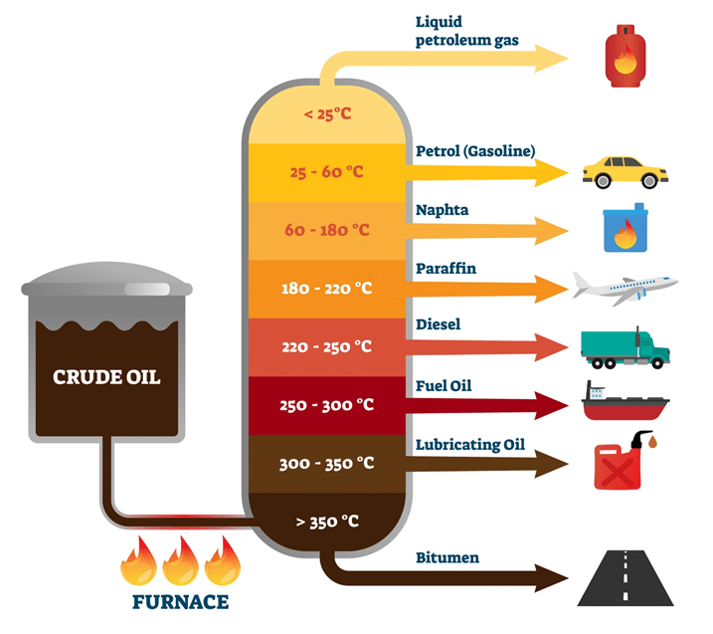

Process

Petroleum (also called crude oil) is made up many different hydrocarbon chains. Some are shorter, some are longer. The shortest chains are the most volatile, have the lowest boiling point, are not viscous (viscosity is how thick and slow a liquid is) and are colorless.

As hydrocarbon chains get longer, the volatility of the substance decreases, the boiling point increases, the viscosity increases, and color gets darker, going from yellow to brown to black.

Each range of chain length has different uses. They are separated from each other out of crude oil through fractional distillation. The crude oil is heated, then flowed into a fractionating column. As you go up the fractionating column, the temperature gradually decreases.

The gaseous hydrocarbons of the crude oil will rise up the fractionating column until they reach a point where temperature is at its boiling point. There, it will condense into liquid, and can be collected there. The lower the hydrocarbon’s boiling point, the higher it will reach up the column. So, the shortest hydrocarbon chains are collected at the top of the column, while the longest ones are found at the bottom of the column.

Uses of each fraction, from top to bottom

* Refinery gas

Cooking and heating

* Gasoline/petrol

Car fuel

* Naphtha

Chemical feedstock (this means a chemical used to provide reactants for a chemical reaction, usually industrially and at a large scale.

* Kerosene/paraffin

Jet fuel

* Diesel oil/gas oil

Fuel used in diesel engines

* Fuel oil

Ships and home heating systems

* Lubricating oil

Lubricants, waxes and polishes

* Bitumen

Building roads

Cracking hydrocarbons

Crude oil is made up of mostly long-chain hydrocarbons which aren’t very valuable and as useful as short-chain hydrocarbons like gasoline and refinery oil, since they aren’t as easy to combust as the short-chained compounds.

Cracking can also produce alkenes that aren’t naturally found in crude oil. Alkenes are very useful for making polymers for plastic and for making alcohols.

So, we crack long-chain hydrocarbons into more useful short-chained hydrocarbons. There are two types of cracking:

Thermal cracking

Thermal cracking is done at high temperatures and pressures, and splits long-chain alkanes into shorter-chain alkanes and alkenes.

Catalytic cracking

Catalytic cracking is done at high temperatures (but not as high as thermal cracking) but relatively low pressures in the presence of a catalyst, putting steam in contact with the long-chain alkanes being cracked. This type of cracking produces turns long-chain alkanes into shorter-chain alkenes, but no alkanes.

Chemistry Of The Environment

Water

Testing for the presence of water

There are two tests you should know of. The first is with copper sulfate: when water is added to the white copper sulfate powder, it will turn blue. Remember how copper (II) sulfate solution/crystals look.

The second test is cobalt (II) chloride. When it is anhydrous, it is blue, and when it is put into contact with water, it turns pink.

Water purity

When it comes to practical chemistry in the lab, we use distilled water because it contains less chemical impurities than regular tap water or mineral water that could interfere with chemical reactions.

To test the purity of a sample of water, we check the sample’s boiling point. Because we know the boiling point of pure water must be exactly 100oC, we heat the sample until it boils, and use a thermometer to check whether it is at 100oC. If not, this means that there are impurities in the water.

Water from natural sources

Substances in water from natural sources

* Dissolved oxygen
* Metal compounds
* Plastics
* Sewage
* Harmful microbes
* Nitrates from fertilizers
* Phosphates from fertilizers and detergents

Benefits

* Dissolved oxygen is important for aquatic life; fish breathe oxygen using their gills to respire
* Some metal compounds provide essential minerals for life.

Harmful substances

* Some metal compounds are toxic
* Some plastics harm aquatic life
* Sewage contains harmful microbes which can cause diseases
* Nitrates and phosphates lead to deoxygenation of water which can be harmful for aquatic life, as these fertilizer compounds accelerate algae growth in the water. This is called eutrophication.

Treatment of domestic water

“Domestic water” refers to water that drinkable and can be used for all sorts of domestic purposes, like showering, cooking, etc. Treatment of water to turn it into domestic water goes in order as follows:

1. Sedimentation

Water is placed in a large tank, where it is left for larger dust and rock to settle at the bottom. After a while, when most of the dust has settled, the water can be easily separated from the sediment at the bottom.

1. Filtration

Water is run through layers of sand, rock and filters to remove any smaller dust and particles in the water.

1. Activated carbon filtration

Water is run through activated carbon particles that adsorb impurities to remove tastes and odors from the water.

1. Chlorination

In the last step, chlorine is added to the water to kill any harmful microbes and bacteria in the water.

Fertilizers

Fertilizers are important for our world and economy since they allow us to substantially increase our food production and provide sustenance for our population.

Usually, ammonium salts and nitrates (for example ammonium nitrate :)) are used as fertilizers, as they provide one of the three key elements needed for plants: nitrogen.

The three key elements needed in fertilizers are nitrogen, potassium, and phosphorus. We call these fertilizers NPK fertilizers, each letter being an element’s symbol.

Air

Composition of air

Air is made up of 78% nitrogen, 21% air, and the remainder being a mix of noble gases and carbon dioxide. You should remember these numbers. For the rest of this section, we will discuss the sources and effects of some pollutants in the air.

Carbon dioxide

Carbon dioxide formed and released into the air through the complete combustion of carbon-containing fuels, where there is enough/excess oxygen for the fuel’s carbon to react with to form carbon dioxide.

Carbon dioxide contributes to the greenhouse gas effect which accelerates global warming and climate change, which will be explained later.

Carbon monoxide

Carbon monoxide is formed from the burning of carbon-containing fuels, like carbon dioxide. However, this forms during incomplete combustion, where there is not enough oxygen to completely react with the available carbon, leading to the formation of carbon monoxide.

Carbon monoxide is a toxic gas as it binds to hemoglobin in our blood and renders the hemoglobin useless and unable to carry oxygen.

Carbon particulates

Carbon particulates also form during incomplete combustion of carbon-containing fuels. A common word we use for carbon particulates is soot.

Breathing in particulates from the air can cause lung cancer and respiratory issues.

Methane

Methane, CH4, is a gas that forms from the decomposition (basically, rotting) of vegetation and plants, and is also a waste gas from digestion in animals, like cows.

Methane is a very effective greenhouse gas that contributes to global warming and climate change.

Oxides of nitrogen

Oxides of nitrogen refer to compounds like NO and NO2. These form in car engines, where the high temperatures and pressures in them cause the oxygen and nitrogen present in the air to react.

Oxides of nitrogen cause acid rain, photochemical smog, and respiratory problems.

Sulfur dioxide

Sulfur dioxide comes from the burning of sulfur-containing fuels, as sulfur is often found as an impurity in them.

Sulfur dioxide is a main cause of acid rain, as it dissolves in the water in clouds to form sulfuric acid.

Global warming

Reducing climate change

* Planting trees
* Reducing use of fossil fuels
* Increasing use of renewable energy
* Reduction in livestock farming

Photosynthesis

6CO2 + 6H2O -> (w/ conditions of chlorophyll and light) C6H12O6 + 6O2

Carbon dioxide + water -> (w/ conditions of chlorophyll and light) glucose + oxygen

Reducing acid rain

Effects of acid rain

* Kills plant and aquatic life
* Erodes stonework
* Corrodes metals

Catalytic converters

Catalytic converters are installed in vehicles to turn carbon monoxide and nitrogen oxides into safer emissions. This is done by using precious metals such as platinum as catalysts to react them into carbon dioxide and nitrogen.

2CO + 2NO -> 2CO2 +N2

Low-sulfur fuels

Low-sulfur fuels are fuels that have had most of their sulfur impurities removed, so when they are burnt, much less sulfur dioxide is emitted.

Flue gas desulfurization

Flue gas desulfurization involves using a scrubber that takes in emissions containing sulfur dioxide into a chamber. In the chamber, a wet mixture of calcium carbonate and calcium oxide is sprayed into the gases, neutralizing the sulfur dioxide into salt like calcium sulfate. This removes the sulfur dioxide in the gas, and the salt can be separated easily.

1. Excluding plasma
2. Well, technically they can but only over a very long period of time
3. I would really like to add that particle movement and particle kinetic energy are separate things, and apparently particle kinetic energy is affected by particle movement *and* mass.
4. This is a general non-specific term for the energy used that might be wrong because there are like 3 ways you can interpret the word ‘heat energy’
5. Please note that this is Fay’s own writing and not from a book or teacher. Contact me if you find anything wrong in this document lmao
6. My explanation is probably hard to understand so here’s [a nice Khan Academy link](https://www.khanacademy.org/science/chemistry/states-of-matter-and-intermolecular-forces/mixtures-and-solutions/v/boiling-point-elevation-and-freezing-point-supression#:~:text=Boiling%20point%20elevation%20is%20the,increases%2C%20its%20freezing%20point%20decreases.)
7. Also, saltwater’s temperature will rise faster than distilled water, but it will still have a higher boiling point. [It’s confusing](https://www.livescience.com/56214-does-salt-make-water-boil-faster.html).
8. Because lighter particles can bounce further off when colliding than heavier particles.
9. I don’t know what that is really. Maybe [this](https://www.hellovaia.com/explanations/chemistry/physical-chemistry/gas-constant/) will help
10. Diamond (made up of only carbon atoms) is an element. Pure water (made up of hydrogen and oxygen atoms) is a compound.
11. i.e. You are assigned to identify the unknown components of a mixture
12. ‘Phase’ means medium here, so the paper is the medium that is not moving, and the solvent is the medium moving.
13. This substances spread across the paper at different speeds due to differences in solubility.
14. Apparently, the solvent front should not be allowed to reach the end of the paper for accurate results.
15. The first example as a result also has a possibility of having more colorless components
16. There are multiple types; some can be sprayed, some need to have the paper dipped in them and then baked…
17. The component’s distance should be measured from the upper tip of the substance mark, like in the diagram.
18. The Rf value can be seen as the ratio between the component and solvent front in distance.
19. It can also be 2 electrons if the outer shell is the 1st electron level
20. The number of electrons an atom has to gain or lose to reach a full outer shell
21. Remember, hydrogen only needs 2 electrons in its valence shell
22. I’m pretty sure this applies to all metals
23. No such thing as ionic molecule. Only covalently bonded atoms are called molecules.
24. I would say that most are soluble, but there are plenty of exceptions to that
25. Besides graphite
26. Intermolecular: between molecules

    Intramolecular: within molecules
27. Compound of multiple metals
28. Bicarbonate is HCO3-(idk if you can see the 1 negative charge there) and is also called hydrogen carbonate
29. I recommend you remember this, because it reminds me of what the pH value actually means
30. Because atoms like hydrogen have a smaller and weaker nucleus
31. Because more of H/OH ions are released to neutralize the other substance
32. Ammonia is amphoteric in certain conditions, though.
33. Basically kettle cleaner
34. Although astatine and tennessine are uncertain
35. This is acetic acid without the H+ ion
36. Ammonium is the only positive ion you will have to remember.
37. This gives a very good idea of how this ‘equal rate of reaction’ works <https://chem.libretexts.org/Bookshelves/General_Chemistry/Map%3A_A_Molecular_Approach_(Tro)/15%3A_Chemical_Equilibrium/15.02%3A_The_Equilibrium_Constant_(K)>
38. Who are they
39. This is because of the thermal energy of steam causing thermal decomposition of the metal hydroxide, specifically for metals that are less reactive and less stable in compounds.